
Coordinate production of brochures and marketing materials
D2.TCS.CL5.06
Trainer Guide

Coordinate production of brochures and marketing materials
D2.TCS.CL5.06
Trainer Guide



Project Base
William Angliss Institute of TAFE
555 La Trobe Street
Melbourne 3000 Victoria
Telephone: | (03) 9606 2111
Facsimile: | (03) 9670 1330
Acknowledgements
Project Director: | Wayne Crosbie
Project Manager | Jim Irwin
Chief Writer: | Alan Hickman
Subject Writer: | Alan Hickman
Editor: | Jim Irwin
DTP/Production: | Daniel Chee, Mai Vu, Cindy Curran

The Association of Southeast Asian Nations (ASEAN) was established on 8 August 1967. The Member States of the Association are Brunei Darussalam, Cambodia, Indonesia, Lao PDR, Malaysia, Myanmar, Philippines, Singapore, Thailand and Viet Nam.
The ASEAN Secretariat is based in Jakarta, Indonesia.
General Information on ASEAN appears online at the ASEAN Website: www.asean.org.
All text is produced by William Angliss Institute of TAFE for the ASEAN Project on “Toolbox Development for Front Office, Food and Beverage Services and Food Production Divisions”.
This publication is supported by the Australian Government’s aid program through the ASEAN-Australia Development Cooperation Program Phase II (AADCP II).
Copyright: Association of Southeast Asian Nations (ASEAN) 2015.
All rights reserved.
Disclaimer
Every effort has been made to ensure that this publication is free from errors or omissions. However, you should conduct your own enquiries and seek professional advice before relying on any fact, statement or matter contained in this book. The ASEAN Secretariat and William Angliss Institute of TAFE are not responsible for any injury, loss or damage as a result of material included or omitted from this course. Information in this module is current at the time of publication. Time of publication is indicated in the date stamp at the bottom of each page.
Some images appearing in this resource have been purchased from stock photography suppliers Shutterstock and iStockphoto and other third party copyright owners and as such are non-transferable and non-exclusive. Clip arts, font images and illustrations used are from the Microsoft Office Clip Art and Media Library. Some images have been provided by and are the property of William Angliss Institute.
Additional images have been sourced from Flickr and SXC and are used under Creative Commons licence: http://creativecommons.org/licenses/by/2.0/deed.en
File name: TG_Coordinate production of brochures_280115



Table of contents
Competency Based Training (CBT) and assessment – An introduction for trainers 1
Competency standard 11
Notes and PowerPoint slides 25
Recommended training equipment 187
Instructions for Trainers for using PowerPoint – Presenter View 189
Appendix – ASEAN acronyms 191

Competency Based Training (CBT) and assessment – An introduction for trainers

Competency
Competency refers to the ability to perform particular tasks and duties to the standard of performance expected in the workplace.
Competency requires the application of specified knowledge, skills and attitudes relevant to effective participation, consistently over time and in the workplace environment.
The essential skills and knowledge are either identified separately or combined.
Knowledge identifies what a person needs to know to perform the work in an informed and effective manner.
Skills describe the application of knowledge to situations where understanding is converted into a workplace outcome.
Attitude describes the founding reasons behind the need for certain knowledge or why skills are performed in a specified manner.
Competency covers all aspects of workplace performance and involves:
- Performing individual tasks
- Managing a range of different tasks
- Responding to contingencies or breakdowns
- Dealing with the responsibilities of the workplace
- Working with others.

Unit of competency
Like with any training qualification or program, a range of subject topics are identified that focus on the ability in a certain work area, responsibility or function.
Each manual focuses on a specific unit of competency that applies in the hospitality workplace.
In this manual a unit of competency is identified as a ‘unit’.
Each unit of competency identifies a discrete workplace requirement and includes:
- Knowledge and skills that underpin competency
- Language, literacy and numeracy
- Occupational safety and health requirements.
Each unit of competency must be adhered to in training and assessment to ensure consistency of outcomes.

Element of competency
An element of competency describes the essential outcomes within a unit of competency.
The elements of competency are the basic building blocks of the unit of competency. They describe in terms of outcomes the significant functions and tasks that make up the competency.
In this manual elements of competency are identified as an ‘element’.

Performance criteria
Performance criteria indicate the standard of performance that is required to demonstrate achievement within an element of competency. The standards reflect identified industry skill needs.
Performance criteria will be made up of certain specified skills, knowledge and attitudes.

Learning
For the purpose of this manual learning incorporates two key activities:
- Training
- Assessment.
Both of these activities will be discussed in detail in this introduction.
Today training and assessment can be delivered in a variety of ways. It may be provided to participants:
- On-the-job – in the workplace
- Off-the-job – at an educational institution or dedicated training environment
- As a combination of these two options.
No longer is it necessary for learners to be absent from the workplace for long periods of time in order to obtain recognised and accredited qualifications.

Learning approaches
This manual will identify two avenues to facilitate learning:
Competency Based Training (CBT)
This is the strategy of developing a participant’s competency.
Educational institutions utilise a range of training strategies to ensure that participants are able to gain the knowledge and skills required for successful:
- Completion of the training program or qualification
- Implementation in the workplace.
The strategies selected should be chosen based on suitability and the learning styles of participants.

Competency Based Assessment (CBA)
This is the strategy of assessing competency of a participant.
Educational institutions utilise a range of assessment strategies to ensure that participants are assessed in a manner that demonstrates validity, fairness, reliability, flexibility and fairness of assessment processes.

Flexibility in learning
It is important to note that flexibility in training and assessment strategies is required to meet the needs of participants who may have learning difficulties. The strategies used will vary, taking into account the needs of individual participants with learning difficulties. However they will be applied in a manner which does not discriminate against the participant or the participant body as a whole.
Catering for participant diversity
Participants have diverse backgrounds, needs and interests. When planning training and assessment activities to cater for individual differences, trainers and assessors should:
- Consider individuals’ experiences, learning styles and interests
- Develop questions and activities that are aimed at different levels of ability
- Modify the expectations for some participants
- Provide opportunities for a variety of forms of participation, such as individual, pair and small group activities
- Assess participants based on individual progress and outcomes.
The diversity among participants also provides a good reason for building up a learning community in which participants support each other’s learning.
Participant centred learning
This involves taking into account structuring training and assessment that:
- Builds on strengths – Training environments need to demonstrate the many positive features of local participants (such as the attribution of academic success to effort, and the social nature of achievement motivation) and of their trainers (such as a strong emphasis on subject disciplines and moral responsibility). These strengths and uniqueness of local participants and trainers should be acknowledged and treasured
- Acknowledges prior knowledge and experience – The learning activities should be planned with participants’ prior knowledge and experience in mind
- Understands learning objectives – Each learning activity should have clear learning objectives and participants should be informed of them at the outset. Trainers should also be clear about the purpose of assignments and explain their significance to participants
- Teaches for understanding – The pedagogies chosen should aim at enabling participants to act and think flexibly with what they know
- Teaches for independent learning – Generic skills and reflection should be nurtured through learning activities in appropriate contexts of the curriculum. Participants should be encouraged to take responsibility for their own learning
- Enhances motivation – Learning is most effective when participants are motivated. Various strategies should be used to arouse the interest of participants
- Makes effective use of resources – A variety of teaching resources can be employed as tools for learning
- Maximises engagement – In conducting learning activities, it is important for the minds of participants to be actively engaged
- Aligns assessment with learning and teaching – Feedback and assessment should be an integral part of learning and teaching
- Caters for learner diversity – Trainers should be aware that participants have different characteristics and strengths and try to nurture these rather than impose a standard set of expectations.
Active learning
The goal of nurturing independent learning in participants does not imply that they always have to work in isolation or solely in a classroom. On the contrary, the construction of knowledge in tourism and hospitality studies can often best be carried out in collaboration with others in the field. Sharing experiences, insights and views on issues of common concern, and working together to collect information through conducting investigative studies in the field (active learning) can contribute a lot to their eventual success.
Active learning has an important part to play in fostering a sense of community in the class. First, to operate successfully, a learning community requires an ethos of acceptance and a sense of trust among participants, and between them and their trainers. Trainers can help to foster acceptance and trust through encouragement and personal example, and by allowing participants to take risks as they explore and articulate their views, however immature these may appear to be. Participants also come to realise that their classmates (and their trainers) are partners in learning and solving.
Trainers can also encourage cooperative learning by designing appropriate group learning tasks, which include, for example, collecting background information, conducting small-scale surveys, or producing media presentations on certain issues and themes. Participants need to be reminded that, while they should work towards successful completion of the field tasks, developing positive peer relationships in the process is an important objective of all group work.

Competency Based Training (CBT)
Principle of Competency Based Training
Competency based training is aimed at developing the knowledge, skills and attitudes of participants, through a variety of training tools.
Training strategies
The aims of this curriculum are to enable participants to:
- Undertake a variety of subject courses that are relevant to industry in the current environment
- Learn current industry skills, information and trends relevant to industry
- Learn through a range of practical and theoretical approaches
- Be able to identify, explore and solve issues in a productive manner
- Be able to become confident, equipped and flexible managers of the future
- Be ‘job ready’ and a valuable employee in the industry upon graduation of any qualification level.
To ensure participants are able to gain the knowledge and skills required to meet competency in each unit of competency in the qualification, a range of training delivery modes are used.
Types of training
In choosing learning and teaching strategies, trainers should take into account the practical, complex and multi-disciplinary nature of the subject area, as well as their participant’s prior knowledge, learning styles and abilities.
Training outcomes can be attained by utilising one or more delivery methods:
Lecture/tutorial
This is a common method of training involving transfer of information from the trainer to the participants. It is an effective approach to introduce new concepts or information to the learners and also to build upon the existing knowledge. The listener is expected to reflect on the subject and seek clarifications on the doubts.
Demonstration
Demonstration is a very effective training method that involves a trainer showing a participant how to perform a task or activity. Through a visual demonstration, trainers may also explain reasoning behind certain actions or provide supplementary information to help facilitate understanding.
Group discussions
Brainstorming in which all the members in a group express their ideas, views and opinions on a given topic. It is a free flow and exchange of knowledge among the participants and the trainer. The discussion is carried out by the group on the basis of their own experience, perceptions and values. This will facilitate acquiring new knowledge. When everybody is expected to participate in the group discussion, even the introverted persons will also get stimulated and try to articulate their feelings.
The ideas that emerge in the discussions should be noted down and presentations are to be made by the groups. Sometimes consensus needs to be arrived at on a given topic. Group discussions are to be held under the moderation of a leader guided by the trainer. Group discussion technique triggers thinking process, encourages interactions and enhances communication skills.
Role play
This is a common and very effective method of bringing into the classroom real life situations, which may not otherwise be possible. Participants are made to enact a particular role so as to give a real feel of the roles they may be called upon to play. This enables participants to understand the behaviour of others as well as their own emotions and feelings. The instructor must brief the role players on what is expected of them. The role player may either be given a ready-made script, which they can memorise and enact, or they may be required to develop their own scripts around a given situation. This technique is extremely useful in understanding creative selling techniques and human relations. It can be entertaining and energising and it helps the reserved and less literate to express their feelings.

Simulation games
When trainees need to become aware of something that they have not been conscious of, simulations can be a useful mechanism. Simulation games are a method based on "here and now" experience shared by all the participants. The games focus on the participation of the trainees and their willingness to share their ideas with others. A "near real life" situation is created providing an opportunity to which they apply themselves by adopting certain behaviour. They then experience the impact of their behaviour on the situation. It is carried out to generate responses and reactions based on the real feelings of the participants, which are subsequently analysed by the trainer.
While use of simulation games can result in very effective learning, it needs considerable trainer competence to analyse the situations.
Individual /group exercises
Exercises are often introduced to find out how much the participant has assimilated. This method involves imparting instructions to participants on a particular subject through use of written exercises. In the group exercises, the entire class is divided into small groups, and members are asked to collaborate to arrive at a consensus or solution to a problem.
Case study
This is a training method that enables the trainer and the participant to experience a real life situation. It may be on account of events in the past or situations in the present, in which there may be one or more problems to be solved and decisions to be taken. The basic objective of a case study is to help participants diagnose, analyse and/or solve a particular problem and to make them internalise the critical inputs delivered in the training. Questions are generally given at the end of the case study to direct the participants and to stimulate their thinking towards possible solutions. Studies may be presented in written or verbal form.
Field visit
This involves a carefully planned visit or tour to a place of learning or interest. The idea is to give first-hand knowledge by personal observation of field situations, and to relate theory with practice. The emphasis is on observing, exploring, asking questions and understanding. The trainer should remember to brief the participants about what they should observe and about the customs and norms that need to be respected.
Group presentation
The participants are asked to work in groups and produce the results and findings of their group work to the members of another sub-group. By this method participants get a good picture of each other's views and perceptions on the topic and they are able to compare them with their own point of view. The pooling and sharing of findings enriches the discussion and learning process.
Practice sessions
This method is of paramount importance for skills training. Participants are provided with an opportunity to practice in a controlled situation what they have learnt. It could be real life or through a make-believe situation.

Games
This is a group process and includes those methods that involve usually fun-based activity, aimed at conveying feelings and experiences, which are everyday in nature, and applying them within the game being played. A game has set rules and regulations, and may or may not include a competitive element. After the game is played, it is essential that the participants be debriefed and their lessons and experiences consolidated by the trainer.
Research
Trainers may require learners to undertake research activities, including online research, to gather information or further understanding about a specific subject area.

Competency Based Assessment (CBA)
Principle of Competency Based Assessment
Competency based assessment is aimed at compiling a list of evidence that shows that a person is competent in a particular unit of competency.
Competencies are gained through a multitude of ways including:
- Training and development programs
- Formal education
- Life experience
- Apprenticeships
- On-the-job experience
- Self-help programs.
All of these together contribute to job competence in a person. Ultimately, assessors and participants work together, through the ‘collection of evidence’ in determining overall competence.
This evidence can be collected:
- Using different formats
- Using different people
- Collected over a period of time.
The assessor, who is ideally someone with considerable experience in the area being assessed, reviews the evidence and verifies the person as being competent or not.
Flexibility in assessment
Whilst allocated assessment tools have been identified for this subject, all attempts are made to determine competency and suitable alternate assessment tools may be used, according to the requirements of the participant.
The assessment needs to be equitable for all participants, taking into account their cultural and linguistic needs.
Competency must be proven regardless of:
- Language
- Delivery Method
- Assessment Method.
Assessment objectives
The assessment tools used for subjects are designed to determine competency against the ‘elements of competency’ and their associated ‘performance criteria’.
The assessment tools are used to identify sufficient:
- Knowledge, including underpinning knowledge
- Skills
- Attitudes
Assessment tools are activities that trainees are required to undertake to prove participant competency in this subject.
All assessments must be completed satisfactorily for participants to obtain competence in this subject. There are no exceptions to this requirement, however, it is possible that in some cases several assessment items may be combined and assessed together.
Types of assessment
Allocated Assessment Tools
There are a number of assessment tools that are used to determine competency in this subject:
- Work projects
- Written questions
- Oral questions
- Third Party Report
- Observation Checklist.
Instructions on how assessors should conduct these assessment methods are explained in the Assessment Manuals.
Alternative assessment tools
Whilst this subject has identified assessment tools, as indicated above, this does not restrict the assessor from using different assessment methods to measure the competency of a participant.
Evidence is simply proof that the assessor gathers to show participants can actually do what they are required to do.
Whilst there is a distinct requirement for participants to demonstrate competency, there are many and diverse sources of evidence available to the assessor.
Ongoing performance at work, as verified by a supervisor or physical evidence, can count towards assessment. Additionally, the assessor can talk to customers or work colleagues to gather evidence about performance.
A range of assessment methods to assess competency include:
- Practical demonstrations
- Practical demonstrations in simulated work conditions
- Problem solving
- Portfolios of evidence
- Critical incident reports
- Journals
- Oral presentations
- Interviews
- Videos
- Visuals: slides, audio tapes
- Case studies
- Log books
- Projects
- Role plays
- Group projects
- Group discussions
- Examinations.
Recognition of Prior Learning
Recognition of Prior Learning is the process that gives current industry professionals who do not have a formal qualification, the opportunity to benchmark their extensive skills and experience against the standards set out in each unit of competency/subject.
Also known as a Skills Recognition Audit (SRA), this process is a learning and assessment pathway which encompasses:
- Recognition of Current Competencies (RCC)
- Skills auditing
- Gap analysis and training
- Credit transfer.
Assessing competency
As mentioned, assessment is the process of identifying a participant’s current knowledge, skills and attitudes sets against all elements of competency within a unit of competency. Traditionally in education, grades or marks were given to participants, dependent on how many questions the participant successfully answered in an assessment tool.
Competency based assessment does not award grades, but simply identifies if the participant has the knowledge, skills and attitudes to undertake the required task to the specified standard.
Therefore, when assessing competency, an assessor has two possible results that can be awarded:
- Pass Competent (PC)
- Not Yet Competent (NYC).
Pass Competent (PC)
If the participant is able to successfully answer or demonstrate what is required, to the expected standards of the performance criteria, they will be deemed as ‘Pass Competent’ (PC).
The assessor will award a ‘Pass Competent’ (PC) if they feel the participant has the necessary knowledge, skills and attitudes in all assessment tasks for a unit.
Not Yet Competent’ (NYC)
If the participant is unable to answer or demonstrate competency to the desired standard, they will be deemed to be ‘Not Yet Competent’ (NYC).
This does not mean the participant will need to complete all the assessment tasks again. The focus will be on the specific assessment tasks that were not performed to the expected standards.
The participant may be required to:
a) Undertake further training or instruction
b) Undertake the assessment task again until they are deemed to be ‘Pass Competent’.

Competency standard
UNIT TITLE: COORDINATE PRODUCTION OF BROCHURES AND MARKETING MATERIALS |  |  |  | NOMINAL HOURS: 70
UNIT NUMBER: D2.TCS.CL5.06
UNIT DESCRIPTOR: This unit deals with skills and knowledge required to manage the production of brochures and marketing materials.
ELEMENTS AND PERFORMANCE CRITERIA | UNIT VARIABLE AND ASSESSMENT GUIDE
Element 1: Identify the context for brochures and marketing materials  - Determine the factors that apply to the production of brochures and marketing materials  - Plan the production of items  - Develop action plans for individual brochures and marketing materials  Element 2: Manage inclusions for brochures and marketing materials  - Determine the target(s) for the items  - Determine the content for the items  - Determine format and layout for the items  - Determine language for the items  - Determine the prices to be stated in the items  - Determine the copy for the items | Unit Variables  The Unit Variables provide advice to interpret the scope and context of this unit of competence, allowing for differences between enterprises and workplaces. It relates to the unit as a whole and facilitates holistic assessment.  This unit applies to organisations that are involved in producing brochures and marketing materials within the labour divisions of the hotel and travel industries and may include:  - Travel Agencies  - Tour Operation  Factors that apply may be related to:  - Objectives  - Target market(s)  - Analysis of the brochures and marketing materials being used by competitors  - Required or preferred style and size of materials including consideration of demands placed on brochures and marketing materials by others in the marketing and distribution chain  - Time parameters including seasonal considerations, and the relationship between product release and the need to promote that product
Element 3: Administer activities relating to the production of draft items  - Provide resources for the production of draft items  - Proof read material  - Circulate items for comment and feedback  - Revise brochures and marketing materials  Element 4: Obtain quotations for production of brochures and marketing materials  - Meet and discuss the proposal with service providers  - Provide detailed specifications as the basis for obtaining a quotation for work to be done  - Obtain quotations from a range of service providers  - Evaluate quotations received to make a purchasing decision  - Select the service provider(s) to supply services and lodge official order  Element 5: Administer activities relating to the production of final items  - Monitor production activities undertaken by selected service providers  - Ensure payment to service providers, as agreed  - Identify and use alternative service providers where production timelines are not being met  - Proof read material that is produced as final items for approval prior to full production | - Budget including consideration of joint venture marketing initiatives  - In-house production capabilities and their availability to produce materials that align with designated timeframes  - Internal and external distribution considerations including cost of distribution, required quantities, language(s) to be used, target market(s) and intermediaries in the distribution chain  - Availability of information that needs to be included in the marketing materials, including relevance, currency and copyright clearance  - Organisational image including consideration of the need to either maintain or extend the existing image, or the need to alter the image  - Legal restrictions and restrictions that may apply including need to ensure accuracy, comprehensiveness and truthfulness in content, detail, descriptions, representations and statistics.  Brochures and marketing materials may include:  - Product and service brochures  - Destination guides  - Promotional flyers and leaflets  - Conference programs and registration/advertorial forms  - Event prospectus  - Display material  - Information kits  - Product support materials  - Advertising materials  - Direct mail items  - Invitations  - Merchandising goods.
- Authorise production of final items  - Check items supplied by service providers as final items | Plan the production will include:  - Identifying the type, nature and volume of items to be produced  - Integrating materials with organisational plans, goals and objectives  - Developing expected outcomes for the brochures and marketing materials  - Identifying methods to evaluate the impact of brochures and marketing materials  - Involving relevant others in the process  - Clarifying resources available to achieve the expected outcomes  - Identifying issues that may impact on developing and producing materials.
Develop action plans may be related to:
- Identifying, detailing and clarifying individual steps to be undertaken in the development and production phases
- Allocating resources to the development and production phases
- Identifying individual responsibilities for the pre-development and production phases including the roles of internal and external people
- Specifying timelines and target dates for the completion of components of each plan
- Referring to previous marketing activities as a basis for future marketing activities
- Seeking input and comment from relevant stakeholders as appropriate to individual project requirements
- Communicating the contents of action plans with relevant stakeholders to explain specific requirements and responsibilities that apply.
Target(s) for the items may relate to:
- Internal customers
- External customers, including other organisations within the marketing and/or distribution chain and designated customer target markets
- The geographical location of the customer
- Consideration of market research data relating to targets, including demographic characteristics and data relating to customer regarding how they prefer to receive their information.
Content for the items may relate to:
- Products and services to be targeted in the material, including consideration of individual products, services and combination packages
- Currency of the items, including estimating the potential lifespan for each item taking into account prices, costs and changing circumstances as they apply to individual projects
- Alignment with stated objectives
- Logos, text/copy, graphics, art work and photographs
- Mandatory inclusions including company logos and statements, contact details, affiliations and indications of Quality Assurance (QA) alignment
- Seeking input from relevant internal personnel and external stakeholders, including consideration of sub-agents and joint venture partners.
Format and layout for the items may include:
- Selecting single page leaflets, bi-fold and/or tri-fold options
- Determining font to be used throughout or in defined sections of the items
- Identifying print size to be used
- Determining the use of colour, including consideration of black and white, limited colour or full-colour
- Determining length of the finished product in terms of pages
- Selecting stock size, quality and colour to be used for page layouts incorporating distribution considerations, such as mailing, costs, stocking and display requirements of distributors
- Positioning text, graphics, photographs on the stock or marketing item
- Enabling sufficient space for required text and information
- Liaising with internal and/or external graphic artists and printers
- Applying basic design principles, including aesthetic appeal, harmony, flow and sequencing, balance, spacing and hierarchy of headings/sub-headings.
Language for the items may include:
- Preparing items in languages appropriate to the target markets, including the use of foreign language, where appropriate
- Using appropriate idioms and terminology for local and target markets
- Appropriate and selective use and/or explanation of industry terminology.
Prices to be stated in the items may include:
- Ensuring accuracy and comprehensiveness of all prices and charges
- Ensuring prices, tariffs are valid only until a stated date
- Ensuring a statement that prices and charges are subject to change without notification is included
- Including prices that are relevant to the specific target audiences of the brochures or marketing materials, including the need to list wholesale prices, commissions, available discounts for trade audiences but not for retail customers
- Ensuring the currency used in the items is relevant to the language being used and/or target market audiences or destinations
- Verifying with management that prices to be included in items are correct and acceptable
- Not releasing any items until pricing issues have been verified and approved by management.
Copy for the items may include:
- Determining the use of headings, headlines, headers and footers
- Determining copy style including factual, imaginative, authoritative, whimsical, contemporary or emotional
- Ensuring clarity of information provided
- Identifying key messages and supplementary messages
- Including special offers, incentives and/or competitions, as required
- Incorporating the AIDA principle, grabbing Attention; appealing to self-Interest; arousing a Desire to buy; urging people to take Action
- Personalising the message
- Using specifics rather than generalisations
- Using trigger words to encourage responses
- Including maps in the items, where appropriate
- Including messages from joint venture or sponsorship partners
- Ensuring material is copyright free.
Provide resources may include:
- Supplying funding
- Arranging for professional external assistance
- Allocating sufficient and appropriate time
- Organising for the inclusion of relevant internal expertise.
Proof read material may include:
- Checking to ensure materials do not give offence
- Ensuring freedom from spelling, grammatical or typographical errors
- Verifying the inclusion of all required information
- Checking that facts and figures contained in the item are accurate, current, relevant and comprehensive
- Ensuring there are no last-minute changes to the information contained within the items.
Circulate items for comment may include:
- Presenting material to management and partners to obtain their final comments
- Obtaining approval to proceed with the proposed items.
Meet and discuss the proposal with service providers may include:
- Graphic artists
- Graphic designers
- Printers
- Obtaining and evaluating samples of work done by potential service providers
- Selecting a service provider with previous relevant industry experience and a proven and successful history.
Detailed specifications may include:
- Defining the decisions relating to:
- Quantities/volume required
- Number of colours
- Type of stock
- Number of photographs
- Layout and style of text
- Production deadlines
- Presentation of draft sample
- Determining terms and conditions of the contract that are acceptable and/or non-negotiable.
Obtain quotations may include:
- Ensuring quotations received accommodate the stated requirements of the specifications supplied
- Ensuring quotations are received from a number of different service providers in keeping with internal requirements to obtain a variety of quotations prior to making a purchasing decision
- Determining the finishing requirements that will apply to hard copy items including folding, trimming, stitching or stapling, as appropriate.
Evaluate quotations may include:
- Comparing quotations received from different service providers
- Assessing quotations against identified criteria for the production of items as contained in the specifications supplied to potential service providers.
Monitor production activities may include:
- Liaising with suppliers to ensure specified targets and requirements are being met
- Meeting with service providers on a regular basis to enable emerging issues to be highlighted and addressed
- Responding to requests for information and/or direction
- Making production decisions to move the project forward, including decisions regarding production variations that occur during the production phase.
Proof read material that is produced as final items may include:
- Checking proofs for accuracy and compliance with initial draft
- Advising service providers of errors and/or changes that need to be made to proofs prior to final production
- Checking revised proofs, if required.
Authorise production may include:
- Signing off on proof to give authority for final production
- Making payment in accordance with agreed contractual conditions
- Filing documentation and communications between the organisation and service providers.
Check items supplied may include:
- Verifying final items match approved proofs
- Checking colour and print clarity
- Checking finishing that has been applied
- Checking quantities supplied
- Verifying distribution activities relating to items where these were agreed to as part of the production contract
- Authorising final payment for services rendered by service providers.
Assessment Guide
The following skills and knowledge must be assessed as part of this unit:
- Enterprise policies and procedures in regard to marketing, advertising and the production of materials that represent the organisation
- Principles of promotion and copy writing
- Knowledge of alternatives that exist in the development of brochures and marketing materials
- Understanding of the brochures and marketing materials used by the competition and elsewhere in the relevant industry sector
- Legislation that relates to fair trading, consumer protection, copyright and truth in advertising
- Ability to use coordination, project management and negotiation skills and techniques
- Knowledge of quality indicators that apply to materials produced
- General knowledge of the printing, graphic design and graphic artist industries
- Knowledge of factors that relate to production decisions including mailing costs, distribution costs, requirements by partners and associated promoters.
Linkages To Other Units
- Access and retrieve computer-based data
- Develop a marketing strategy and coordinate sales activities
- Establish and maintain a business relationship
- Produce documents, reports and worksheets on a computer
- Gather and present product information
- Prepare business documents
- Use common business tools and technology
- Lead and manage people
- Manage legal requirements for business compliance
- Monitor staff performance
- Provide professional support to business colleagues
- Develop and update tourism industry knowledge
- Promote products and services to customers
- Source and package tourism products and services
- Source and provide destination information and advice
- Create, implement and evaluate strategic product initiatives
- Develop, implement and evaluate sponsorship plans
- Develop, manage and evaluate local marketing strategies
- Promote tourism products and services
- Plan and implement sales activities
- Source and present information
- Lead and manage a development team
- Monitor workplace operations.
Critical Aspects of Assessment
Evidence of the following is essential:
- Understanding of host enterprise policies and procedures in regard to marketing, advertising and the production of materials that represent the organisation
- Demonstrated ability to identify the brochures and marketing materials required to support the attainment of organisational objectives in a defined context and develop effective and comprehensive action plans to guide the development of final items
- Demonstrated ability to oversee the development of a nominated draft item for presentation to a service provider, such as a printer, ensuring the material for inclusion is appropriate for the target audience, does not give offence, is legally compliant and is appropriate and acceptable in terms of content, accuracy, format, layout, language and copy writing style
- Demonstrated ability to undertake dealings with an internal or external service provider to submit a draft item for discussion, negotiate a contract for the delivery of services, obtain a nominated number of quotations for the job, proof read the material and give final approval for the production phase
- Demonstrated ability to oversee the production of nominated brochures and/or marketing materials including responding to production issues, checking the finished product and finalising payment and other internal and operational requirements.
Context of Assessment
Assessment must ensure:
- Actual or simulated workplace application of skills and knowledge to manage the development and production of actual brochures and marketing materials, including consultation and interaction with external service providers however, there is no necessity for the brochures and marketing materials to be produced by an external professional provider.
Resource Implications
Training and assessment must include identification of one or more real objectives for the brochures and marketing materials and interaction with real service providers, real internal staff with relevant expertise, where appropriate, real materials and a real industry context.
Assessment Methods
The following methods may be used to assess competency for this unit:
- Observation of practical candidate performance
- Analysis of hard copy materials produced as part of the project including draft items, contracts, sample materials, action plans, proofs and final products
- Discussions with members of target audiences to identify the effectiveness of materials that have been produced
- Role plays
- Oral and written questions
- Third party reports completed by a supervisor
- Project and assignment work.
Key Competencies in this Unit
Level 1 = competence to undertake tasks effectively
Level 2 = competence to manage tasks
Level 3 = competence to use concepts for evaluating
 | Key Competencies | Level | Examples
 | Collecting, organising and analysing information | 2 | Validate information for inclusion in brochures and marketing materials
 | Communicating ideas and information | 1 | Share organisational requirements with development staff and external service providers
 | Planning and organising activities | 2 | Organise staff activities and the services of external service providers to produce brochures and marketing materials
 | Working with others and in teams | 2 | Assist colleagues and provide resources to develop copy, layout and content for draft items
 | Using mathematical ideas and techniques | 3 | Determine the acceptability of quotations received from service providers
 | Solving problems | 2 | Resolve copy, content and production issues
 | Using technology | 2 | Determine the technologies to be used in the production of brochures and marketing materials

Notes and PowerPoint slides
Slide

Slide No | Trainer Notes
 | Trainer welcomes students to class.

Slide
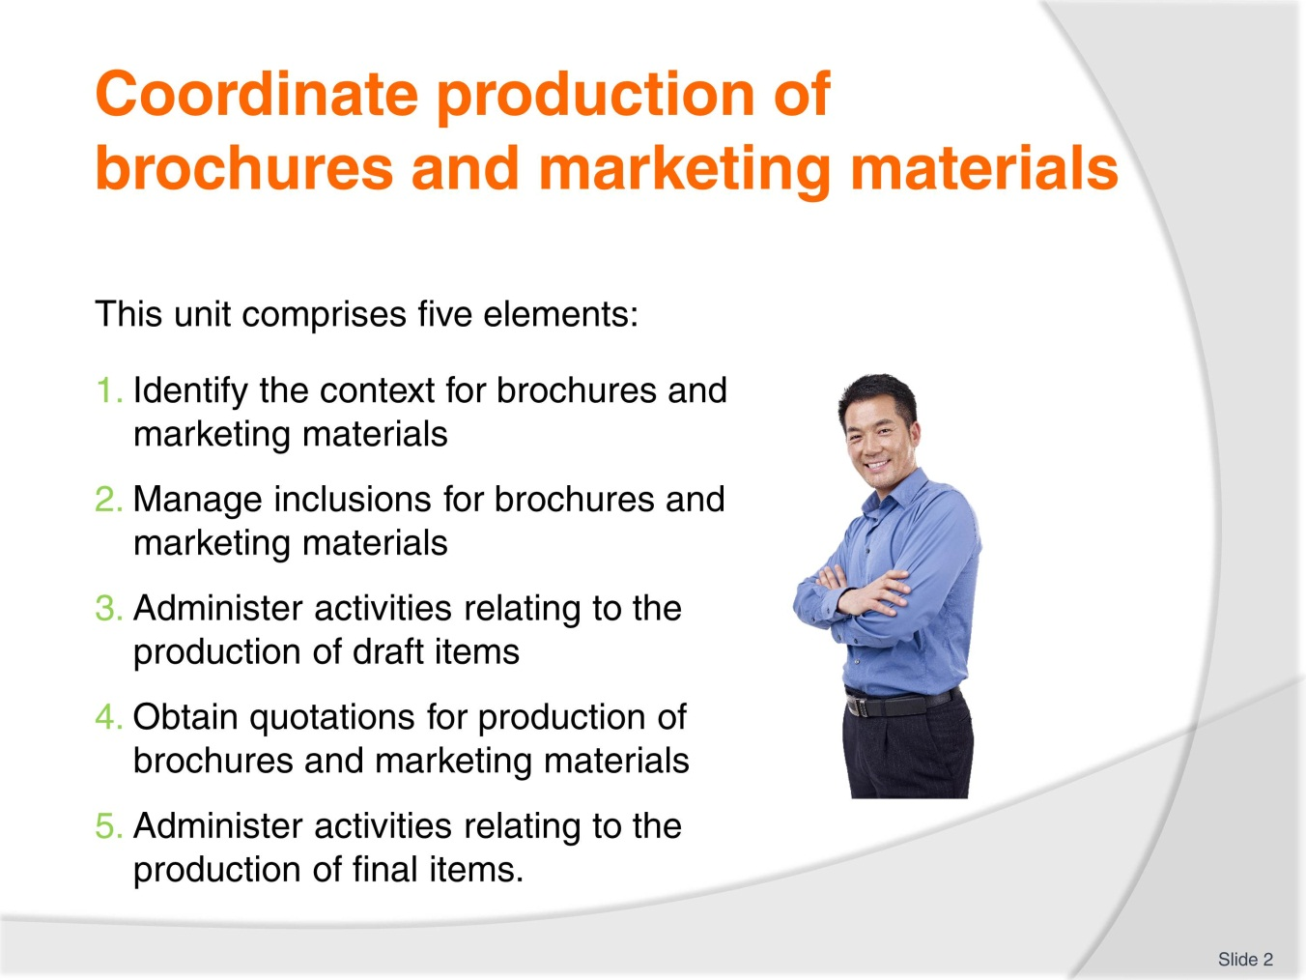
Slide No | Trainer Notes
Trainer advises trainees this Unit comprises five Elements, as listed on the slide explaining:
- Each Element comprises a number of Performance Criteria which will be identified throughout the class and explained in detail
- Trainees can obtain more detail from their Trainee Manual
- At times the course presents advice and information about various protocols but where their workplace requirements differ to what is presented, the workplace practices and standards, as well as policies and procedures must be observed.

Slide
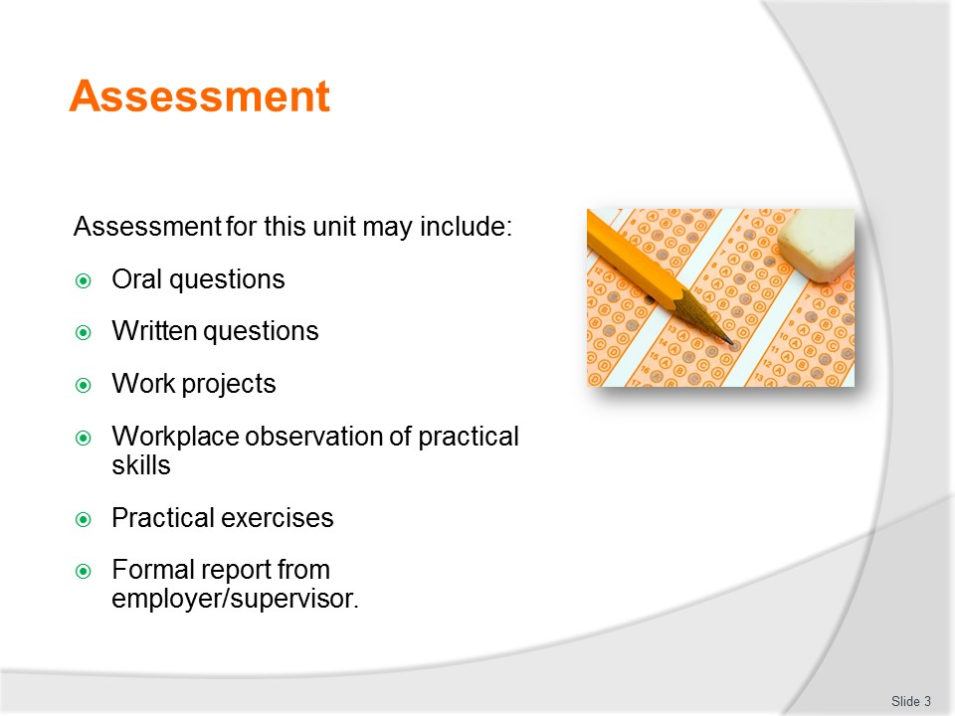
Slide No | Trainer Notes
Trainer advises trainees that assessment for this Unit may take several forms, all of which are aimed at verifying they have achieved competency for the Unit as required.
Trainer indicates to trainees the methods of assessment that will be applied to them for this Unit.

Slide
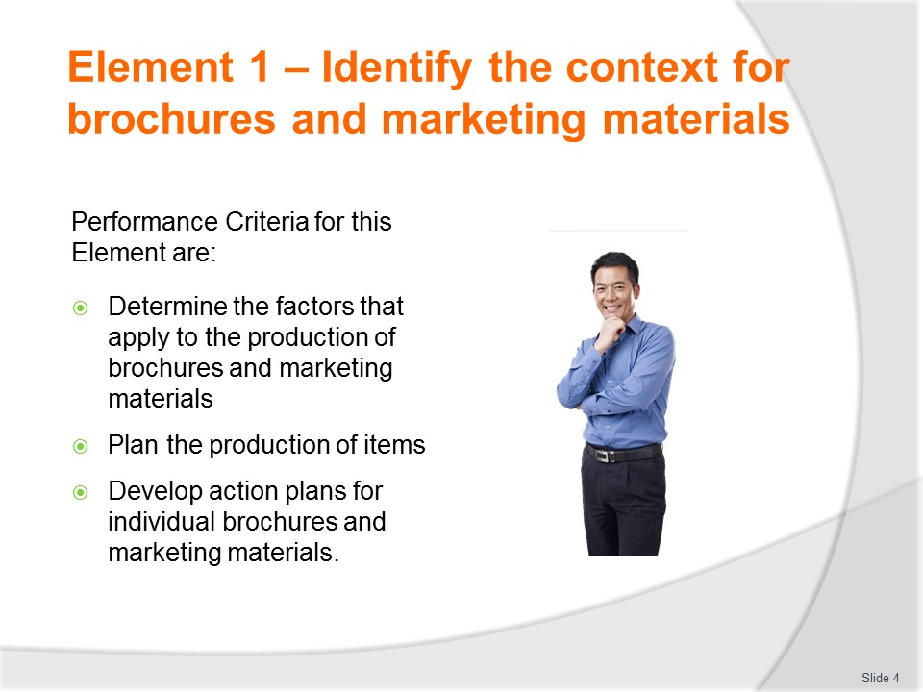
Slide No | Trainer Notes
Trainer identifies for trainees the Performance Criteria for this Element, as listed on the slide.
Class Activity – General Discussion
Trainer leads a general class discussion by asking questions such as:
- What do you know about travel and tourism brochures?
- When and why are they used?
- What is contained in them?
- What are ‘marketing materials’?

Slide
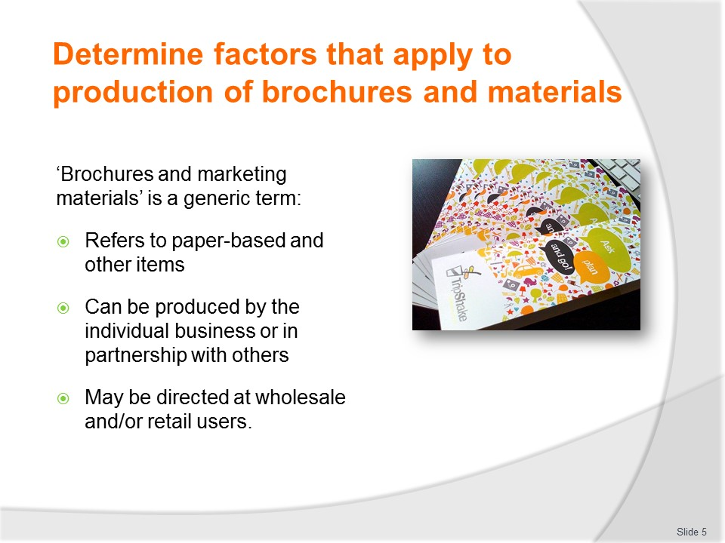
Slide No | Trainer Notes
Trainer indicates the phrase ‘brochures and marketing materials’ is a generic term referring to any form of items used by a business to promote their travel agency or tour operation business:
- Often these items are paper-based but the definition also embraces other items used to advertise and promote the organisation and what it has to offer.
- The items may be produced:
- Solely by the business – operating entirely on its own
- As a partnership arrangement with a joint-venture partner – such as when materials are prepared in cooperation with a carrier, destination, attraction or other business
- For the wholesale market – for other businesses, agencies, sales staff and partners operating as co-partners in the industry and advising them of what is available: the materials provided to this sector contains commercially confidential information/detail (prices, terms, facts, figures) not released to the general public
- For the retail market – these are the materials generated for distribution/release to the general public/the paying customers who will buy the tours and purchase the travel.

Slide
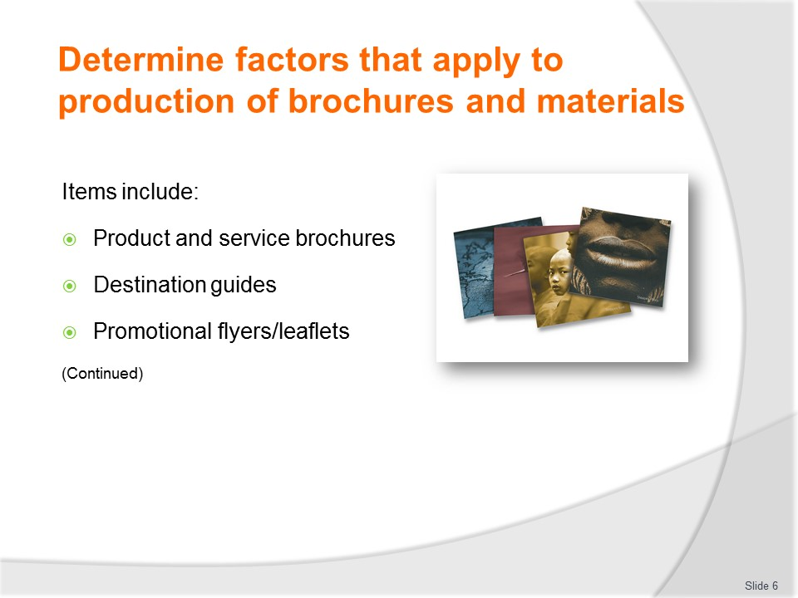
Slide No | Trainer Notes
Trainer introduces examples of brochures and marketing materials stating travel agencies and tour operators have traditionally used the following items:
- Product and service brochures – these are ‘general purpose’ items which give an indication of (for example):
- Who the business is, what is does, where it is located and how to make contact with it
- How long it has been in operation, the quality and credentials of its staff, special awards the business has won and testimonies from happy/satisfied customers
- All the products available (such as all the different tours and packages) giving sufficient detail (departure dates, names of destinations and inclusions but not giving all the detail of accommodation, side-tours, activities and options) to enable an understanding of the basics of the product so comparisons can be made with other products listed in the same document
- All the services available again limiting information provided just to the generalities but sufficient to give an impression of what is able to be purchased
- These brochures are designed to attract attention and spike the interest of customers so they make further enquiries and/or obtain a copy of a tour-specific or travel-specific item to gain extra detail about the product/service they are interested in
- Destination guides – these are detailed guides providing information and advice about one (or more) destinations.
- The brochure may cover all the destinations which will be visited on a trip/tour.
- It is designed to create interest and generate enthusiasm for travel.
- Promotional flyers (or ‘fliers’) and leaflets – these are handbills or circulars commonly (but not always) consisting simply of a single page containing basic information designed and intended:
- To be relatively inexpensive – these are perhaps the least expensive form of ‘brochure and marketing material’ created by a business
- For mass distribution – that is they are handed out to ‘everyone’ instead of being targeted to a defined market
- To create attention and raise interest in the topic which if the focus of the flyer/leaflet
- To direct interested customers to another source for more information – such as a website, an office/agency or a telephone number.
Classroom Activity – Handouts
Trainer distributes and discusses examples of items as described on the slide.

Slide
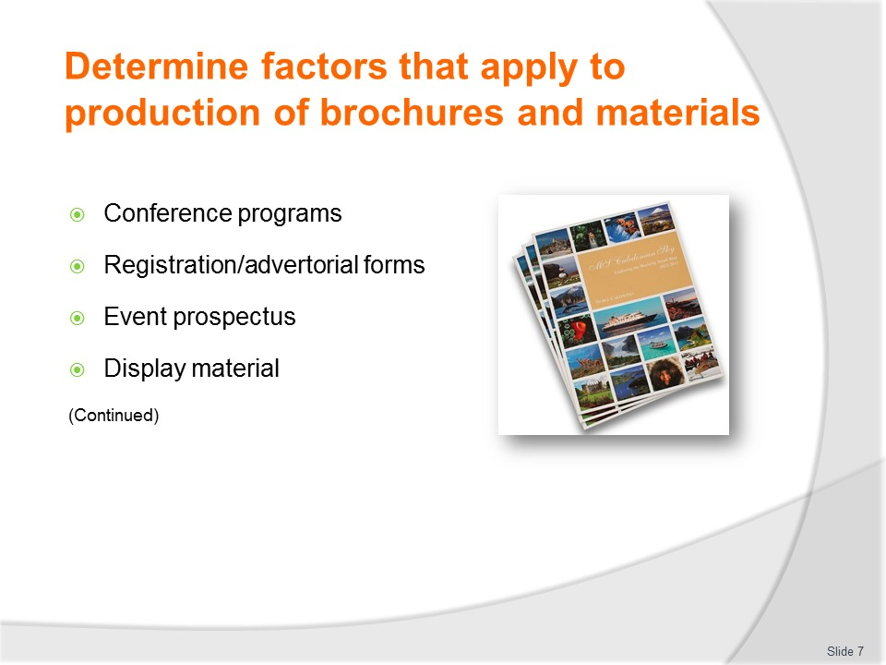
Slide No | Trainer Notes
Trainer continues giving examples of items:
- Conference programs, registration/advertorial forms and event prospectus – this relates specifically to advertising aimed at those who are/will be attending events (MICE). The materials may be:
- Integrated into the physical MICE program or prospectus handed out to people who attend – and may entail the tour/travel business paying for the printing of the programs in return for promoting their business and having sole access to attendees via this medium
- Integrated into the registration forms sent to attendees to pre-register for MICE – thereby gaining direct and targeted access to people who will/might be attending and may need the products and/or services being promoted by the travel/tour organisation.
- Display material – this refers to items used in the office to display the trips, tours and travel) products and services) the business has for sale. They are frequently used:
- In or at (outside) the office
- In an agency
- In the office of a joint venture partner
- At a sales event – such as a travel and tourism exhibition or to support a stand/display at a shopping centre or some other ‘pop-up’ event or location
- They:
- Need to remain current
- Must be eye-catching
- Often need to support a certain sales/marketing campaign
Classroom Activity – Handouts
Trainer distributes and discusses examples of items as described on the slide.

Slide
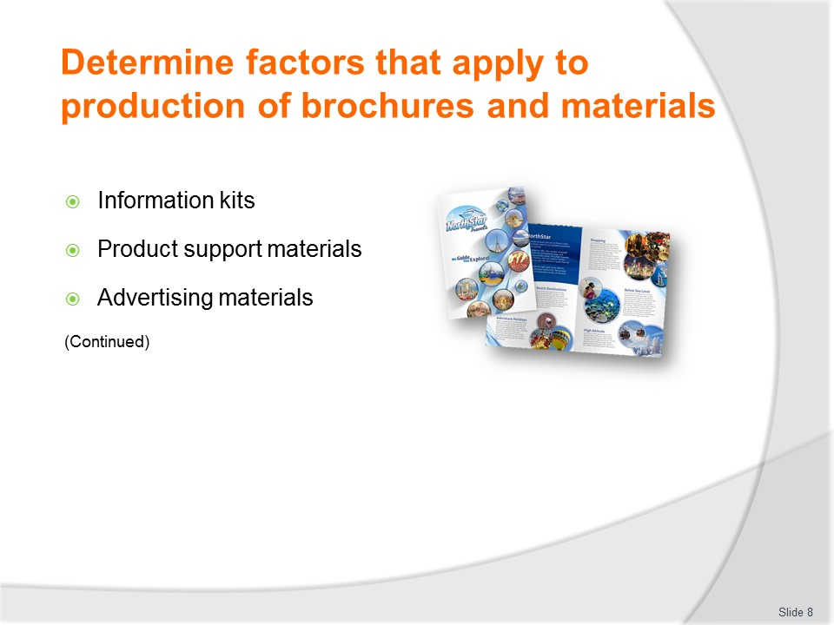
Slide No | Trainer Notes
Trainer continues giving examples of items:
- Information kits – these are develop for various reasons such as to:
- Give to people who visit displays/stands at an exhibition or some other sales/promotional event – these kits may feature information about the company and generic items on different carriers, destinations, packages, schedules, price lists as well as some lower-grade/value merchandise (pens, pencils, rulers, caps)
- Provide potential customers with detailed information about an intended trip, tour, destination or itinerary – the idea being to supply more compelling reasons for the people to purchase the ticket (trip, tour/product/service)
- Supply actual customers (that is, people who have actually bought a product/service) with even more detail and information about the destinations, countries, attractions they are going to see, visit and experience. This is all part of building the excitement and anticipation as well as demonstrating professionalism in terms of customer service.
- Product support materials – these items are developed to assist users/customers make the most of the products and services they have purchased. They are frequently used by sales staff to help make the sale but are predominantly intended for use by the purchase so they can:
- Learn about the product/service
- Instruct customers on what to do and what not to do
- Give tips and advice
- Show diagrams and photos of actual use of products
- Explain aspects and parts of items
- Direct people to other sources for even more information or advice.
- Advertising materials – this is a very wide classification of marketing materials. Advertising is communication with customers and/or potential customers which is paid for by the business (as opposed to similar communication which is unpaid – such as PR). Advertising materials can therefore cover things such as:
- Media advertisements
- CDs and DVDs
- Posters
- Billboards.
Classroom Activity – Handouts
Trainer distributes and discusses examples of items as described on the slide.

Slide
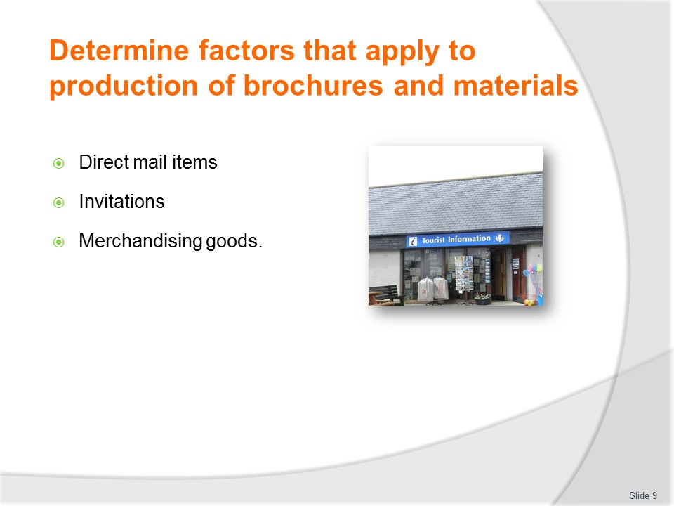
Slide No | Trainer Notes
Trainer continues giving examples of items:
- Direct mail items – these are items sent directly to:
- Those who request them
- Targeted recipients on the company database – when the organisation has a new product/service they believe will be of interest to the individual.
- The direct mail items will generally include:
- A covering letter explaining the offer/product/service
- Additional items as appropriate to the nature of the product/service as listed in this section (flyers, information kits, merchandising goods).
- Invitations – these may be sent to people when the organisation wishes to:
- Make them aware of a new product/service
- Ask them to participate in a feedback session or focus group
- Reward them for certain levels of buying/loyalty.
- Invitations may be sent to:
- Regular customers
- People who have never bought from the business but have made an enquiry or shown interest/expressed an interest in what is available
- Individuals, families, groups and clubs, companies, government bodies and the media
- Merchandising goods – this relates to products the organisation produces which:
- Carry its name/logo
- Are offered as inducements to make sales
- Are distributed to promote the company and products/services it offers
- Are given away to customers who make a purchase – as part of the inclusions for a trip/tour
- May be available for people to purchase as separate/stand-alone items.
- These need to change from time-to-time as/when:
- New/revised products/services are developed and offered for sale
- The organisation enters into new partnerships with other businesses
- Re-branding of the business occurs
- A new sales campaign starts.
Classroom Activity (1) – Handouts
Trainer distributes and discusses examples of items as described on the slide.
Classroom Activity (2) – Internet Research
Trainer facilitates online research and discussion relating to relevant sites such as:
- Wholesale travel brochure at http://latitudetravelservices.com.au/wholesale-travel-brochure/
- Brochure at http://en.wikipedia.org/wiki/Brochure
- Producing a tourism brochure at http://businessbreaks.takeabreak.com.au/FrontDoor/LoungeRoom/Articles/TourismArticles/producing-a-tourism-brochure
- How to create an effective travel brochure at http://aspiringbackpacker.com/2012/11/good-travel-brochure/
- Tips for an effective tourist brochure at http://www.offtherack.com.au/effective-brochure-tips.html
- How to make a good travel brochure at http://www.ehow.com/how_6754029_make-good-travel-brochure.html
- Destination guides at http://travelinsider.qantas.com.au/destination-guides-index.htm
- Leaflets and flyers at http://solihull-sustain.org.uk/uploads/leaflets-and-flyers.pdf

Slide

Slide No | Trainer Notes
Trainer introduces and explains factors need to be taken into account when considering new marketing materials to be produced:
- Objectives – these will change over time and relate to what the business wants to achieve by producing the brochures and/or marketing materials. Examples of standard objectives can be to:
- Support a specific advertising/marketing campaign
- Generate interest from nominated markets
- Encourage responses/queries from potential customers
- Increase market share
- Enhance public awareness of the business or a product/service
- Target market/s – these are the cohorts of people/organisations the business wishes to target/attract through the use of certain marketing materials. Target markets are commonly based on one of more demographic characteristics such as:
- Age
- Gender
- Income
- Type of employment
- Education level
- Race/nationality
- Marital status
- Home country
- Preferred activity/reason for travel or tourism.
Slide
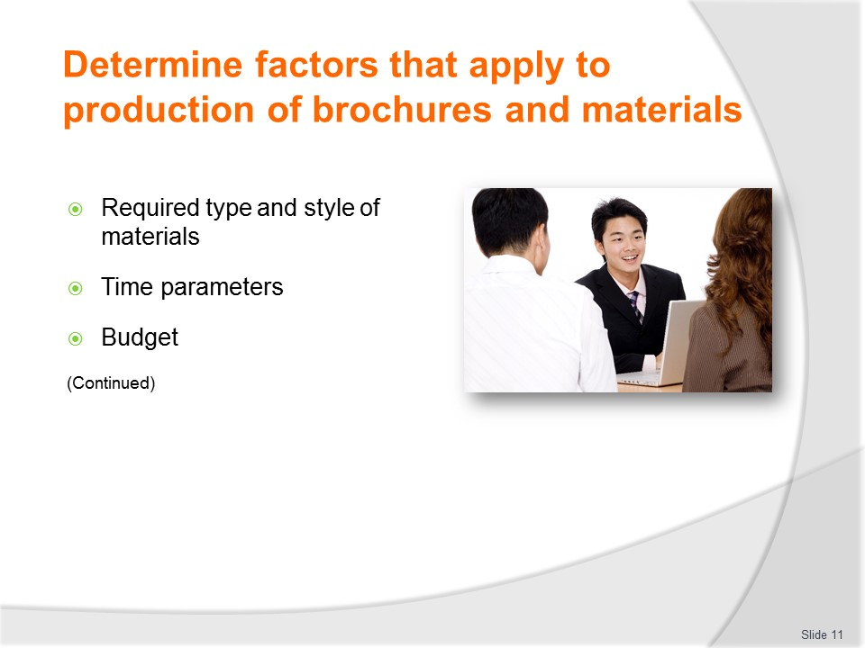
Slide No | Trainer Notes
Trainer continues discussing factors which need to be taken into account when considering new marketing materials to be produced:
- Required type and style of materials – as appropriate to the identified objectives and the identified roles marketing materials will be expected to fulfil when employed by end-users of the materials. For example:
- Some sales staff will require Fact Sheets about destinations while others may want more detail on costs, prices, options and packages
- Some target market customers prefer to get their information online while others prefer a DVD and other want a hard copy brochure
- Time parameters – this can relate to:
- Seasonal considerations of trips/tours being offered
- Dates/times of festivals, MICE and sporting events
- Need for materials to be ready in time to support campaigns and/or products and services being offered
- Budget – there will always be limitations placed on the amount of funds available to generate marketing materials. The budget may be:
- Formulated in terms of cash plus ‘in kind’ resources – that is, money plus help and assistance from other sources (partners, joint venture associates, other businesses likely to benefit from the overall initiative) in terms of (for example) product, help from their staff (advice, market research data, loan of materials and items) and exposure,
- Specific to one individual/specific marketing initiative or generic to a department, business or campaign.
Slide
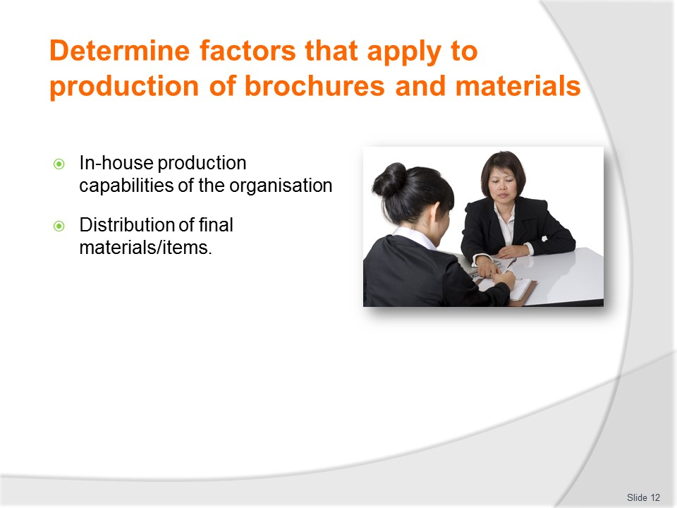
Slide No | Trainer Notes
Trainer continues discussing factors which need to be taken into account when considering new marketing materials to be produced:
- In-house production capabilities of the organisation – and associated issues such as:
- Availability of the capability to focus on what is required at the time required – the internal expertise may be busy working on something else which cannot be re-scheduled
- Expertise to deliver what is required – most internal production departments have limitations on what they can do in terms of the experience they have, the equipment they own and the technology they have access to.
- An internal marketing production department is no guarantee all required marketing items can be prepared within the organisation.
- Distribution of final materials/items – when marketing items have been produced there is often a need for them to be distributed. Considerations in this regard may be:
- Cost to distribute to all required targets, outlets, clients/customers, agencies, destinations, partners and similar
- Identification of how materials will be physically moved from printers/production houses to end user destinations such as Visitor Information Centres, other agencies, hotels and identified other locations where the materials are required/need to be sent (locally and internationally)
- Determination of quantities of materials required in order to accommodate the distribution schedules identified for each item
- The intermediaries in the distribution chain – for large businesses there can be a need to develop variations on certain marketing materials such that wholesale outlets receive a different marketing product to retail offices/agencies who, in turn, receive something different to the end user/customer

Slide
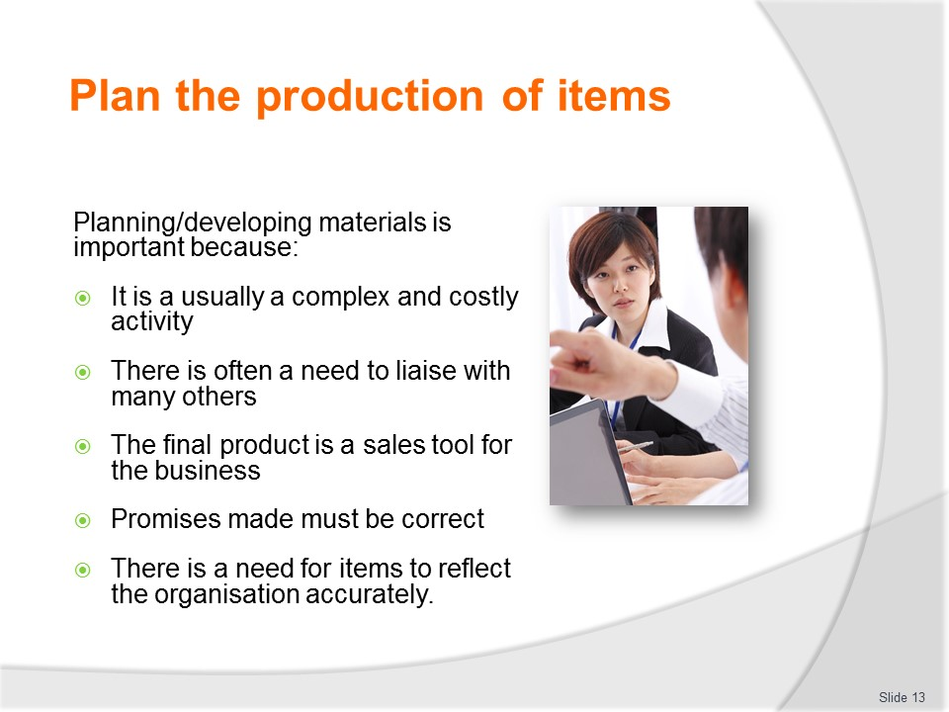
Slide No | Trainer Notes
Trainer highlights the importance of developing marketing items stating the entire procedure of developing brochures and marketing materials is important because:
- It is a complex activity – there is a lot involved in doing this and getting it right
- It often involves the expenditure of substantial amounts of money
- There is frequently a need to liaise with numerous other business/stakeholders to coordinate the final/finished product
- The end product is an essential sales tool for the organisation and the revenue of the business (and the jobs of the staff) rely on these items to a significant extent
- What is produced must be correct – there is no room for errors or omissions
- All items must reflect the image, standards and reputation the organisation wants to portray for the specific item for a given target market.

Slide
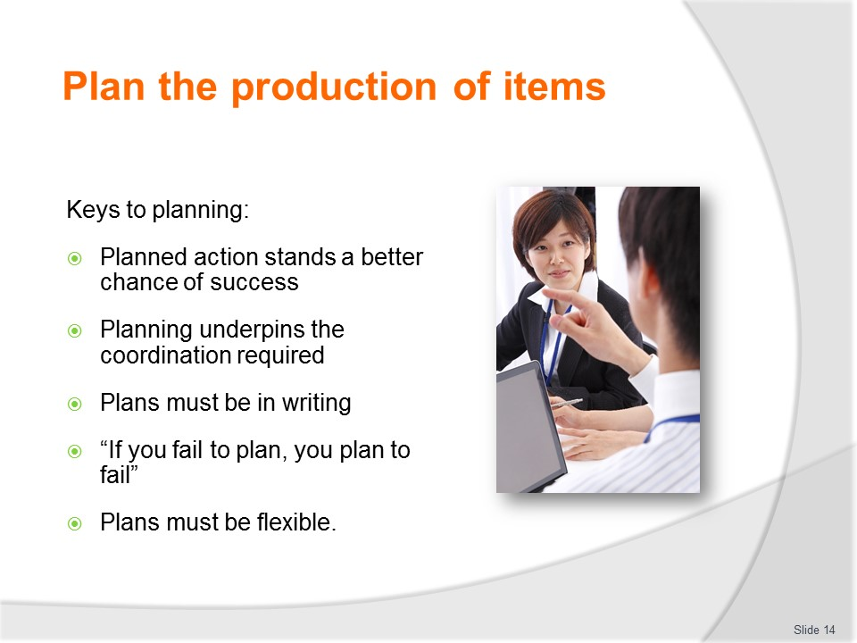
Slide No | Trainer Notes
Trainer discusses keys to planning explaining in this job there must be realisation of the following:
- Planned action always stands a much higher chance of success than unplanned action
- Planning underpins coordination – and developing these items demands coordination with many other people and organisations
- Plans need to be in writing – so others can see them and they can be shared with others for their information, comment, feedback and for them to follow
- ‘If you fail to plan, you plan to fail’
- All plans which are developed need to be flexible – plans need to be ‘set in jelly and not in concrete’.

Slide
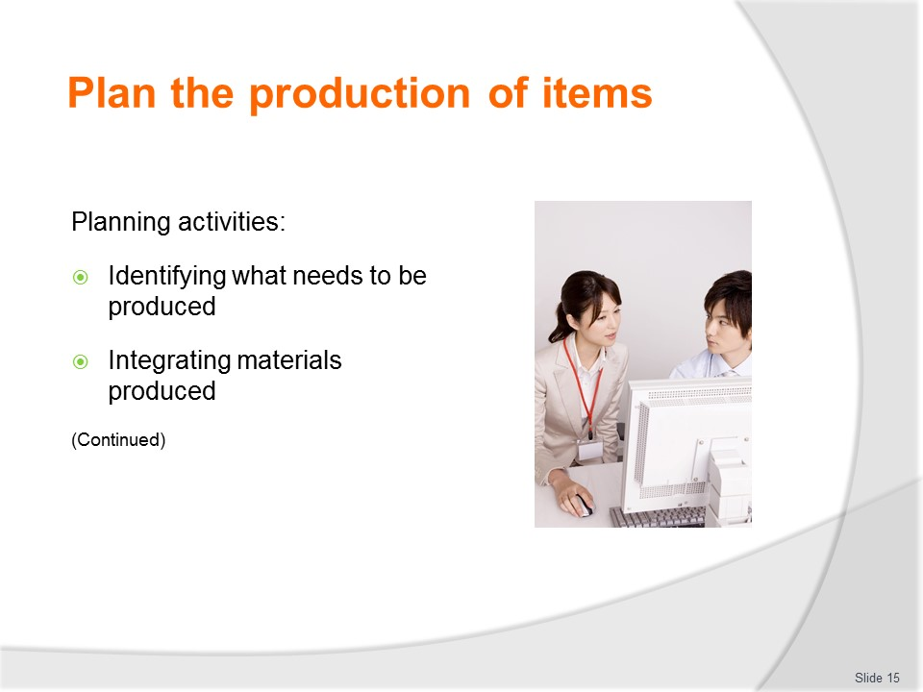
Slide No | Trainer Notes
Trainer presents activities essential to the overall planning process:
Identifying what needs to be produced
The basic way of determining the need for brochures and marketing materials is to keep a check of the stock on hand. Other factors to take into account are:
- Time of the year; Age/currency of brochures and other materials; Level of brochures and materials present in agencies and other outlets where brochures and materials are normally available; Available alternatives; Special promotions or campaigns being undertaken; Extent of organisational participation in exhibitions to promote the business; Extent of sales presentations scheduled for the future.
- Analysis of the above should enable identification of:
- Type of items/materials to be produced; Nature of the items; Volumes needed; Dates by which they are required.
Integrating materials produced
It is important the development of brochures and marketing materials does not take place in isolation from everything else which is taking place within the organisation.
- After all, the tile of this unit is ‘Coordinate production...’. This highlights the need to:
- Determine and respond to the demands/objectives of other higher level organisational plans
- Ensure the brochures and marketing materials produced assist the organisation achieve its identified goals and objectives
- Liaise with people to track potential future needs of the company so these can be researched now for development into products/services in the future.
- Integration of these marketing-related activities also needs to occur in order to:
- Take advantage of any ‘economies of scale’ which may emerge when producing materials
- Allow cross-promotion of products/services where appropriate to do so
- Ensure the entire organisation sends a consistent message and portrays a uniform image to nominated target markets
- Make sure brochures and marketing materials are available to support actions being taken by other departments (especially Sales) within the business.
Classroom Activity – Guest Speaker
Trainer arranges for an experienced person to attend and discuss the planning processes/activities involved in developing/producing brochures and marketing materials.

Slide
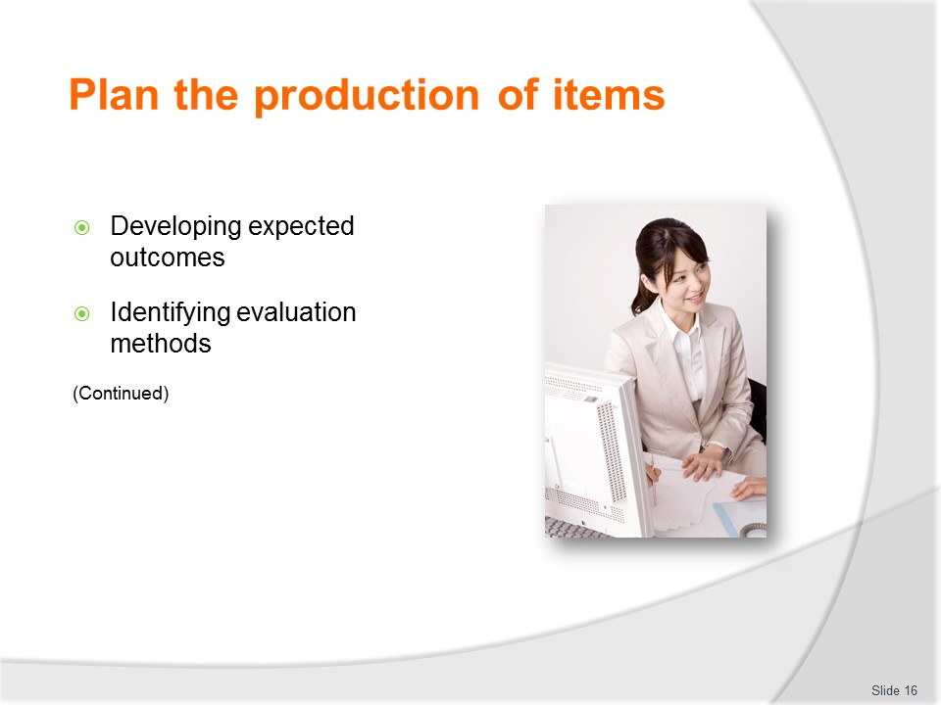
Slide No | Trainer Notes
Trainer continues presenting activities essential to the overall planning process:
Developing expected outcomes
There can be a need to identify what the brochures and marketing materials being developed are expected to achieve. This is not always the case, but sometimes it is. Standard outcomes are:
- Increase or generate sales; Increase/generate enquiries; Build database contacts; Build awareness of the organisation and/or a specific aspect of the business.
- It is useful in this context to:
- Whether existing brochures/materials should be re-ordered to replenish exhausted/depleted stock levels, or
- Whether there is another specific focus for the materials and there need to be new materials created.
- Where items are replenishing supplies, process would be contact people who produced previous items and re-order
- Where there is a new focus for the materials there is a need to:
- Identify the new focus
- Where changes need to be made to existing brochures and marketing materials, they can be seen as:
- Updates; Revisions; Introduction of a new product or service
- A new item may be needed for a variety of reasons, including:
- Addition or removal of products or services; Development of new items to target new markets;
- Production of materials in new language; Support for new campaign; Inclusion of material relating to an award won or accreditation received; Changing items to reflect new image or change of ownership/management.
- Identifying evaluation methods
Sometimes there is a requirement to determine in advance what will be used to determine whether or not the brochures and items produced have achieved there expected outcomes or not.
This relates to identifying what KPIs will be used to judge how effective certain brochures/items have been – such as:
- To increase or generate sales:
- Setting a certain percentage increase in revenue
- Nominating a certain amount/target of sales to be achieved
- To increase/generate enquiries:
- Setting a certain percentage increase enquiries from nominated sources (telephone, online, walk-in)
- Nominating a certain number of enquiries to be received
- To build database contacts:
- Setting a certain percentage increase in numbers for identified target markets/database classifications
- Nominating a certain number of new contacts for a new classification of customers
- Identifying specific new/updated data required for given database contacts
- To build awareness of the organisation and/or a specific aspect of the business:
- Setting figures for the numbers of brochures to be given away/taken by the public.

Slide
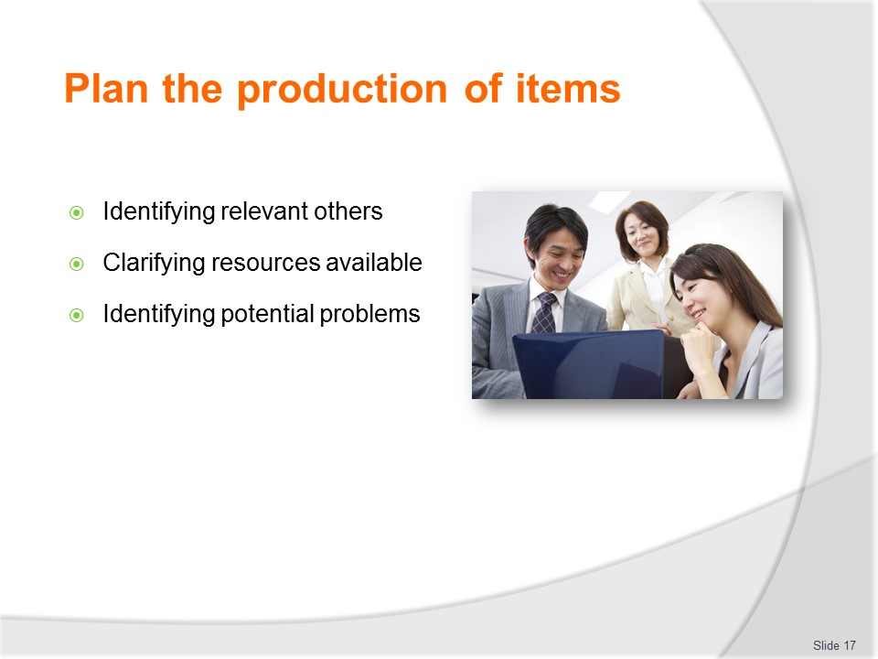
Slide No | Trainer Notes
Trainer continues presenting activities essential to the overall planning process:
Identifying relevant others
Stakeholders who need to be included will vary between organisations, campaigns and the individual item being produced. Those possibly needing to be involved could be:
- Senior or more experienced Sales and Marketing personnel; Management; Head office; Department heads; Housekeeping; – where the venue has accommodation facilities marketing materials are often placed in guest rooms; Hospitality venues targeted by the organisation: such as local hotels; Agencies with whom the venue has a business relationship;
- Airlines, bus/coach companies and other carriers; Inbound and local tour operators; Tourist information centres; Other tourist attractions ‘Any business, location, or organisation where the venue traditionally places brochures and materials.
Clarifying resources available
Resources refer to:
- Financial resources – the cash/money available
- Human resources – staff/hours available
- Physical resources – equipment, technology and stock
- Information – about business plans and goals, products and services, venues, carriers, destinations and all related topics
- It may be possible resources can be obtained from a variety/mix of sources – such as:
- The host organisation – often (but not always) the primary source; Joint venture partners; Carriers; Destinations and attractions; Industry groups, associations and bodies; Government agencies.
Identifying potential problems
The planning process should always seek to identify issues that may impact on developing and producing materials.
The aim of doing this is to identify plans for effectively addressing the issues which have been identified.
There is no comprehensive list of what these may be but the following is an indicative list:
- Absence of sufficient funds
- Clash of demand on personnel required to participate/contribute
- Limits on availability or presence of required information/data
- Timelines for production are too tight or unrealistic.

Slide
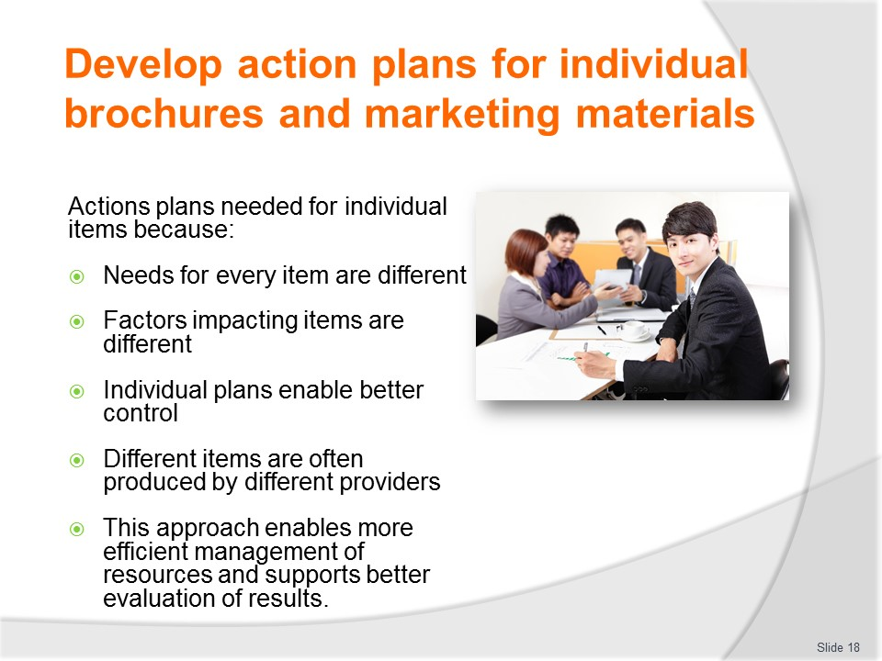
Slide No | Trainer Notes
Trainer explains action plans are needed for each individual item to be produced because:
- The needs of each item (content, prices, information, dates, times) are usually different
- The factors (budget, timelines, quantities required) impacting each item vary
- Individual plans enable better control and optimise the likelihood of a more effective/successful outcome – this allows better tracking of progress
- Different items are often produced by different external providers – so a plan for each product facilitates more effective management of the process for each item
- It enables more efficient management of resources for each item
- This approach supports better evaluation of outcomes.

Slide
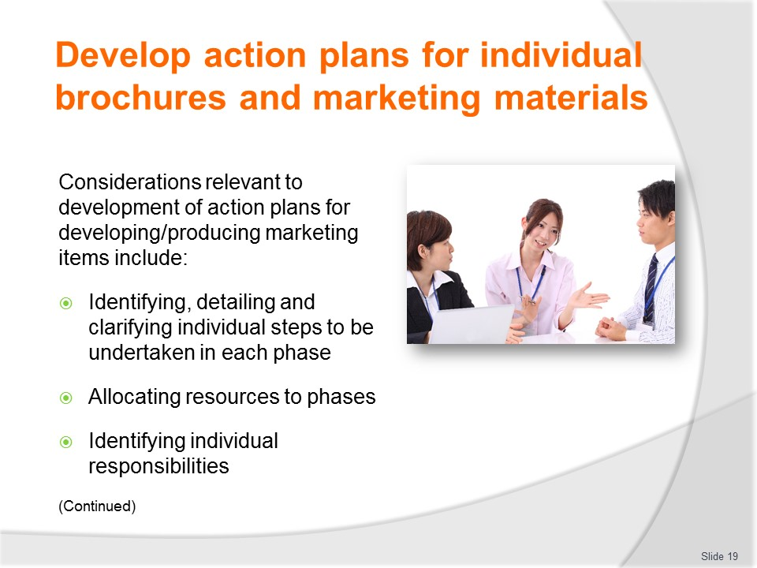
Slide No | Trainer Notes
Trainer suggests considerations which have emerged as relevant to the development of action plans for developing/producing marketing items include:
- Identifying, detailing and clarifying individual steps to be undertaken in the development and production phases – these may include:
- Determining stakeholders
- Working out content and objectives
- Settling timelines
- Producing KPIs
- Allocating roles and responsibilities
- Allocating resources to the development and production phases – in terms of:
- Individual internal staff and the work they are expected to undertake
- Allocation of labour/hours to the project/plan/item
- Working out needs and requirements
- Canvassing all types of resource needs (financial, human, physical, information)
- Sourcing supplementary/complementary funding
- Identifying individual responsibilities – for:
- The activities necessary as part of the pre-development phase
- Work needed in the production phases
- Internal and external people.

Slide
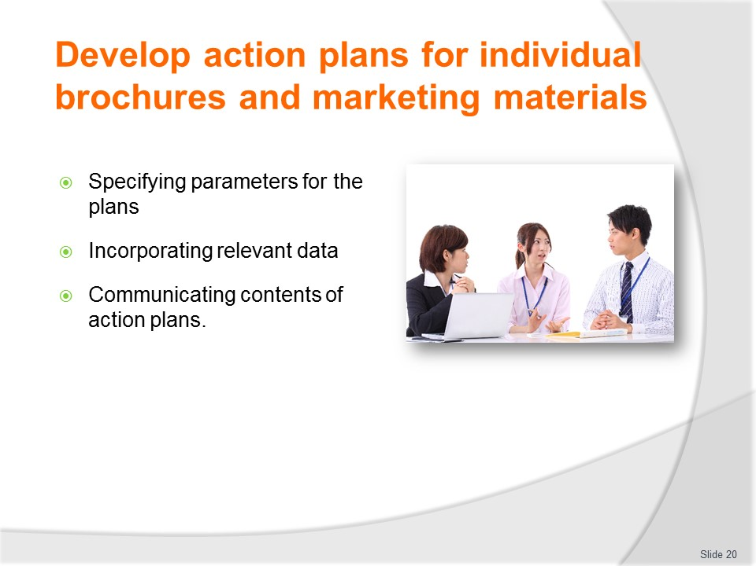
Slide No | Trainer Notes
Trainer continues identifying considerations for plans:
- Specifying parameters for the plan – in terms of:
- Timelines and target dates for the completion of components of each plan
- Quality standards and criteria
- Costs/expenditure
- Hours worked
- Incorporating relevant data – which may require:
- Referring to previous marketing activities as a basis for future marketing activities
- Seeking input and comment from relevant stakeholders as appropriate to individual project requirements
- Generating new market research data
- Communicating the contents of action plans:
- With relevant stakeholders – to keep them informed and seek their feedback/comment
- To explain specific requirements and responsibilities that apply
- So those with roles and responsibilities under the plan are aware of what they are expected to do, when they are expected to have it competed and the standard that apply to the work they have to do.
Classroom Activity – Small Group Exercise
Trainer asks students to identify a target/focus for a marketing item and develop an action plan for the development of same.
Slide
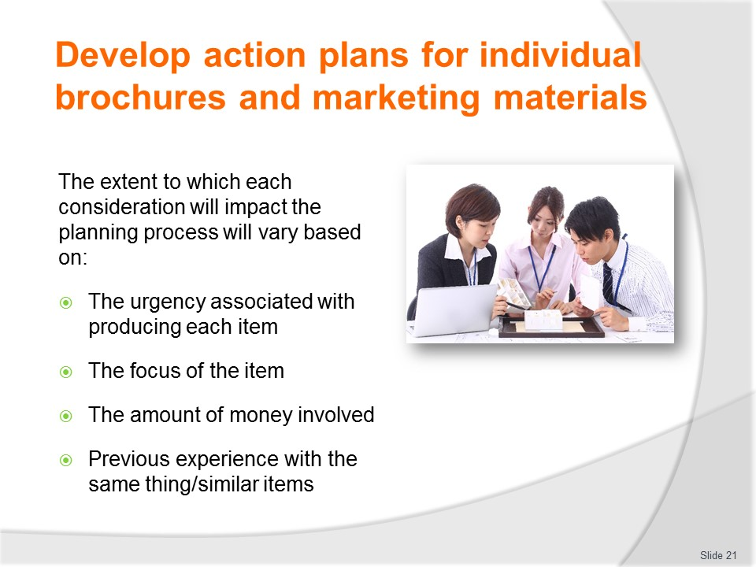
Slide No | Trainer Notes
Trainer explains the extent to which each of the factors identified will impact/influence the process will vary considerably based on:
- The urgency associated with producing each item – the timelines which apply
- The focus of the item – in terms of whether it is as critical/central element of a campaign or merely a peripheral item supplementing something bigger
- The amount of money involved – the more money involved, the greater the need for detailed planning
- Previous experience with the same thing/similar items.

Slide
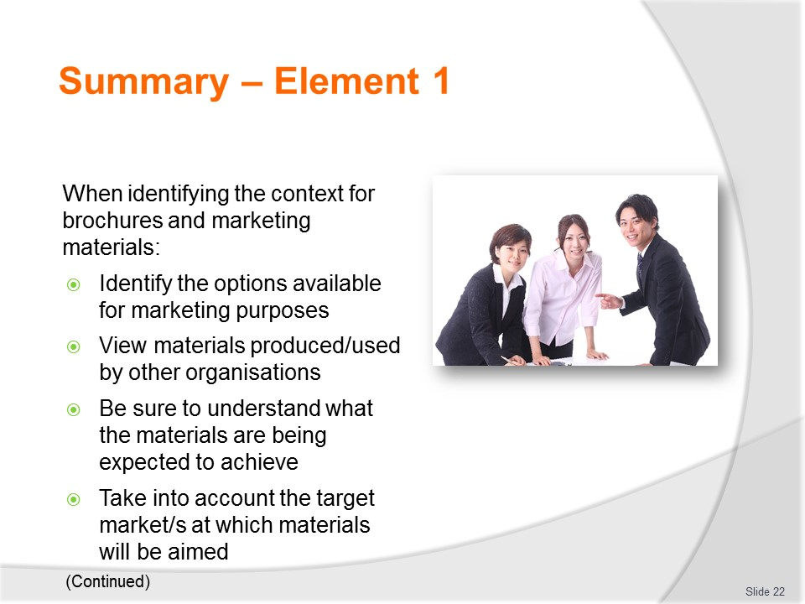
Slide No | Trainer Notes
 | Trainer provides a recap of the Element asking questions to check trainee understanding and responding to questions from trainees, as required.

Slide
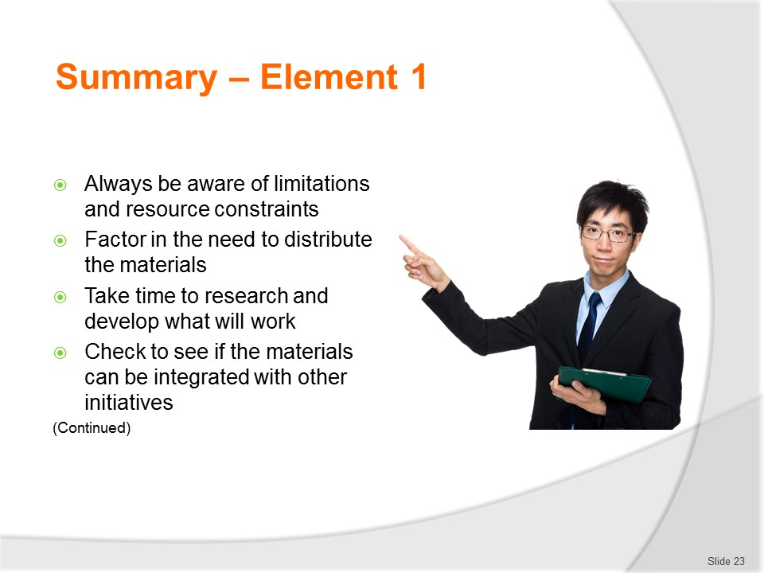
Slide No | Trainer Notes
 | Trainer provides a recap of the Element asking questions to check trainee understanding and responding to questions from trainees, as required.

Slide
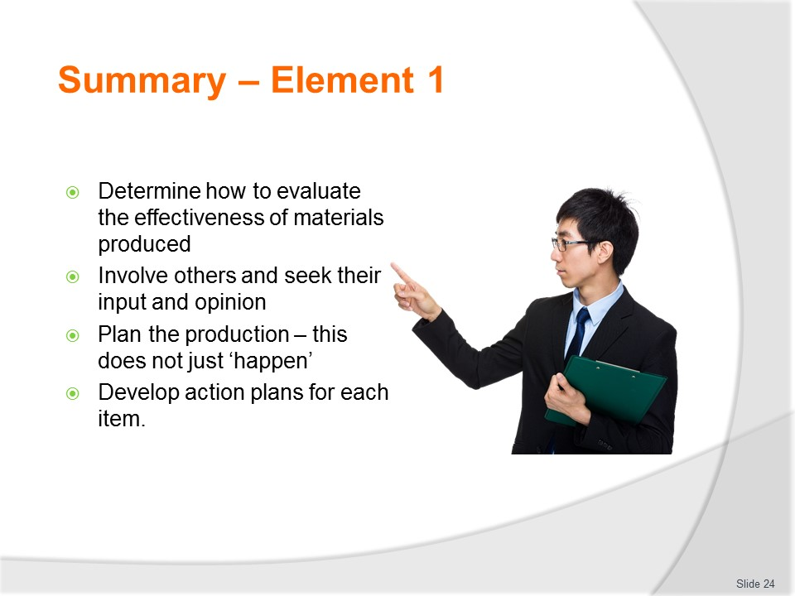
Slide No | Trainer Notes
 | Trainer provides a recap of the Element asking questions to check trainee understanding and responding to questions from trainees, as required.

Slide
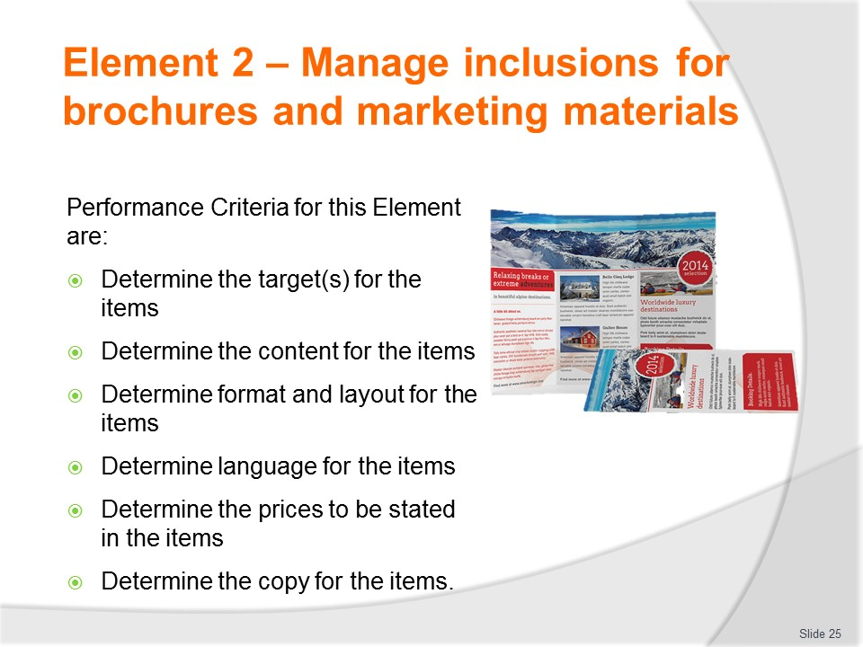
Slide No | Trainer Notes
Trainer identifies for trainees the Performance Criteria for this Element, as listed on the slide.
Class Activity – General Discussion
Trainer leads a general class discussion by asking questions such as:
- What are inclusions’?
- Why is there a need to determine these?
- Who might be involved in the process?
- When would this work be done?

Slide
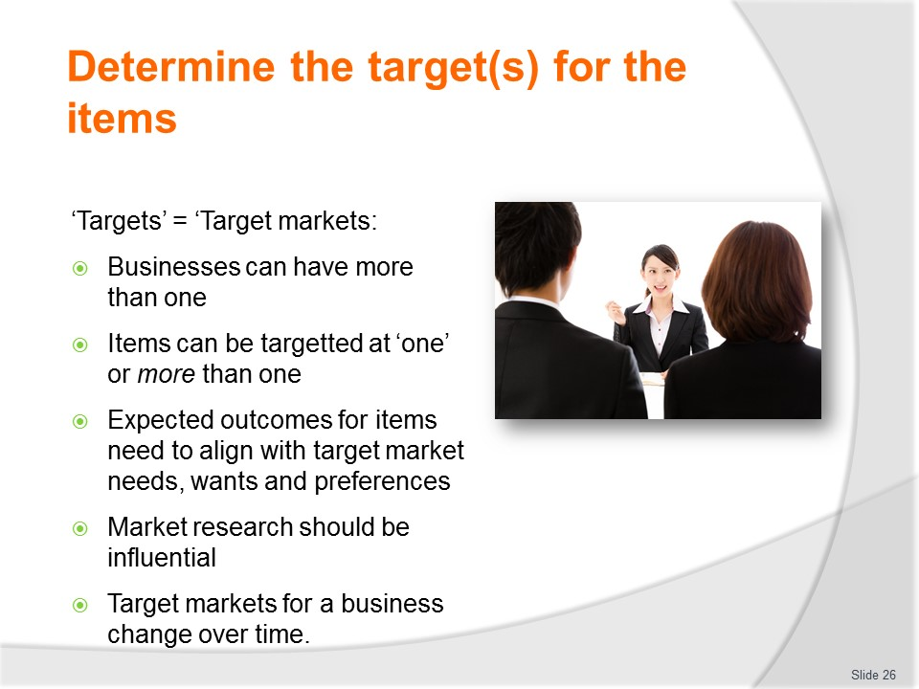
Slide No | Trainer Notes
Trainer advises ‘Targets’ refers to ‘target markets’ as defined by the individual organisation and these definitions vary between operators emphasising it is important to note:
- There is no limit to the type/nature of targets
- A brochure/marketing item may be targeted at one or more than one market/target
- The anticipated/expected outcome for the item need to correspond to what is produced and to align with the target (market) the item is aimed at
- Market research data should guide/govern production – in terms of (for example):
- How markets prefer to receive their information
- What they want/need to know.
- Target markets for are likely to change over time as the organisation grows, expand their business, introduce new products/services. In reality a business may seek to:
- Expand the number of target markets it has – to capitalise on an identified opportunity, to cater for an emerging trend, to capture additional market share, to enter a new market or to respond to data uncovered by market research
- Reduce existing target markets – where it has identified a declining and unprofitable previous target market, or where it seeks to alter its image by moving out of an existing market.
Classroom Activity – Guest Speaker
Trainer arranges for manager/suitable person to attend and discuss:
- Target markets for their organisations describing their demographics
- How they determined what their markets would be
- The market research they employ to discover what their target markets are and what they want
- Why they use the concept of target markets
- How their marketing items vary to suit their different target markets

Slide
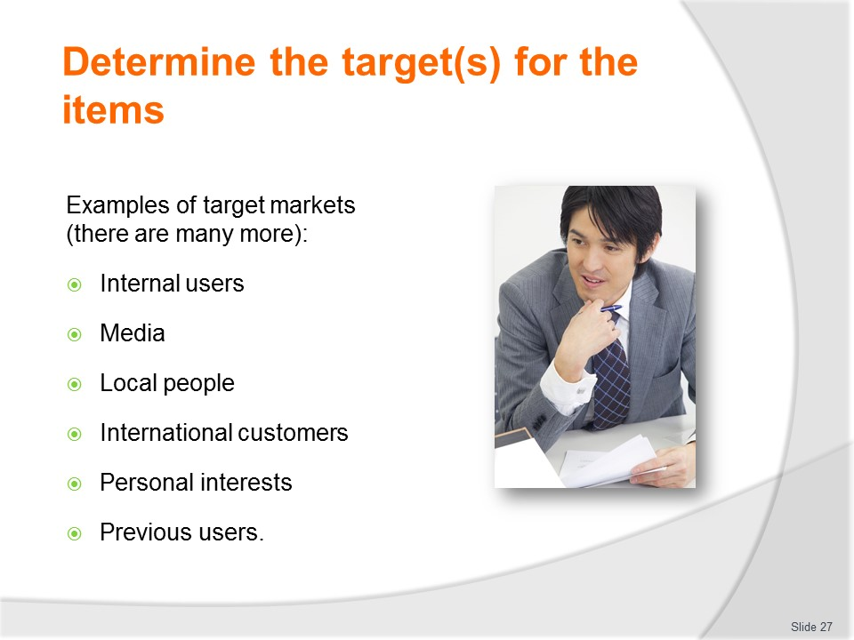
Slide No | Trainer Notes
Trainer gives examples of target markets:
- Internal users – this refers to items aimed at:
- Sales staff working within the business; Middle men in the sales process; Joint venture partners
- Agencies working with/on behalf of the organisation; Operational staff
- Media – in order to:
- Provide information for publicity articles; Generate interest in an initiative; Support advertising efforts
- Local people – who may be further categorised into sub-sections such as:
- Individuals; Groups, clubs and associations; Families; Business people
- International customers – who may be divided/classified by (a combination of factors) such as:
- Country; Reason for travel; Gender; Age
- Personal interests – which may give rise to classifications/distinctions such as:
- Action tourists – those seeling excitement and action; Medical tourists – who seek operations of various types
- Historical tours – focussing on history and wars; Experiential tourists – who want to immerse themselves into the experiences and culture of different regions/countries; Food and beverage tours – where the emphasis is on local foods, cooking, drinks and eating/dining facilities
- Previous users – this is any person or organisation who has used the services of the business before.
Classroom Activity – Internet Research
Trainer facilitates online research and discussion relating to relevant sites such as:
- ‘ASEAN Tourism Marketing Strategy 2012-2015 (especially Chapter 3) at http://www10.iadb.org/intal/intalcdi/PE/2012/10151.pdf
- ‘Tourism Australia: our target market’ at http://www.tourism.australia.com/markets/our-target-consumers.aspx
- ‘Tourism Australia: youth’ at http://www.tourism.australia.com/markets/youth-markets.aspx
- ‘Tourism Australia: market regions’ at http://www.tourism.australia.com/markets/market-regions.aspx
- ‘Newfoundland Canada, Dept. of Tourism, Culture and Recreation ‘Target markets’ at http://www.tcr.gov.nl.ca/tcr/tourism/tourism_marketing/target_markets.html

Slide
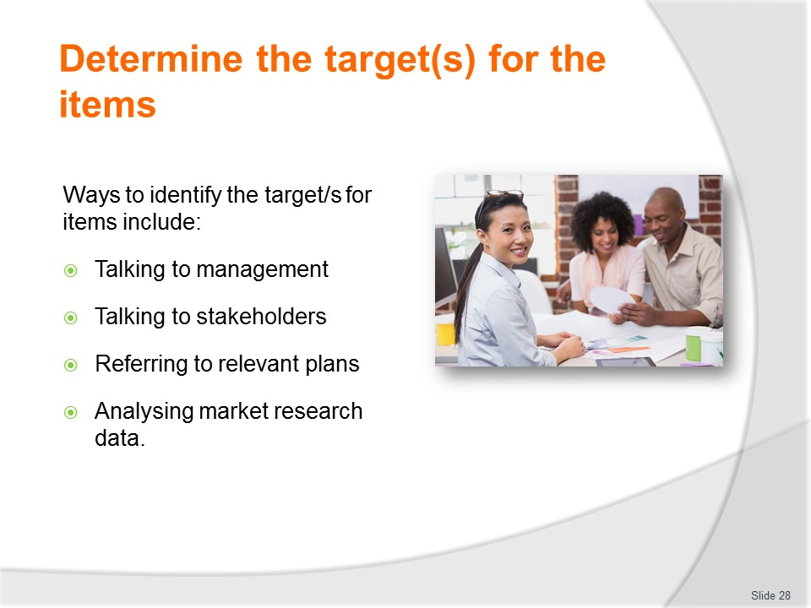
Slide No | Trainer Notes
Trainer indicates ways to identify the target/s for items include:
- Talking to management – to get their input
- Talking with relevant stakeholders – to obtain their comment and to coordinate and align organisational items with items they may be producing
- Referring to relevant plans – to identify the targets as described in those documents which will indicate the direction the business wants to take in this regard
- Analysing market research data – to identify emerging markets and to refresh knowledge regarding changing and/or ongoing requirements as they apply to existing/established markets.
Classroom Activity – Small Group Exercise
Trainer asks students to develop a suite of target markets for a nominated business/industry/sector and specify the descriptors of each.

Slide
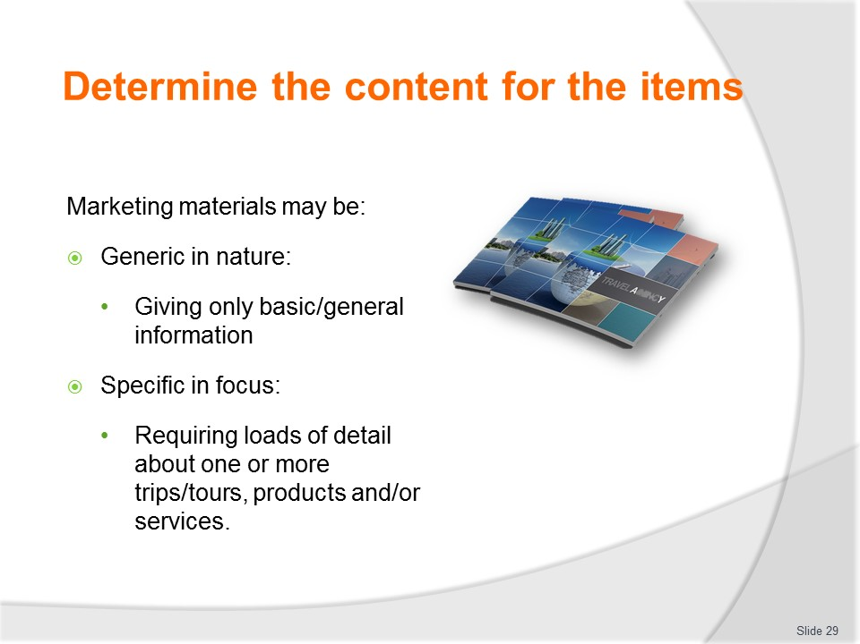
Slide No | Trainer Notes
Trainer stresses it is vital to understand:
- Some materials will be generic in nature – this means there will be little in the way of specifics in terms of promoting a nominated trip/tour, or a certain product or service. This will apply to items such as:
- Travel bags; T-shirts; Key rings; Pens; Luggage tags; Give-away merchandising items; Any item intended for the mass market
- The content in these cases will just concentrate on:
- Providing an overview of what the organisation does/provides – such as:
  - Highlighting the business in travel, tours, trips or other identified major/priority products and services
  - Emphasising the name of the company – which often also includes their primary focus (‘Atlas Tours’, ‘Worldwide Travel’)
- Giving the basis contact details for the business – in terms of:
  - Street address; Web address; Telephone number
- Other items will demand a high-degree of focus and emphasis on a given product or service – or a selection of nominated products or services. This is the case for items such as:
- Tour brochures; Destination information; Travel services; Individual products.
Classroom Activity – Handouts
Trainer distributes and discusses examples of items listed on slide.

Slide
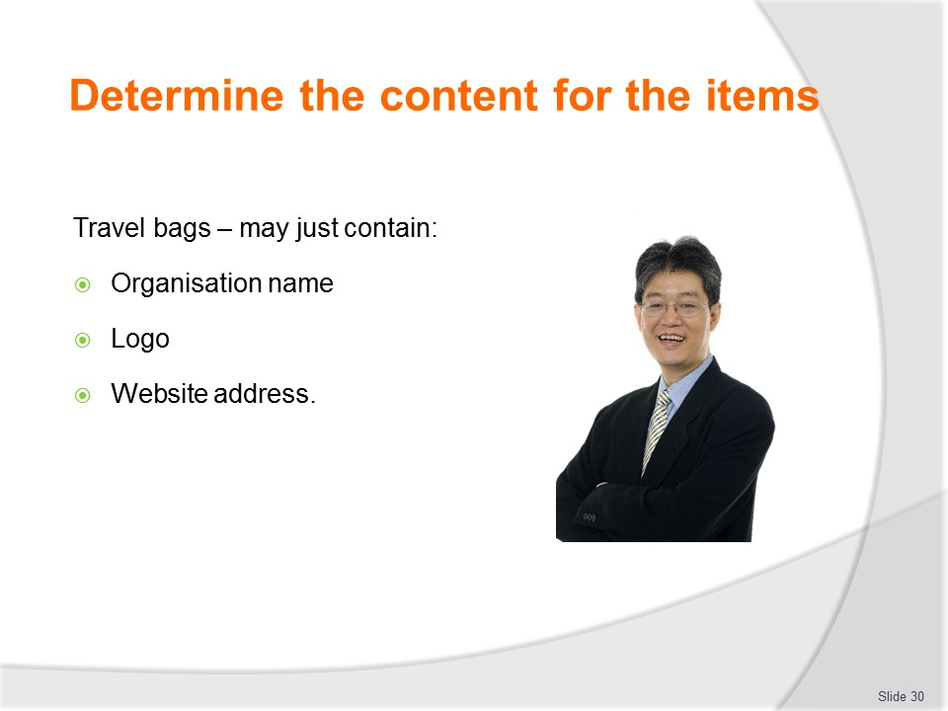
Slide No | Trainer Notes
Trainer details content for travel bags explaining the content on a travel bag may be quite simple/basic, consisting of:
- Name of the organisation
- Logo
- Web site address.
Classroom Activity – Presentation of Sample/s
Trainer uses sample bag to illustrate slide.

Slide
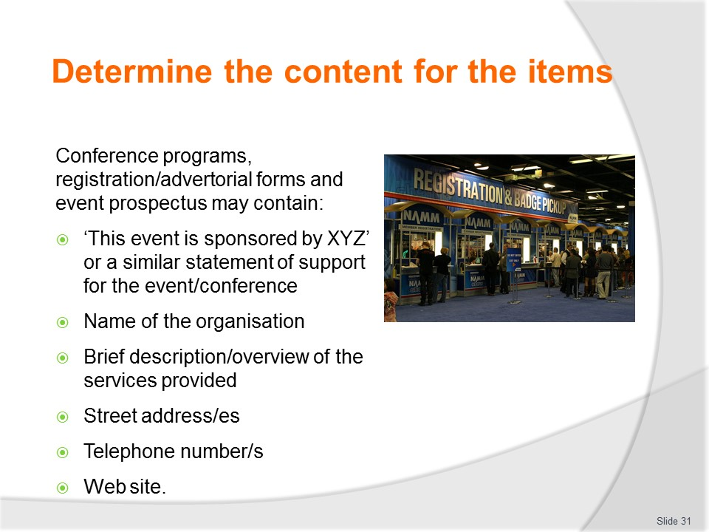
Slide No | Trainer Notes
Trainer details information included on Conference programs, registration/advertorial forms and event prospectus will be limited due to the restricted space available to promote the business so primary content only will be mentioned, such as:
- ‘This event is sponsored by XYZ’ or a similar statement of support for the event/conference
- Name of the organisation
- Brief description/overview of the services provided
- Street address
- Telephone number/s
- Web site.
Classroom Activity – Handouts
Trainer distributes and discusses sample materials identified on slide.

Slide
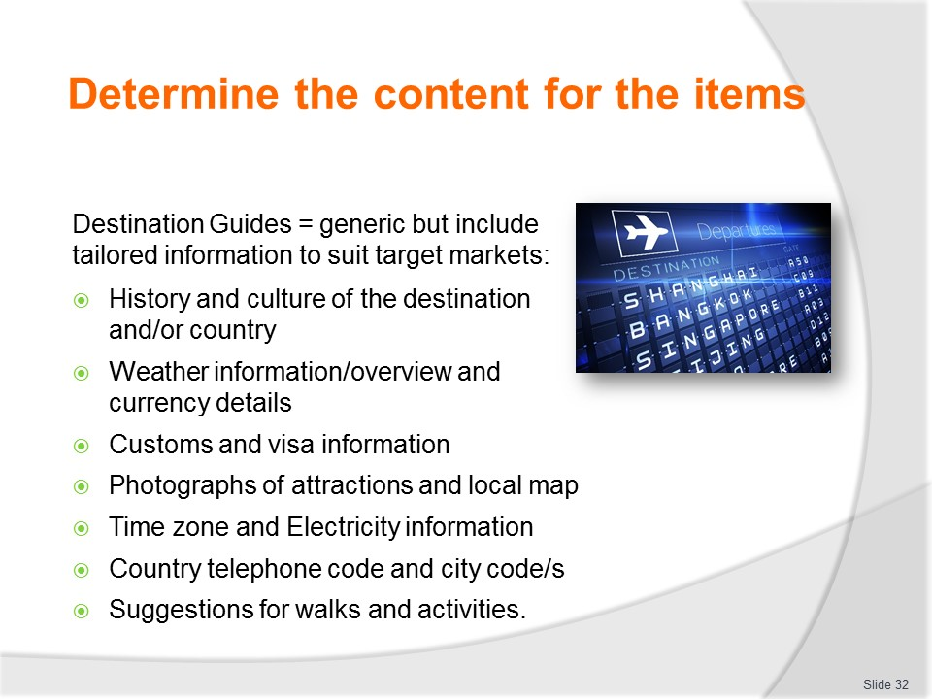
Slide No | Trainer Notes
Trainer details information/content of Destination Guides will usually be generic in nature but include tailored information to suit the identified needs, wants and preferences of target markets the Guide is being pitched at:
- History and culture of the destination and/or country
- Weather information/overview
- Currency details
- Customs and visa information
- Photographs of attractions, interesting sites, landmarks, popular precincts
- Local map and local transport
- Time zone
- Electricity information – for domestic/personal appliances
- Country telephone code and city code/s
- Highlights – in relation to sporting events, religious festivals, seasonal occurrences
- Suggestions for walks and activities – specific to the target market/s.
Classroom Activity – Handouts
Trainer distributes and discusses sample materials identified on slide.

Slide
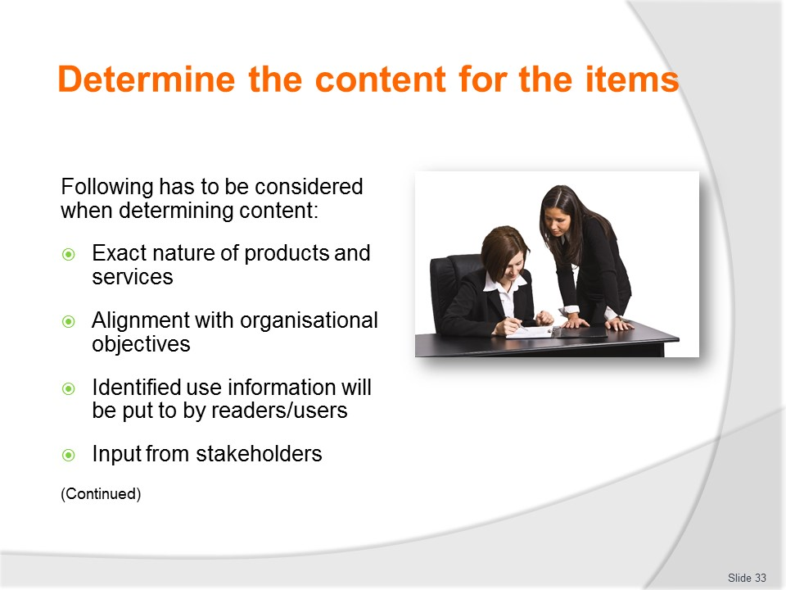
Slide No | Trainer Notes
Trainer states when determining content for brochures and marketing materials the following need to be taken into account and accommodated:
- There needs to be identification of the exact nature of all the products and services to be targeted in the material – this is the case where materials are being developed to promote one or specific trips or tours, or one or more services the business can provide. This means detailing:
- Names and costs of products and services; Relevant times and dates; Inclusions; Packages; Terms and conditions
- Alignment with stated objectives for the organisation and/or individual departmental or operational plan – this means ensuring what is written, included or otherwise indicated in or on the materials/items:
- Matches the direction the business wants to take; Helps the business achieve its strategic and business goals
- Targets the people who are in identified target market/s; Maintains image and reputation of the organisation
- There is a need to provide information which has been identified as being required by/important to the identified users of the items – this may have been determined as a result of verbal feedback, focus groups, market research or as a result of input from staff who have spoken with tour group members/travellers, or contributions from joint venture partners
- Input from all relevant stakeholders – in this context this means seeking and accommodating (as/where appropriate) contributions from:
- Internal personnel and the different departments within the larger organisation; Sub-agents and joint venture partners; Related carriers and major attractions, destinations and third party providers.
Classroom Activity – Internet Research
Trainer facilitates online research and discussion relating to relevant sites such as:
- ‘Marketing content for brochures’ at http://mywebwriters.wordpres.com/2011/08/29/marketing-content-for-brochures/
- ‘How to Write a Brochure Your Customers Will Want to Read – The Brochure Copywriting Cheat Sheet’ at http://www.text-centric.com/brochure-copywriting-cheat-sheet/
- ‘Brochure content writing’ at http://dorightmarketing.com/tag/brochure-content-writing/
- ‘Brochure marketing: 12 tips on how to do it effectively’ at http://marketing.about.com/od/directmarketin1/a/brochmktg.htm
- ‘Marketing tips and trips: Brochures’ athttp://www.smallbusiness.wa.gov.au/TourismBoost/marketing-tips-and-tricks/brochures/

Slide
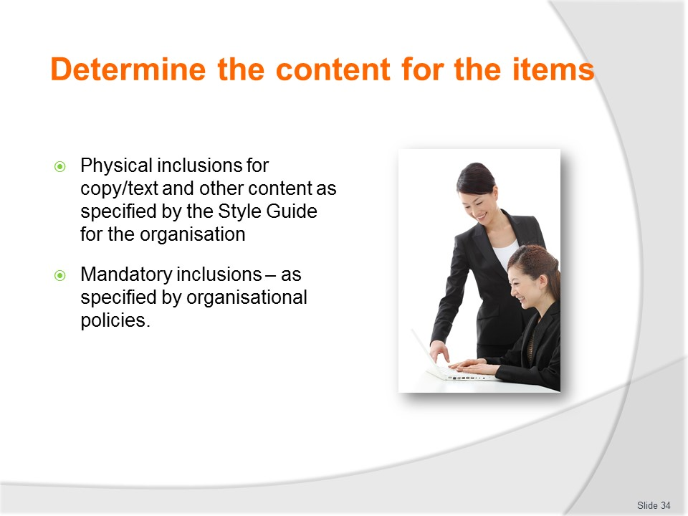
Slide No | Trainer Notes
Trainer continues discussing considerations when determining content:
- Physical inclusions must be addressed – for example:
- All the Style Guide specifications for individual item need to be complied with – these requirements will be presented in the Style Guide for all brochures and all marketing materials produced by the business.
- The specifications will differ between items in relation to matters such as:
- Use, size and position of logos on physical items (merchandise) and on brochures and other paper-based materials as well as electronic formats
- Font
- Use of colour – stipulating what colour is to be used and in what position
- Material to be used as basis for each product/item being produced – this dictates the type of paper, card or stock to be used for print-based materials
- Type of, positioning and size of graphics, art work and photographs
- Mandatory inclusions – making sure all compulsory inclusions as determined by management are included:
- Need to include nominated statements on certain documents/items such as:
- Mission statement; Vision statement; Value statement
- Contact details
- Affiliations the business has with other organisations, agencies, carriers, associations, industry groups/bodies
- Indications the organisation aligns with/subscribes to QA schemes or industry schemes, or Codes of Practice.
- Details of nominated guarantees and/or warranties offered by the operator
- Terms and Conditions of the organisation
Classroom Activity – Handouts
Trainer distributes and discusses sample materials illustrating the points identified on the slide.

Slide
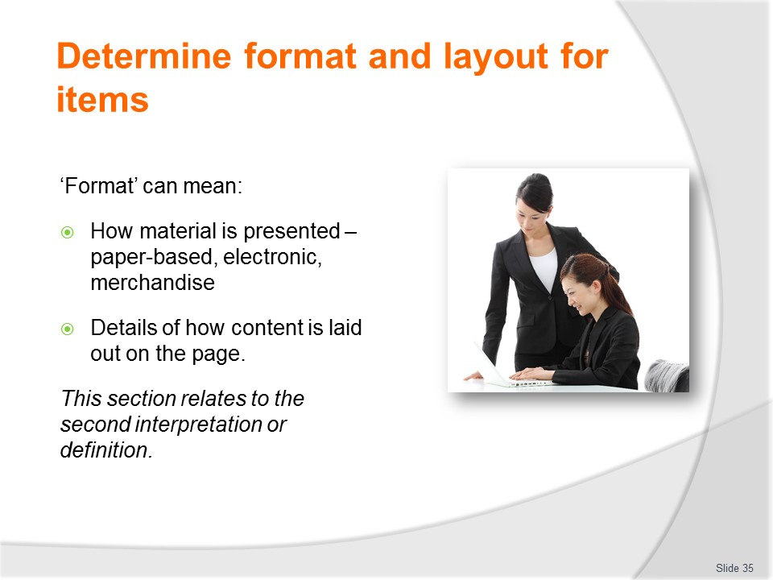
Slide No | Trainer Notes
Trainer explains it is possible for the word ‘format’ to have two meanings in common usage:
- First – it can mean the underlying basis of the item. For example, advertising/promotional/marketing material can come in several formats – it can be:
- Paper-based (such as brochures, flyer, mail-outs, newspaper and magazine adverts and hard copy schedules, price lists and itineraries)
- Electronic – such as SMS texts, websites, Facebook posts, blogs or tweets
- Merchandise – such as travel bags, caps and T-shirts.
- Second – it can refer to the formatting of a page. This includes the layout of the page (that is the physical position of items on a page) but also includes several other features of what appears on the page such as:
- Fonts which are used
- Choice of font sizes
- Whether photographs are used or whether pictures/graphics are used
- Selection and use of colour.
This section relates to the second of these definitions/interpretations.

Slide
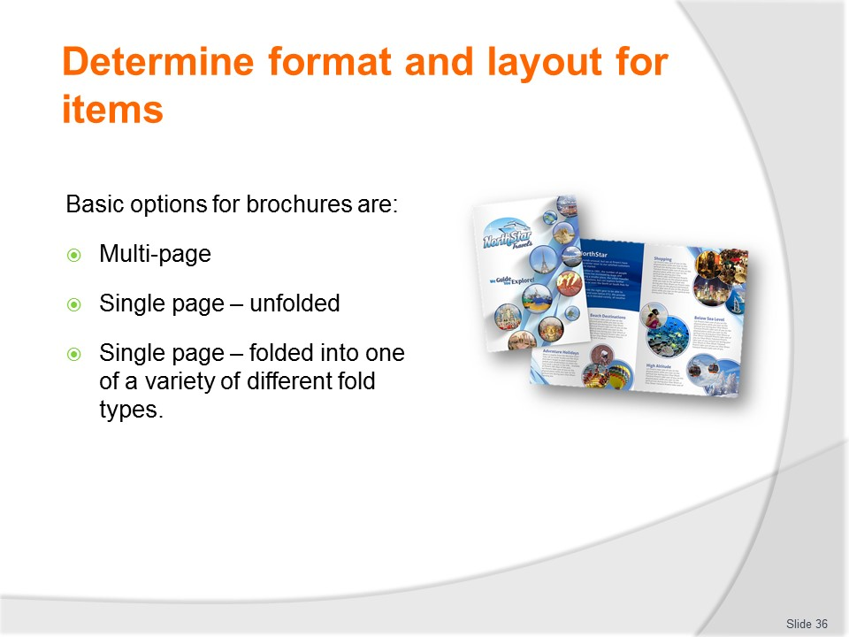
Slide No | Trainer Notes
Trainer explains a main requirement is to determine the page layout/format for the item. Basic options are:
- Using multi-page brochure – stapled or bound in some way.
- Most A4-sized marketing materials are produced in multiples of four, due to the rolls of paper commonly used by printers, and are therefore generally 8, 12, 16, 20, 24, or 28 pages long.
- Selecting single unfolded page leaflets
- Electing to use a single page which is folded in one of several ways traditionally used for promotional materials – these include:
- Half-fold/bi-fold
- Tri-fold
- Accordion fold
- Z-fold
- Accordion fold
- Quarter fold
- Gate fold
Classroom Activity (1) – Internet Research
Trainer facilitates online research and discussion relating to relevant sites such as:
- ‘Brochure templates’ at http://www.brochureprinting.com/brochure-templates.html
Classroom Activity (2) – Exercise
Trainer provides students with card/stock and asks them to fold into the different brochure folds identified on the slide.
Slide
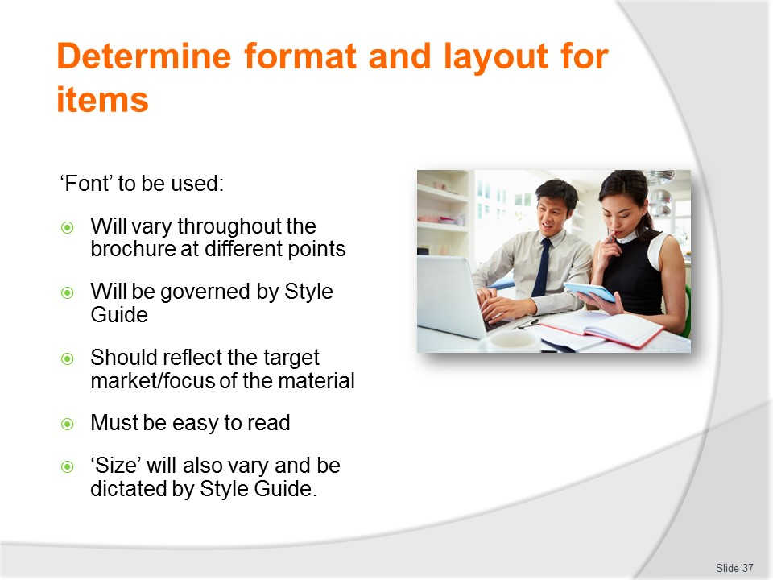
Slide No | Trainer Notes
Trainer states there is always a need to determine the font to be used throughout or in defined sections of the items explaining generally:
- Type face and size will change for text/copy at different physical locations on/in each brochure and marketing items
- The Style Guide will govern what is used
- The font type should relate to the target market – for example:
- Traditional typefaces for traditional markets (Arial, Helvetica, Calibri, Verdana)
- Items aimed at younger/active/adventure seeking target markets may feature typefaces which are more ‘creative’/different (Mistral, Freestyle Script, Impact)
- The font may be chosen to reflect the nature of the trip/tour being promoted – for example a product such as a ‘romantic get-away’ might use French Script or Monotype Corsiva or Lucinda Handwriting
- Attention needs to be paid to legibility – type faces selected must (usually) be easy to read so customers can quickly scan the materials and obtain the information they need and the detail the organisation wants to convey
- Font size will:
- Be dictated by the Style Guide in many cases
- Vary between locations/positions in the item in order to:
- Introduce difference in appearance
- Help differentiate segments of information
- Change to suit ‘available space’ – where there is lots of white space/room then type sizes can increase, and where room is scarce there is often the option of decreasing font size.
Classroom Activity – Handouts
Trainer distributes and discusses sample material illustrating points made on the slide.

Slide
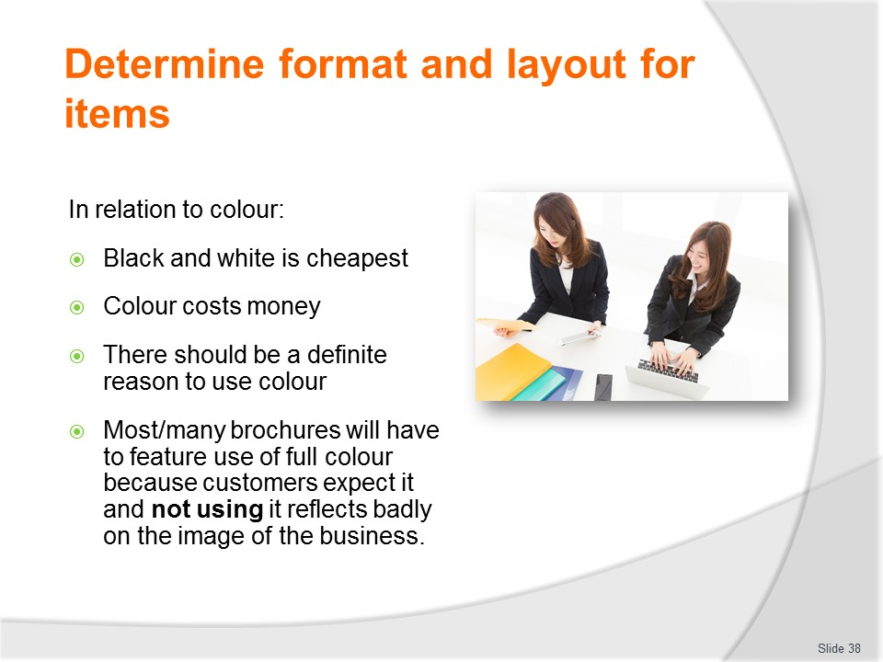
Slide No | Trainer Notes
Trainer discusses colour stating:
- While most materials will seek to convey the standard ‘colours of the company’ there is also a need to determine the use of colour in individual brochures. This point forces consideration of black and white, limited colour or full-colour options.
- It is important to realise colour costs money.
- Black and white is cheapest, a limited number of colours (two or three) is next and the most expensive is full-colour printing.
- The more colour used, the more expensive the end price
- Before deciding on colour for brochures it is useful to ask:
- What will the use of colour achieve?
- How many colours will be needed to create the desired effect?
- Is the cost of full-colour printing within budget?
- Does use of colour align with objectives and intentions for this product?
- It is also important to take into account the paper on which the final product will be printed – for example lighter paper is slightly cheaper, but the quality of print material can become bad because colour can ‘bleed’ through the thin pages.
- Key points are:
- Full-colour or four-colour printing (that is, colours derived from the four primary colours) is the most expensive choice; however, it will generally create a more lasting impression
- One-, two- and three-colour printing can also be used effectively. If the budget will allow only one colour, remember there are numerous shades and hues for each colour so (in reality) this expands available colour options
- The nature of the industry is such that colour needs to be used in all/most marketing materials.
Classroom Activity – Guest Speaker
Trainer arranges for printer to attend and discuss:
- Printing of brochures
- Options available
- Use of colour
- Finishing options
- Nature of relationship between client and printer.

Slide
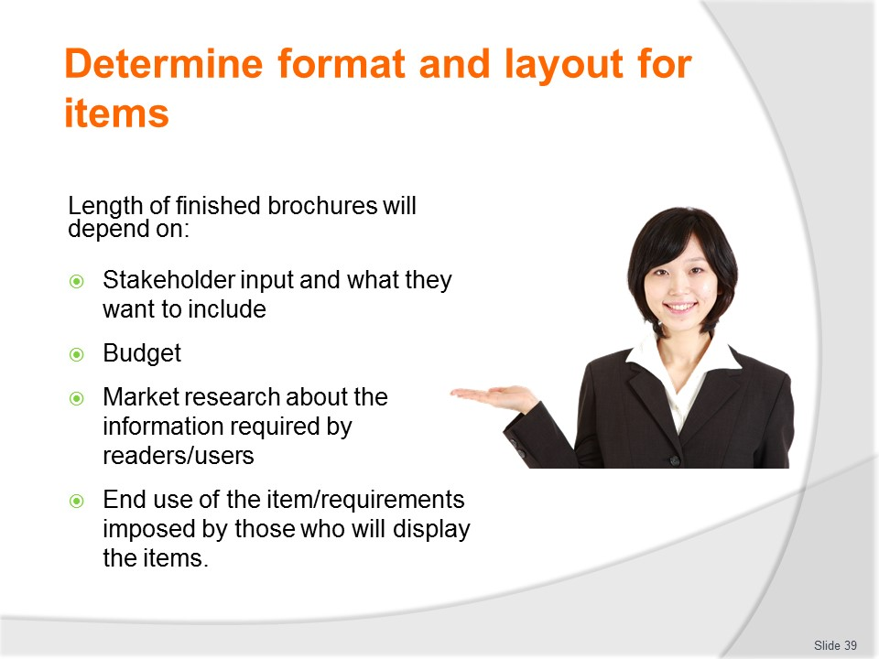
Slide No | Trainer Notes
Trainer mentions length of the final item in term of number of pages will be determined by a combination of factors such as:
- Input stakeholders want to make – the desire/need for stakeholders to contribute nearly always has to be accommodated
- Budget – in relation to:
- Production – lengthier items are more expensive to produce
- Distribution – bigger/weightier items cost more to mail or send out
- Market research about the amount of detail customers/consumers want – some items will seek only to give brief pieces of information while others will be produced to supply extra/comprehensive details
- End use of the item – for example, some promotional materials will be required to be single page, bi-fold or tri-fold where they are to be included in/added to a pre-existing range/rack/stocking and display option of other advertising items (such as in a pre-existing facility in a hotel lobby or a Visitor Information Centre).
- When deciding on the format and size of print material, make sure it is appropriate for purpose and easy to distribute. For example, make sure the final product fits easily into brochure display stands or they can be mailed out in standard size envelopes.
- A standard size leaflet such as A4 folded down to one third A4 (gatefold) is easiest to use as it fits into standard brochure racks and envelopes.

Slide
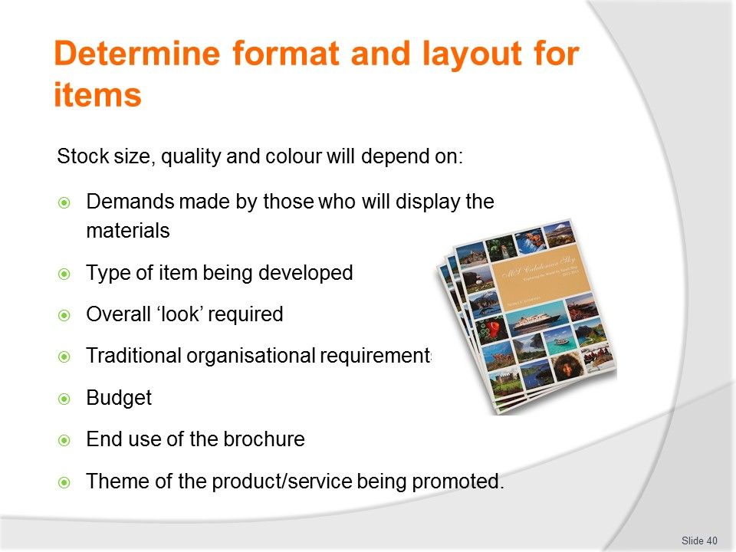
Slide No | Trainer Notes
Trainer observes stock size, quality and colour will depend on:
- Demands/requirements of those who are going to display the item – see previous slide
- Type of product/item being developed – for example, there are certain higher expectations of quality for a brochure that do not exist for a flyer
- Overall ‘look’ to be achieved by the item
- Traditional/non-negotiable requirements of the organisation and stakeholders involved in the initiative
- Budget
- End-use of the finished product – if the item is to be used by staff inside the business or at another organisation/agency then the emphasis must be on practicality and ‘useability’ of the item rather than ‘show and appearance’
- The theme of the product/service – there needs to be a resonance between what is being promoted (in terms of quality, value, reliability and other emotional criteria/factors) and the way it is promoted.
Classroom Activity – Handouts
Trainer distributes and discusses samples of stock as described on slide.

Slide
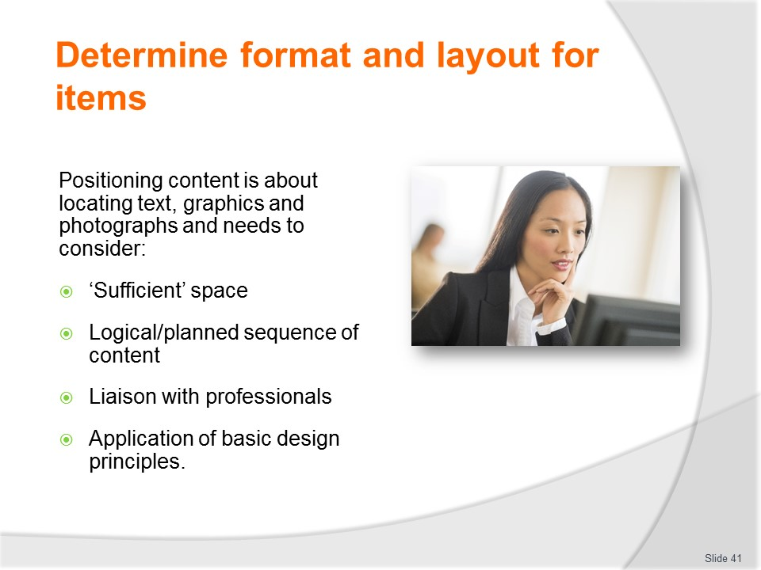
Slide No | Trainer Notes
Trainer states positioning of content relates to locating text, graphics, photographs on the stock or marketing item and involves activities and considerations such as:
- Enabling sufficient space for required text and information – this is important to ensure:
- Items do not look too cluttered or ‘busy’; There is enough space to communicate what needs to be communicated;
- The type face is legible and is not too small
- Sequencing of material in a logical manner – so it is easy-to-follow/find or otherwise presented in a planned order
- Liaising with professionals – these are people with expertise in brochure design and development and include:
- Graphic artists – it is always good to get their input about layout
- Printers – where materials have to be printed by an external printer it is vital to meet with the printer and see what they have to offer and find out what they suggest in terms of what is needed
- Applying basic design principles – this is often a matter of taste/personal judgement and subjectivity about:
- Aesthetic appeal; Harmony of content; Flow and sequencing of information and content; Balance of the final product/page; Spacing between lines, paragraphs, tables, information, sections and so on; Hierarchy of headings/sub-headings; Cover shots and other ‘visuals’.

Classroom Activity (1) – Handouts
Trainer distributes and discusses samples of materials to illustrate points described on slide.
Classroom Activity (2) – Internet Research
Trainer facilitates online research and discussion relating to relevant sites such as:
- ‘Ready-made free design templates’ at http://www.stocklayouts.com/Templates/Free-Templates/Free-Sample-Brochure-Template-Design.aspx
- ‘Make an impression with colourful brochures’ at http://www.stocklayouts.com/Templates/Brochure/Brochure-Templates-Designs.aspx
- ‘Brochure layout template’ at http://all-free-download.com/free-vector/brochure-layout-template.html
- ‘Layout of a promotional brochure’ at http://www.vtaide.com/gleanings/BrochureLayout.htm
- ‘How to design brochures’ at http://www.wikihow.com/Design-Brochures.

Slide
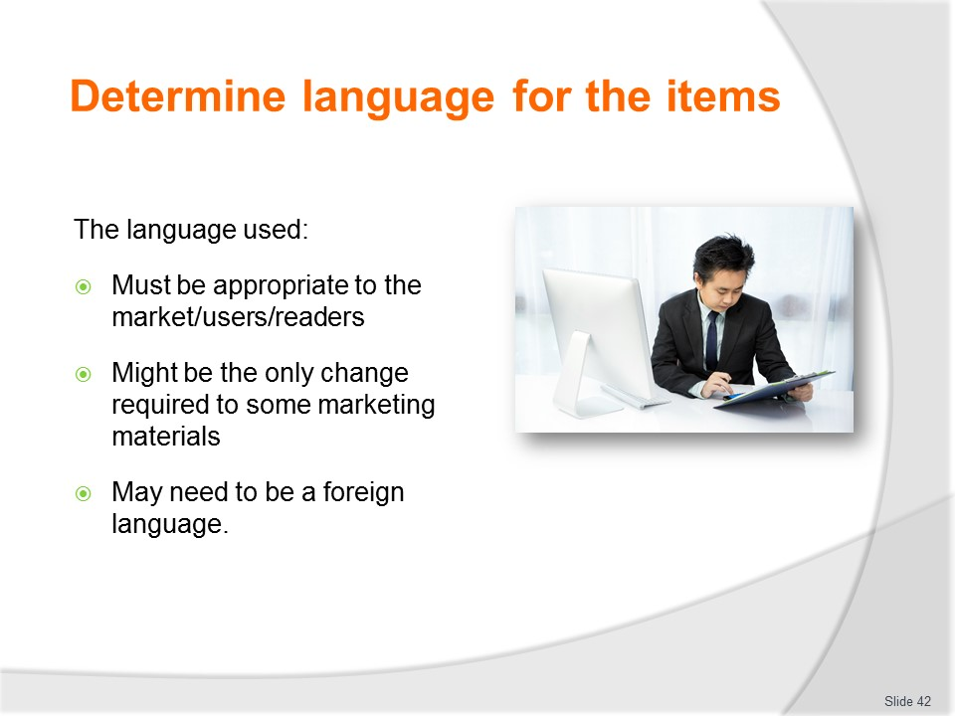
Slide No | Trainer Notes
Trainer observes the most basic decision to be made about brochures and items is about the language to be used:
- The language must be appropriate to the user/target market and in lots of cases this can mean using a ‘foreign’ language.
- There is little point producing a magnificent brochure if the people it is aimed at are unable to read and understand it
- If the target market is English-speaking then the item must be written in English
- Indeed, in some cases the only change that needs to be made to some marketing materials is for there to be a translation of existing materials into another language. This means some organisations have the same brochure but produce it in six or seven different languages
- Where a foreign language is used it is ESSENTIAL a person whose mother tongue is that language is employed to proof read and amend the draft version of the item before it is approved for final printing in order to avoid unintended linguistic gaffs.

Slide
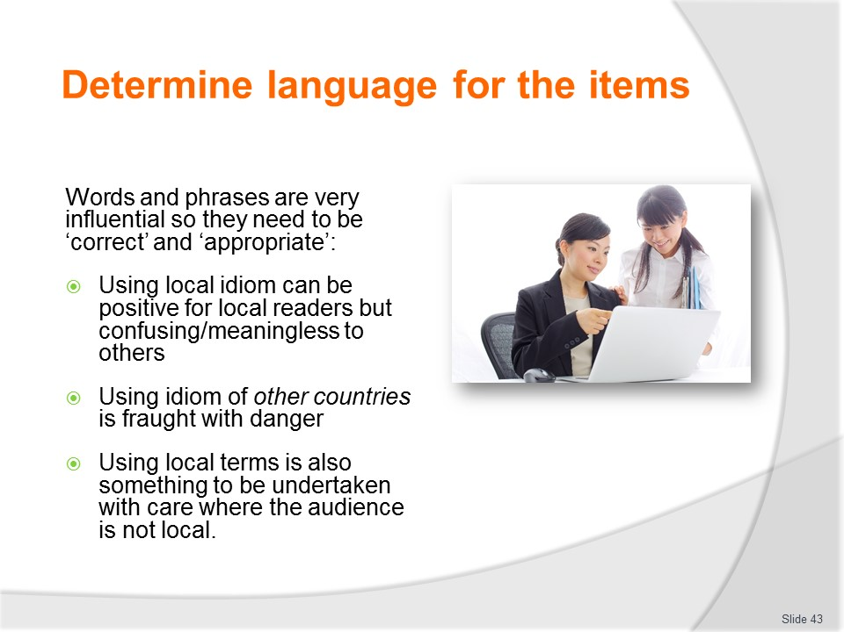
Slide No | Trainer Notes
Trainer advises words and phrases used in marketing materials are extremely influential in conveying meaning to readers but they must be correct and they need to be appropriate to the reader/target market:
- Using local idiom can be a positive thing to do for local readers but confusing and meaningless to those from other countries and cultures. For example:
- If the brochure reads ‘You will be over the moon when you take one of our cruises’ will readers understand this does not mean the ship is sailing past the moon?!
- An Australian would understand if the brochure stated ‘Come to Vietnam and we will give you the drum about our food’ (meaning we will tell you all about the great local food)
- Using idiom of other countries is fraught with danger – as there is always a real danger:
- It will be used in the wrong content/inappropriately – and give the impression the business is ‘out of touch’ with the very country/culture it is trying to connect with
- Of using sayings which are out-of-date and no longer in common usage
- Of including phrases not commonly used by the target market who the brochure is being aimed at
- Using local terms is also something to be undertaken with care where the audience is not local – this is not to say local terms are to be avoided but they must be:
- Explained
- Put into context
- Used sparingly.
- Local terms can be used as/wherever needed when marketing materials are aimed at locals but if the readers are foreigners the use of ‘too many’ local terms has been shown to:
  - Confuse the reader
  - Produce negative feelings about the material
  - Fail to fully describe/convey what is intended to the target.
Classroom Activity – Handouts
Trainer distributes and discusses examples of materials to illustrate the points made on the slide.

Slide
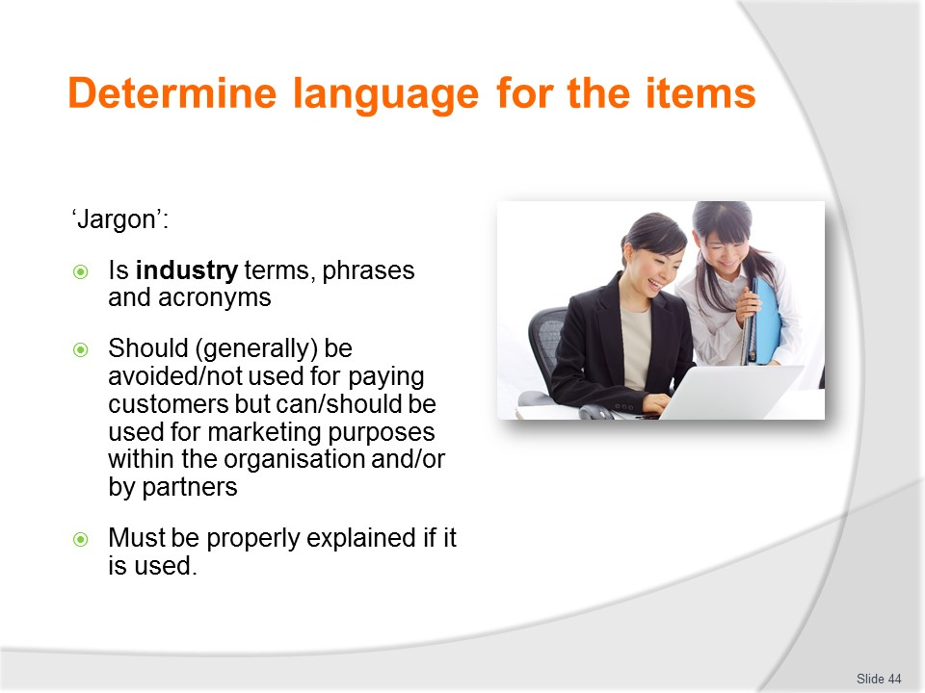
Slide No | Trainer Notes
Trainer discusses use of ‘jargon’ advising jargon refers to:
- Industry terminology specific to a certain industry type/sector and understood (generally) only by those in that industry
- Terminology, words, phrases and/or abbreviations used by an organisation and not commonly understood by anyone outside the organisation.
- The following ‘rules’ apply to the use of jargon in marketing materials:
- Avoid it – for use where the target is ‘the public’. If it is deemed necessary to use jargon in a marketing item aimed at any public/target market it needs to be explained – never assume the reader:
- Knows what it means
- Will interpret it the way the material wants/needs it to be interpreted
- It is customary to use accepted industry terms and abbreviations for ‘internal’ marketing materials – this means it is acceptable to use jargon in documents:
- For use by organisational staff such as sales staff, members of the marketing department, consultants and counter staff
- For use by employees at other branches, agencies, intermediary organisations or support service providers.
Classroom Activity – Internet Research
Trainer facilitates online research and discussion relating to relevant sites such as:
- ‘Travel jargon: what hotels say vs. what they mean’ at http://travel.cnn.com/explorations/life/deciphering-travel-marketing-lingo-911627
- ‘Why you should avoid jargon in your business brochure’ at http://www.swallowtailprint.co.uk/news/articles/post/34-why-you-should-avoid-jargon-in-your-business-brochure
- ‘Hotel industry jargon buster’ at http://www.cms-cmck.com/Hubbard.FileSystem/files/Publication/50afd4a2-e2aa-4f0c-87be-073ab6b6a63f/Presentation/PublicationAttachment/b19a0c04-85a1-4106-8011-07c8ae8bcb51/HotelsJargonBrochure.pdf.

Slide
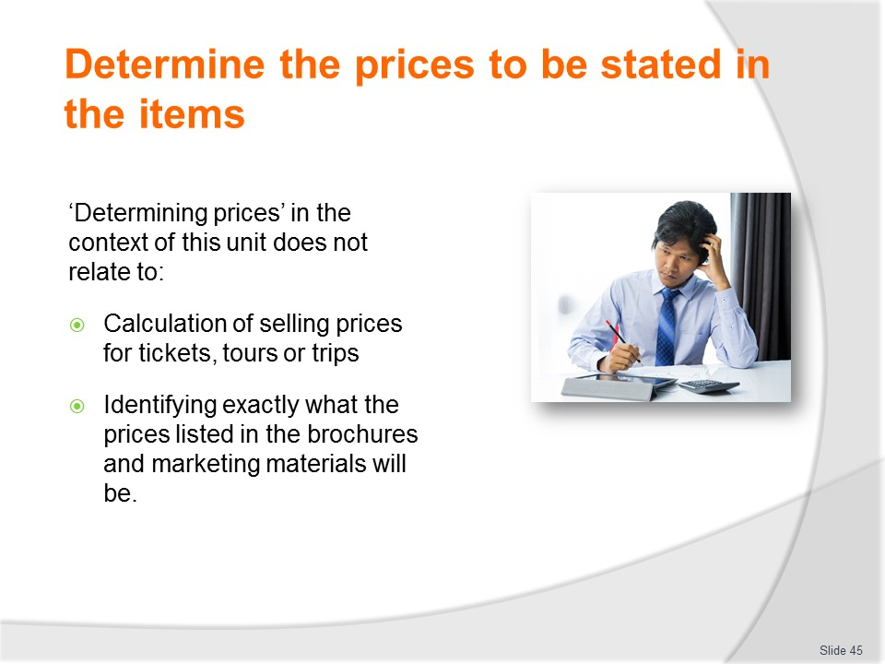
Slide No | Trainer Notes
Trainer explains in the context of this unit this section ‘Determining prices’ does not relate to:
- Actually calculating the selling prices to be listed in brochures
- Determining what the prices listed in materials should be
- This is the responsibility of management or a mix of financial personnel/accountants and the marketing and sales departments.

Slide
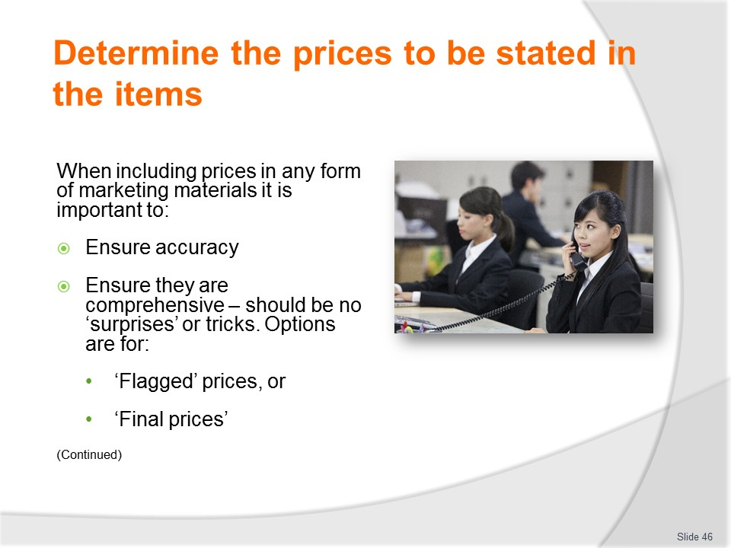
Slide No | Trainer Notes
Trainer states when including prices in any form of marketing materials it is important to:
- Ensure the accuracy of prices quoted – this means making sure the prices listed are the prices that should be there. It means double-checking to ensure (for example):
- Figures have been correctly copied from the original/source document
- No figures have been accidentally transposed – so 915 has not become 195
- Ensure prices listed are comprehensive – in practice (because it is illegal and unethical to be misleading and deceptive) this means:
- All prices and charges should be listed – if the traveller/purchaser is going to be levied a charge/fee for anything it should be listed.
- There should be no ‘surprises’ after the initial decision to purchase has been made.
- Prices/charges imposed by other businesses or government agencies should be listed as such
- A decision may need to be made about whether selling prices are ‘flagged’ or ‘final’:
- ‘Flagged’ means a listed price is flagged with an asterisk (*) indicating other fees and charges apply (such as taxes, transfers and potentially a host of other on-costs)
- ‘Final’ means the quoted price is inclusive of all fees and charges and the buyer has nothing else to pay
Classroom Activity – Handouts
Trainer distributes and discusses sample brochures which illustrate points on the slide.
Slide
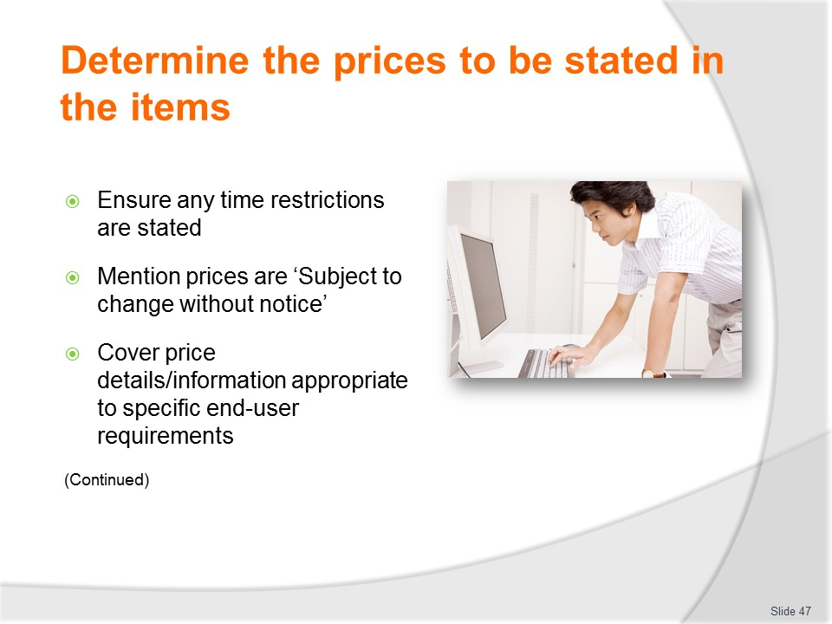
Slide No | Trainer Notes
Trainer continues discussing points about prices on brochures:
- Ensure time limitations for stated prices – this means including a statement in the brochure indicating prices, tariffs and similar are valid only until a stated date
- Determine organisational requirements regarding need to include a statement highlighting prices and charges are subject to change without notification – this can be a standard inclusion in most/all advertising materials
- Incorporate prices relevant to the specific target audiences of the brochures or marketing materials – this means:
- Including details for sales staff and agencies appropriate to their needs – such as wholesale prices, commissions, available discounts for trade audiences but not for retail customers
- Stating retail process for end-users
- Varying prices where materials are being generated for different segments (sub-sections) of certain target markets – for example, the ‘local’ target market maybe differentiated into ‘corporate’, ‘clubs and groups’ and ‘families’ with each group having a different price point
Classroom Activity – Handouts
Trainer distributes and discusses sample brochures which illustrate points on the slide.

Slide
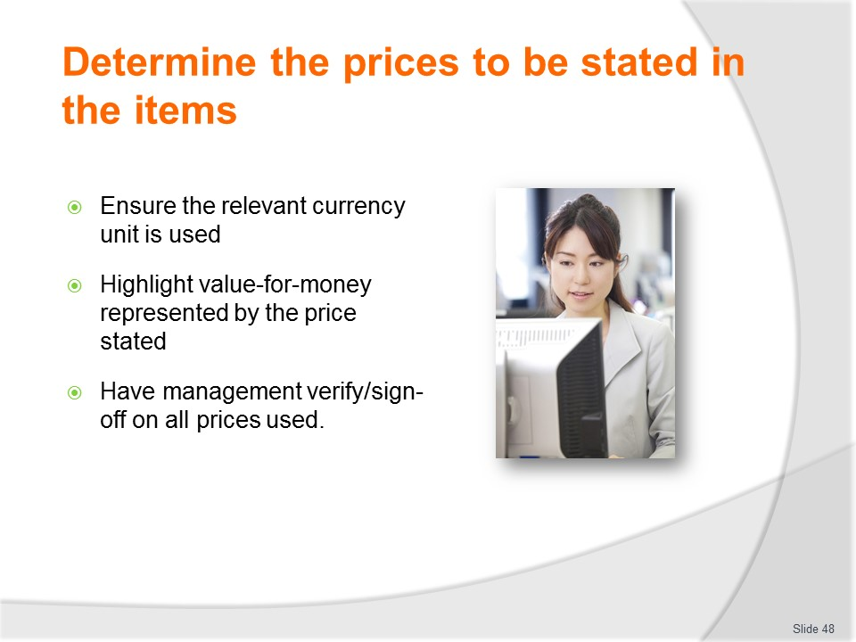
Slide No | Trainer Notes
Trainer continues discussing points about prices on brochures:
- Ensure the currency used in the items is relevant to the language being used and/or target market audiences or destinations – the price stated/listed needs to ‘mean something to those who read it.
- Using Rupiah, Dong, Singapore dollars or Ringgit may mean a lot to those who produce the materials but is likely to mean nothing to the people it is pitched at: all prices should be:
- Given in local currency
- Converted to the currency of the country of the target customers – meaning there may be a need to list prices in five or six currencies.
- Highlight the value-for-money represented by the price being charged – by referencing:
- Unique nature of the offer
- Special features being offered
- Items/inclusions of the package
- Verify with management prices to be included in items are correct – as part of standard procedure for proof reading and authorisation to proceed to printing and distribution.
- It should be mandatory for management to sign-off on all items at these stages.
Classroom Activity – Handouts
Trainer distributes and discusses sample brochures which illustrate points on the slide.
Slide
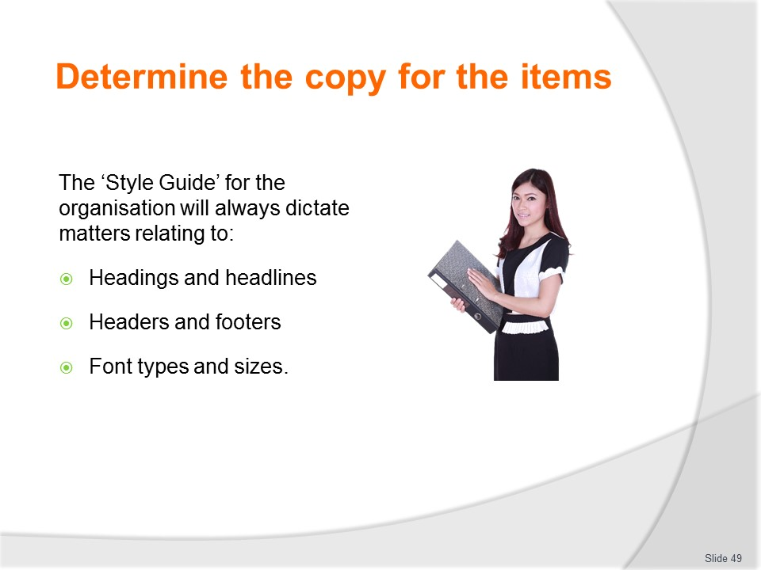
Slide No | Trainer Notes
Trainer reminds students it is important to take into account the requirements of any Style Guide which may be used by the organisation in terms of things such as:
- Headings
- Headlines
- Headers
- Footers
- Font types
- Font sizes.

Slide
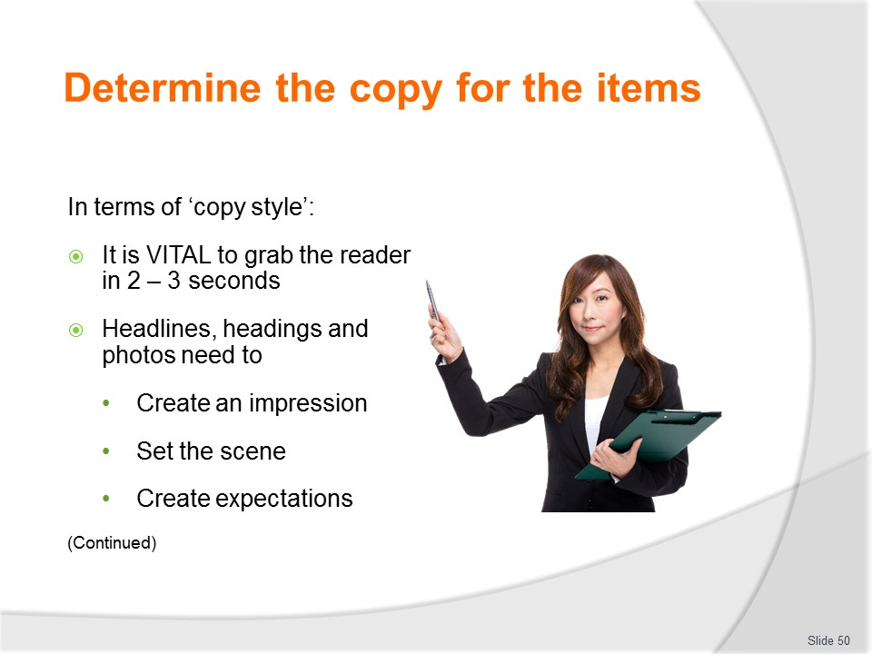
Slide No | Trainer Notes
Trainer introduces ‘copy style’ stating it is worth remembering the words and images used in brochures get the attention of a potential customer within the brief two to three seconds their eyes focus on the headline, picture, or cover page when they browse a brochure display.
The headline, headings, sub-headings and photos are often the first point of contact between the brochure and the customer and is important because it:
- Creates an impression
- Sets the scene
- Creates expectations.
Headlines are all about attracting attention and they must link to the first sentence of the body of the copy.
It can be worth starting with something different, or a surprising fact, rather than a standard introduction – be prepared to be different.

Slide
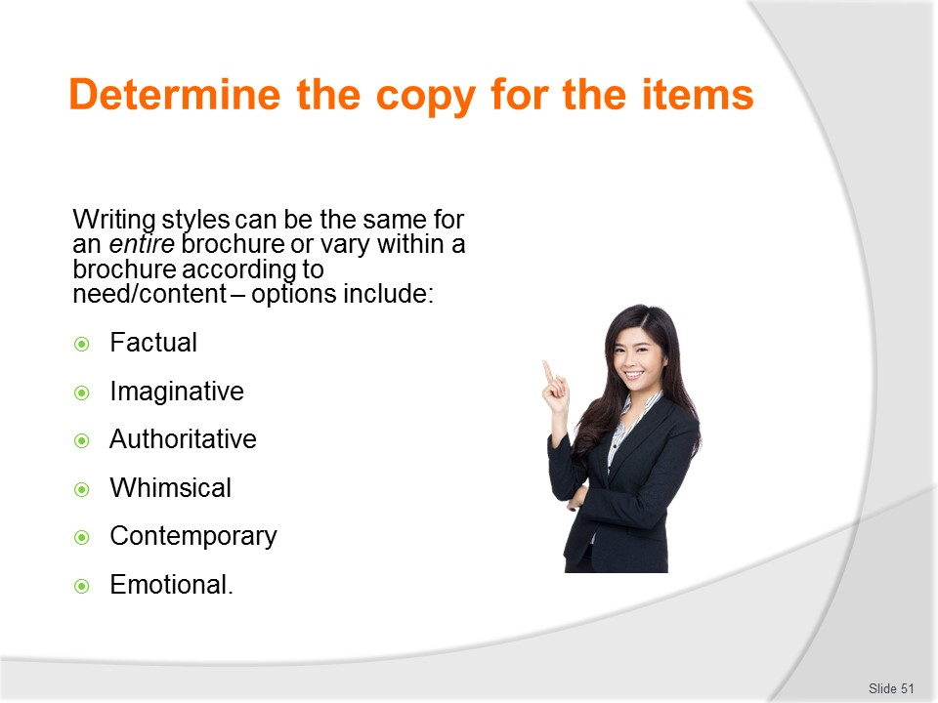
Slide No | Trainer Notes
Trainer continues talking about ‘copy style’ saying the writing style chosen needs to fit with the objective of the brochure indicating the most commonly used writing styles are:
- Factual
- Imaginative
- Authoritative
- Whimsical
- Contemporary
- Emotional.
The one writing style can be used for the entire brochure or a combination of styles may be used throughout the item: many brochures alter styles depending on the focus of the description for individual points/sections.
- For example, a brochure for a zoo may adopt a ‘learning’ style; a brochure for a sports venue may use an ‘action’ orientation; a brochure for a theme park would feature a ‘fun’ style and descriptions for cultures, religion and wars would more respectful and objective.
Classroom Activity (1) – Group Exercise
Trainer presents class with a set of brochures and asks students to analyse them and identify the different copy/writing styles used and explain why those styles are used.
Classroom Activity (2) – Individual Exercise
Trainer asks students to write copy for a nominated product/service to be pitched at a nominated target market.
Slide
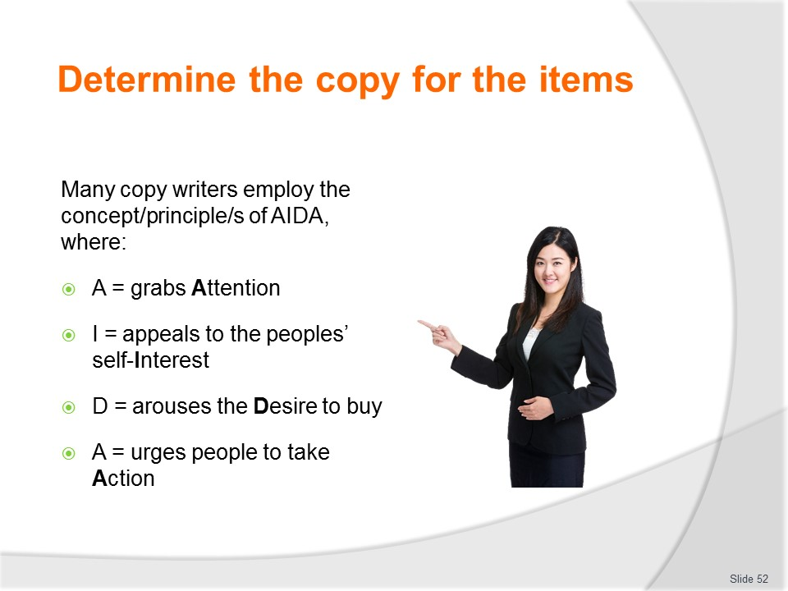
Slide No | Trainer Notes
Trainer identifies many copy writers use the concept of AIDA, where:
- A = grabs Attention
- I = appeals to the peoples’ self-Interest
- D = arouses the Desire to buy
- A = urges people to take Action.

Slide
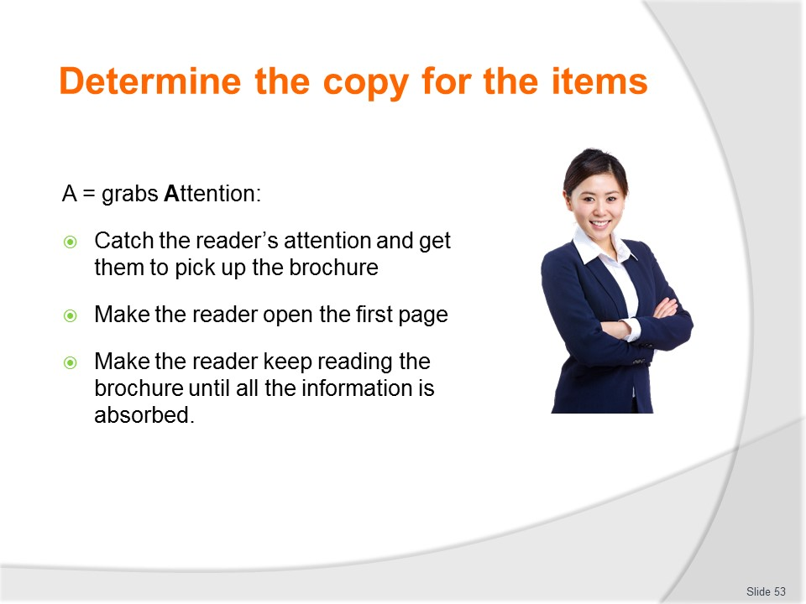
Slide No | Trainer Notes
Trainer continues discussing AIDA stating:
A = grabs Attention
This highlights the need for the brochure to:
- Catch the reader’s attention and get them to pick up the brochure
- Make the reader open the first page
- Make the reader keep reading the brochure until all the information is absorbed.

Slide
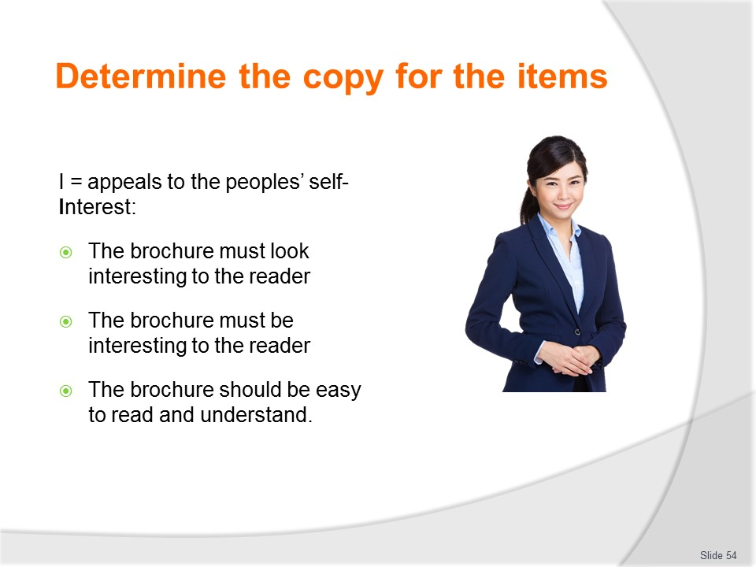
Slide No | Trainer Notes
Trainer continues discussing AIDA stating:
I = appeals to the peoples’ self-Interest
This means:
- The brochure must look interesting to the reader
- The brochure must be interesting to the reader
- The brochure should be easy to read and understand.

Slide
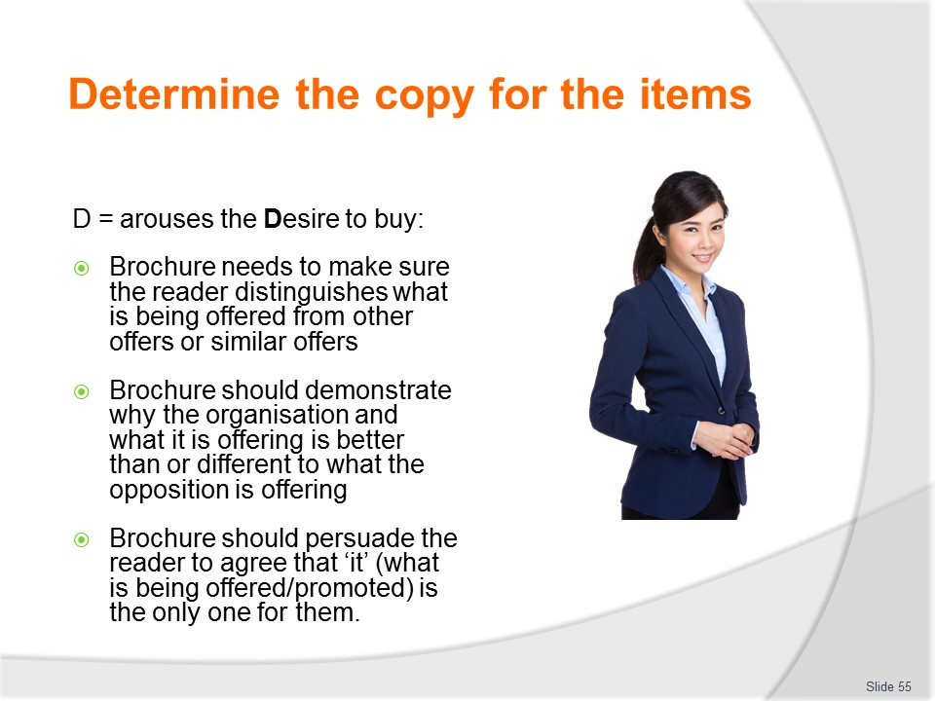
Slide No | Trainer Notes
Trainer continues discussing AIDA stating:
D = arouses the Desire to buy
Keys at this stage are:
- The brochure needs to make sure the reader distinguishes what is being offered from other offers or similar offers
- The brochure should demonstrate why the organisation and what it is offering is better than or different to what the opposition is offering
- The brochure should persuade the reader to agree that ‘it’ (what is being offered/promoted) is the only one for them.

Slide
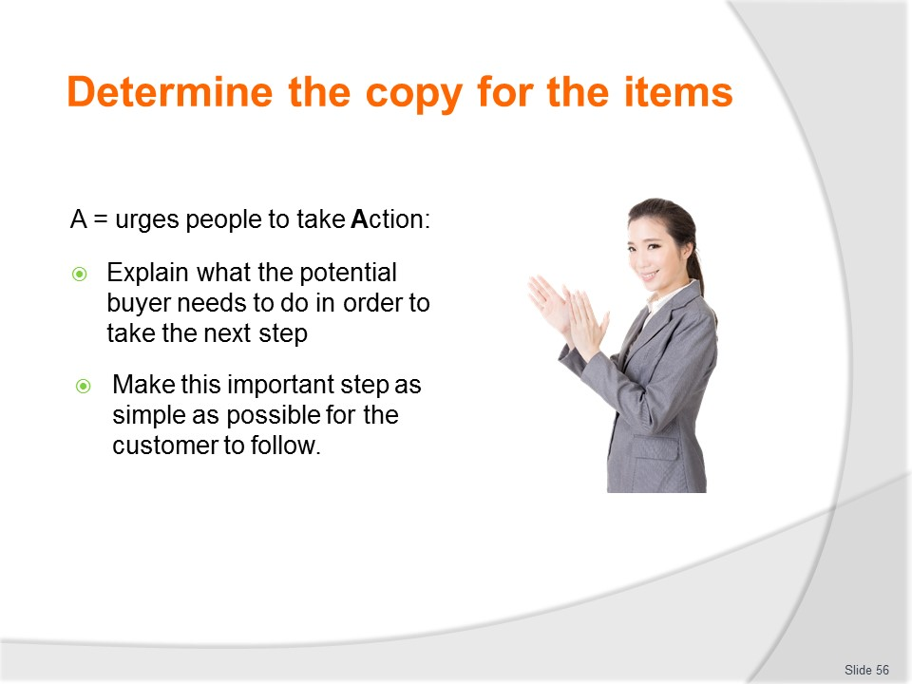
Slide No | Trainer Notes
Trainer continues discussing AIDA stating:
A = urges people to take Action
This means the brochure has to:
- Explain what the potential buyer needs to do in order to take the next step – for example:
- ‘Call now for more information’
- ‘Visit our website’
- ‘Phone for free quote’
Make this important step as simple as possible for the customer to follow.

Slide
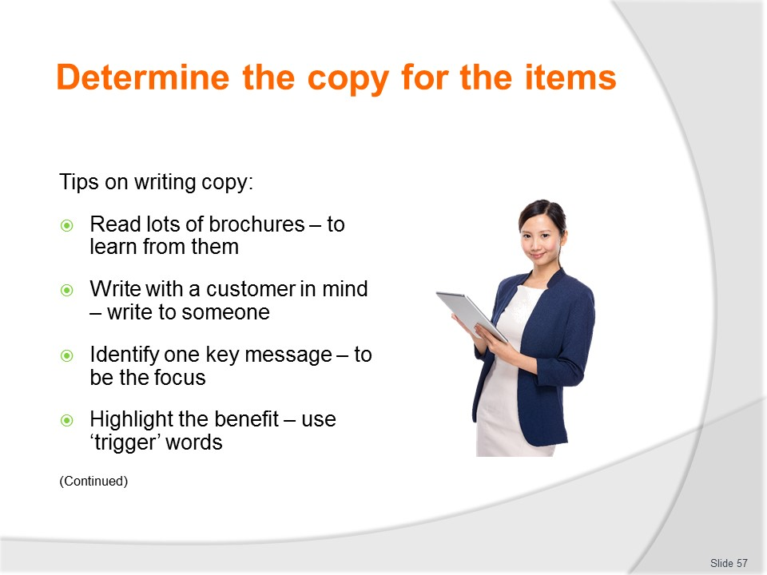
Slide No | Trainer Notes
Trainer provides tips on writing copy:
- Read lots of other brochures from a range of other businesses – to get a feel for what they include and how they write
- Write to an identified customer (the target customer/group as determined by the objective/s for the brochure) in ordinary everyday language – read what is written out loud to check if it flows smoothly
- More persuasive copy will be written if there is one typical reader in mind. This will help in ‘speaking’ to them.
- Use words the reader might like to read – for example:
- Parents will like to see words such as ‘fun’, ‘educational’, and ‘safe’
- Younger people can respond best to words such as ‘exciting’ and ‘full of action’
- Older travellers want to read about ‘safety’, ‘security’, ‘established’ and ‘traditional’
- Identify one key message the brochure is to carry – for example the key message might be:
- Quality
- Relaxation
- Experiential
- Value-for-money
- Note the benefits to be sold – and think about the reasons the typical reader might want to come to buy
- What is it that will motivate the purchase of the product/service? Perfume manufacturers do not sell smell – they promise romance. Car advertisers do not sell a means of transport – they offer excitement or a very powerful, manly image. Theme parks do not sell rides and games – they offer an experience
- This highlights the use of trigger words (words that carry special ideas or feelings) – such as:
- ‘Free’
- ‘Fun’
- ‘Exciting’
- ‘New’
- ‘Safe’
- ‘Unique’
- ‘Save’
- ‘Extra’
- ‘Limited offer’
- ‘Special’.

Slide
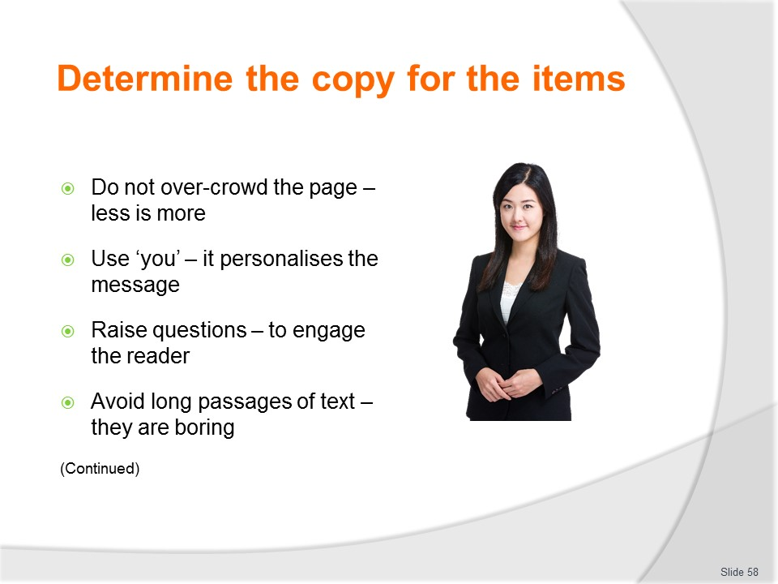
Slide No | Trainer Notes
Trainer continues providing tips on writing copy:
- Do not crowd the brochure with words and explanations – the best copy is often the shortest: ‘less is more’
- Use the word ‘you’ – this instantly grabs attention and really personalises the message/communication.
- Readers identify with it and instinctively assume it means them.
- Sentences should be turned around to make them more appealing, for example:
- ‘All our tours are exciting, fun and safe’
- should become
- ‘You’ll be able to enjoy the fun and excitement of our tours in total safety’.
- Use questions – using questions helps to involve the reader, particularly if the answer is almost certainly ‘yes’, for example:
- ‘Wouldn’t you just love to escape the pressures of everyday life and spend a day thrilling your senses? XYZ offers the perfect opportunity to live life as you thought it should be’
- The benefits and features offered are the real reason people will buy.
- If prospects read ‘You’ll feel challenged and exhilarated, enjoying a true family experience at XYZ’, they would be even more likely to purchase.
- Avoid using long passages of text – loads of print appears dull and uninteresting
- Short everyday words, short paragraphs, and short sentences are easier to read
- Short sentences have more impact – remember it is brochure that is being written and not a book.

Slide
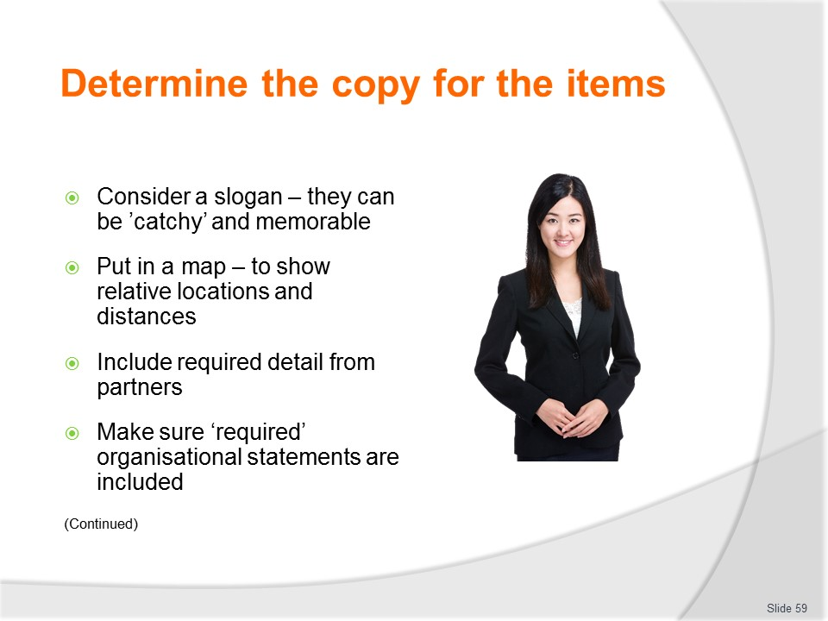
Slide No | Trainer Notes
Trainer continues providing tips on writing copy:
- Consider a slogan – a slogan is a brief message with an idea or image that people can instantly recognise, relate to and understand/form a connection with. If the organisation (or a destination or attraction) has a slogan, it is usual for this slogan to be included on all promotional materials, including brochures.
- Examples may include:
- ‘XYZ zoo – fun in learning’
- ‘XYZ park – challenge yourself!’
- ‘XYZ museum – take a step into the past’.
- Successful slogans aim to:
- Create a ‘brand’ name
- Describe the product or service available
- Create or support a recognisable image.
- Include a map – to show relative locations, landmarks and distances
- Be sure to include ‘required’ information from joint venture or sponsorship partners – there are often expectations (or contractual requirements) to include certain statements or other inclusions (logos, facts, details) from stakeholders
- Include statements the organisation insists are included on all brochure materials – these may include words to the effect of:
- ‘Offer valid until XX/XX/XX’
- ‘Prices subject to change without notice’ – this allows brochures with prices to continue to be used even where there have been price increases
- ‘Some attractions and inclusions may be unavailable due to weather conditions, maintenance or other causes’
- ‘Information contained in this brochure was accurate at the time of printing’.

Slide
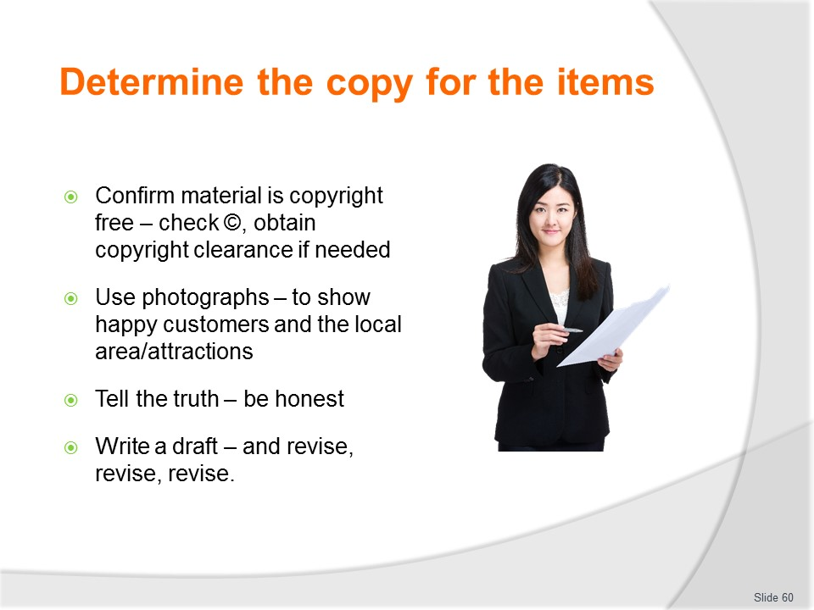
Slide No | Trainer Notes
Trainer continues providing tips on writing copy:
- Confirm all material written is either copyright free or copyrighted material has been granted permission for use – never copy anything directly from another source without getting permission to use it.
- Most brochures produced are covered by copyright, so a business cannot legally copy text and photos found in other brochures from other organisations and use them in their own.
- Note, too, most of the information on the Internet is also covered by (inferred) copyright or express copyright.
- The © symbol indicates material is protected by copyright, but there is no legal requirement for this to be present for the work to be covered by copyright protection.
- The message is simple: do not copy someone else’s work and use it as if it is original work – because it can be an offence.
- Use/consider photographs – photographs can be used for different things/in different ways.
- Photographs of customers/visitors are common in brochures and are used to:
- Encourage identification by potential customers who recognise the service or product is being targeted at their age or social status group
- Reinforce benefits (fun, safety, excitement, a family experience, action) being offered
- Create expectations.
- Photographs of the environment are used to:
- Validate claims made in the text about the existence, quality, safety of a particular aspect of the trip, tour or destination
- Create a sense of atmosphere/ambience
- Motivate and inspire the viewer to come or seek further information.
- Tell the truth – be creative but always remain honest. It is acceptable to embellish but not to tell deliberate untruths
- Write a draft – and be prepared to revise and re-write many times
Classroom Activity – Guest Speaker
Trainer arranges for copy writer to attend and discuss:
- Tips/advice on copy writing
- Examples of copy
- Determining ideas for copy
- The process of copy writing.

Slide
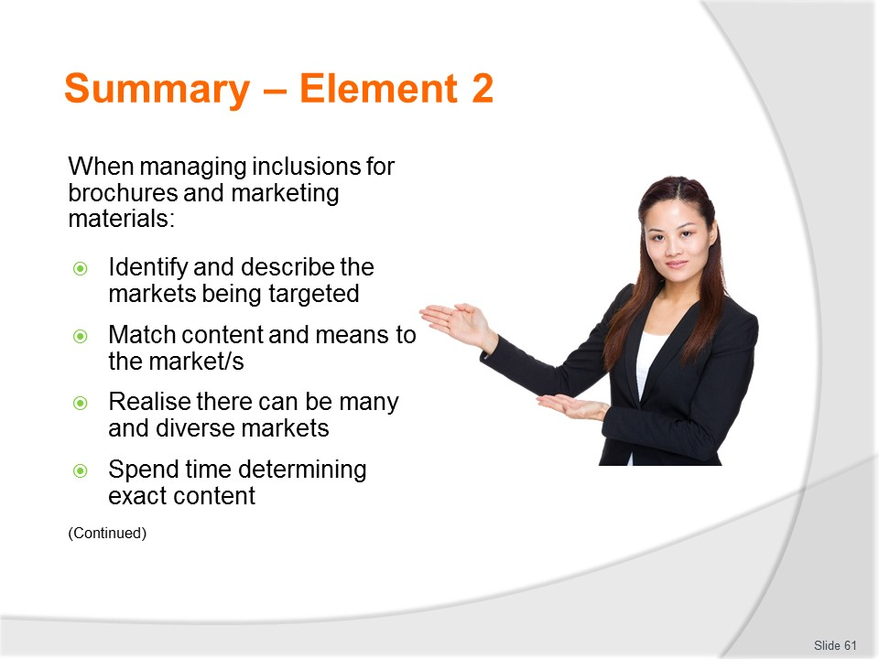
Slide No | Trainer Notes
 | Trainer provides a recap of the Element asking questions to check trainee understanding and responding to questions from trainees, as required.

Slide
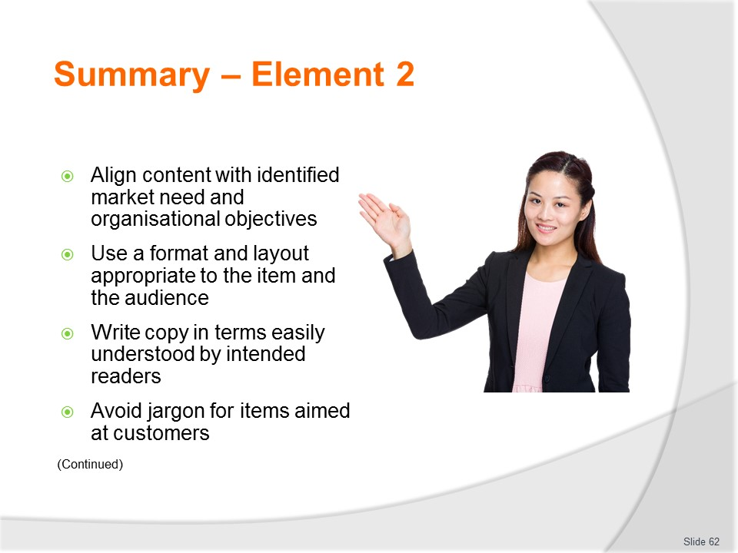
Slide No | Trainer Notes
 | Trainer provides a recap of the Element asking questions to check trainee understanding and responding to questions from trainees, as required.

Slide
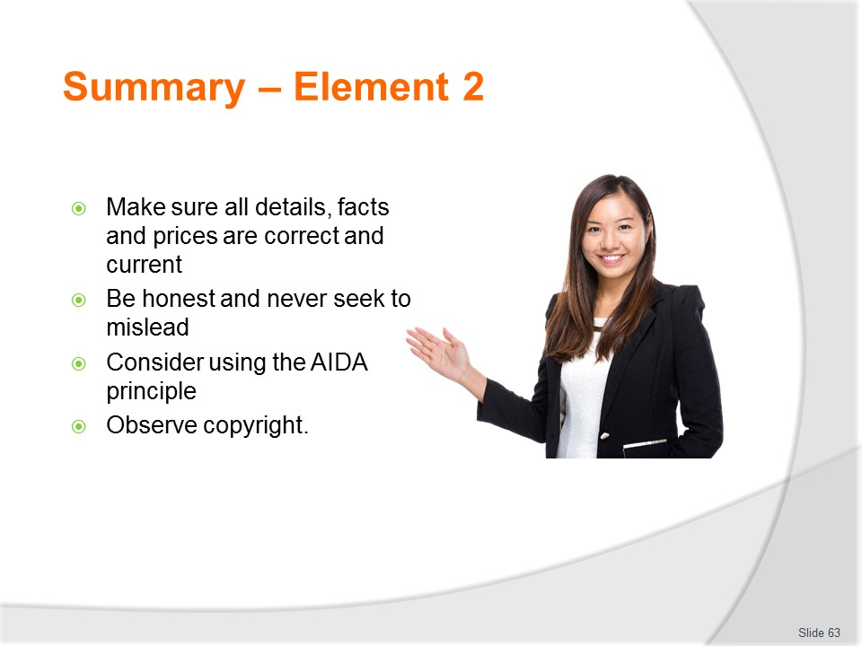
Slide No | Trainer Notes
 | Trainer provides a recap of the Element asking questions to check trainee understanding and responding to questions from trainees, as required.

Slide
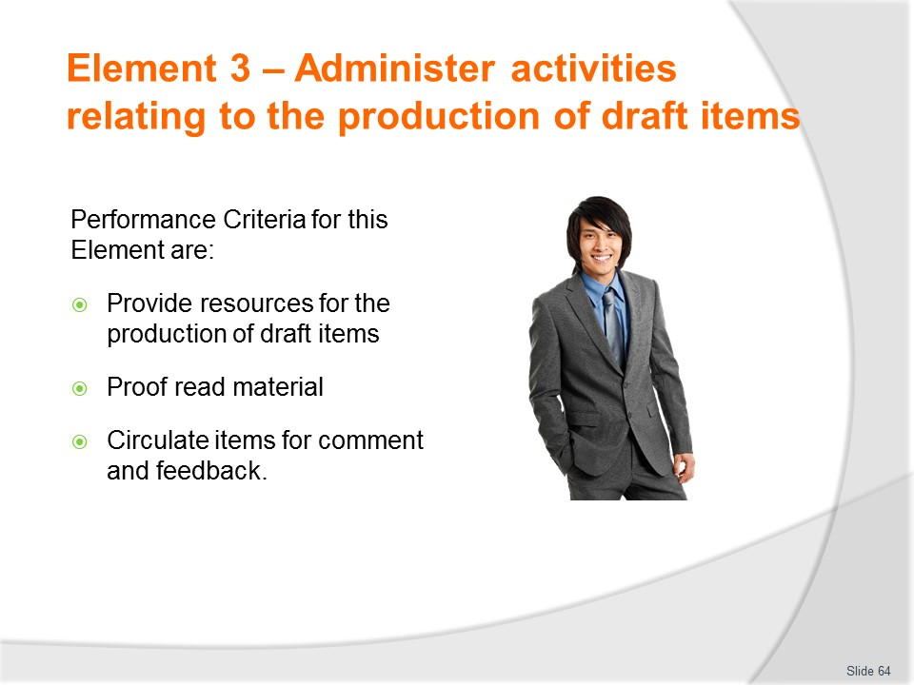
Slide No | Trainer Notes
Trainer identifies for trainees the Performance Criteria for this Element, as listed on the slide.
Class Activity – General Discussion
Trainer leads a general class discussion by asking questions such as:
- What resources may be required to support the production of brochures and marketing materials?
- What is proof reading?
- Why is proof reading done?

Slide
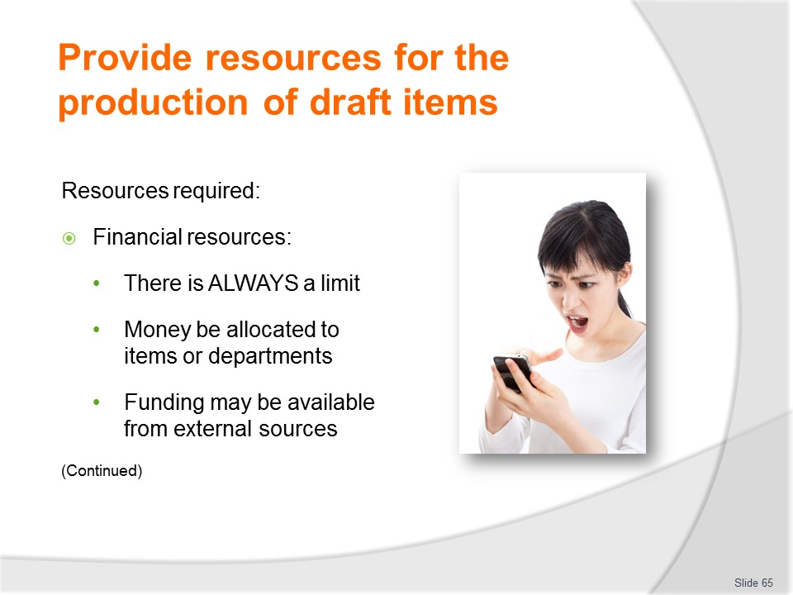
Slide No | Trainer Notes
Trainer explains resources required for production of items:
- Funding – this is the money, cash or credit authorised and allocated by management for each individual item.
- There is always a limit as to what is available.
- Financial resources may be allocated:
- To a department – and it is up to the department how they spend this money
- On a project-by-project basis – for individual items
- Attention should be paid to trying to obtain external funding for marketing materials – this may be available from:
- Carriers who are to be used
- Attractions named in the items
- Government agencies such as tourism bodies interested in securing visitors to the country.
    - Where funds are obtained from other sources there is usually a trade-off in that they will normally require some input to the text or insist they/their logo is included.

Slide
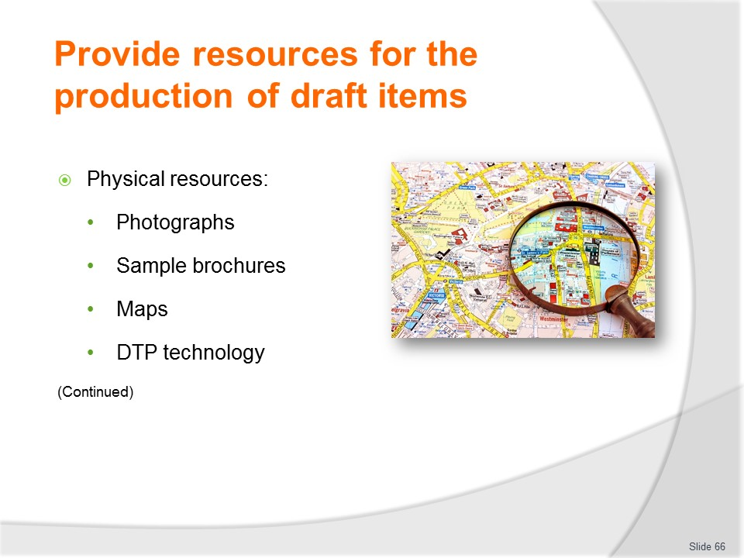
Slide No | Trainer Notes
Trainer continues explaining resources required for production of items:
- Physical resources – which may relate to:
- Photographs
- Sample brochures
- Maps
- Copies of previous items the organisation has produced
- DTP technology and facilities – there has been a significant growth in the availability of desktop publishing packages over recent years: many businesses now conduct their own in-house desktop publishing. Common publishing packages include:
- Adobe InDesign – a more sophisticated option than PageMaker
- Adobe PageMaker
- FrameMaker – now owned by Adobe
- Microsoft Office Publisher
- PagePlus
- PageStream
- QuarkXPress.
Classroom Activity – Demonstrations
Trainer demonstrates how to use a range of DTP software/options.

Slide
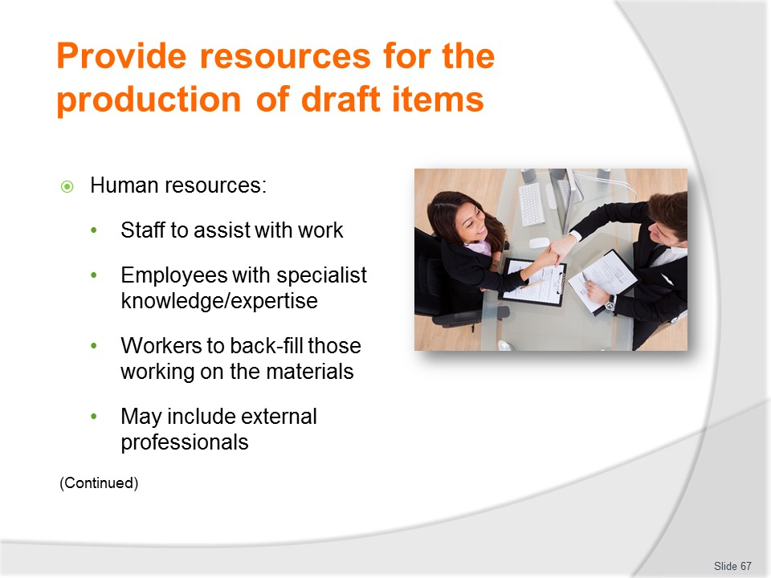
Slide No | Trainer Notes
Trainer continues explaining resources required for production of items:
- Staff – which relates to:
- Allocation of individual employees with certain knowledge and specific skills to assist in the production process
- Allocation of hours/time for the development and production process
- Possible need to arrange for back-filling of staff who are seconded from their normal duties to participate in the development process
- Specification of external professionals who:
- May be used
- Can be used

Slide
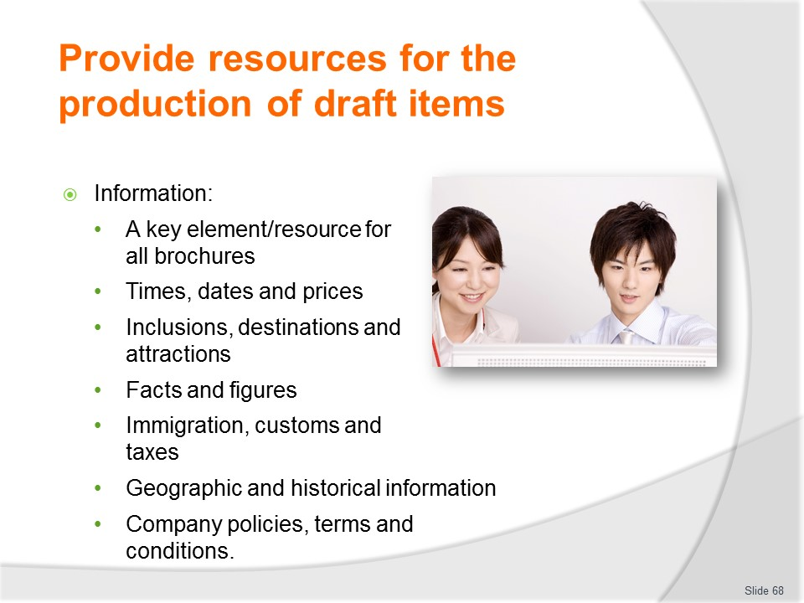
Slide No | Trainer Notes
Trainer continues explaining resources required for production of items:
- Information – this is arguably the single biggest/most important primary resource requirement for all marketing materials.
- Common needs relate to an endless list of information such as detail relating to:
- Times
- Dates
- What is available in/at destinations and attractions
- Prices
- Facts and figures
- Taxes
- Immigration and customs requirements
- Geographical and historic features
- Company policies
    - Terms and Conditions
    - Guarantees and Warranties.

Slide
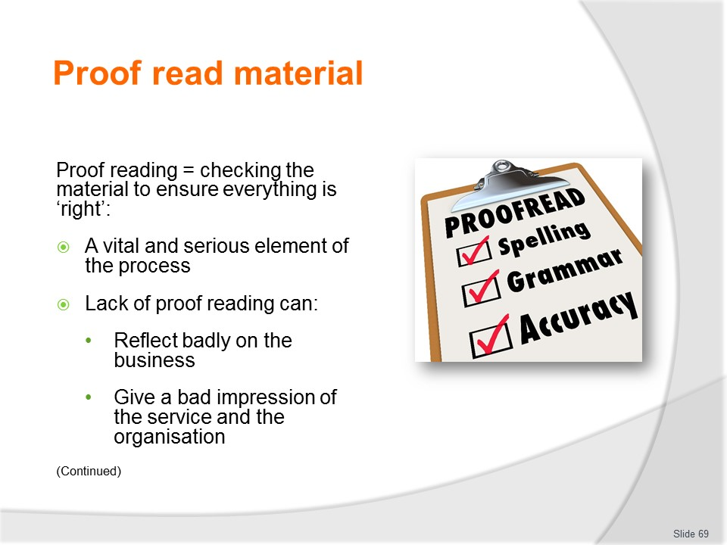
Slide No | Trainer Notes
Trainer explains proof reading is checking the material to ensure everything is ‘right’.
- It is a serious part of the development process for marketing materials because if there is a mistake in anything that is produced:
- It will reflect badly on the organisation
- It can give potential customers grounds to believe the organisation is unprofessional in other aspects of its business – such as taking care of its customers.
- Note: proof reading will be looked at again later when there is a need to check materials from the printer.

Slide
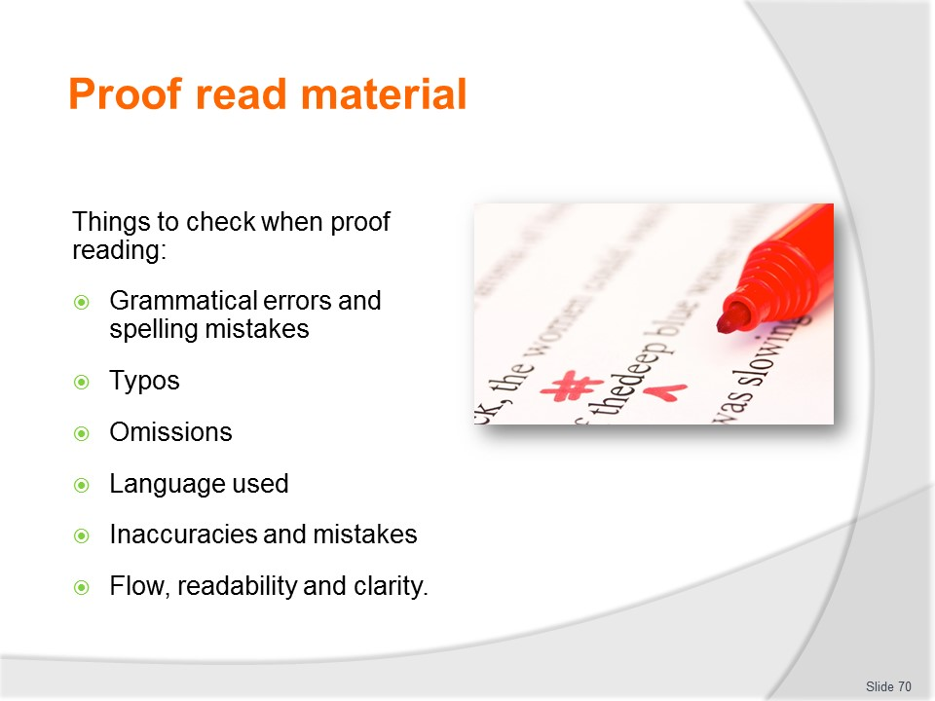
Slide No | Trainer Notes
Trainer identifies things to be checked:
- Grammatical errors
- Spelling mistakes
- Typographical errors
- Omissions (things left out)
- Language used
- Inaccuracies
- Mistakes
- Flow
- Readability
- Clarity.
Classroom Activity – Handouts/Exercise
Trainer provides students with a range of mock brochures containing intentional errors and omissions and asks students to:
- Identify them
- Correct them.

Slide
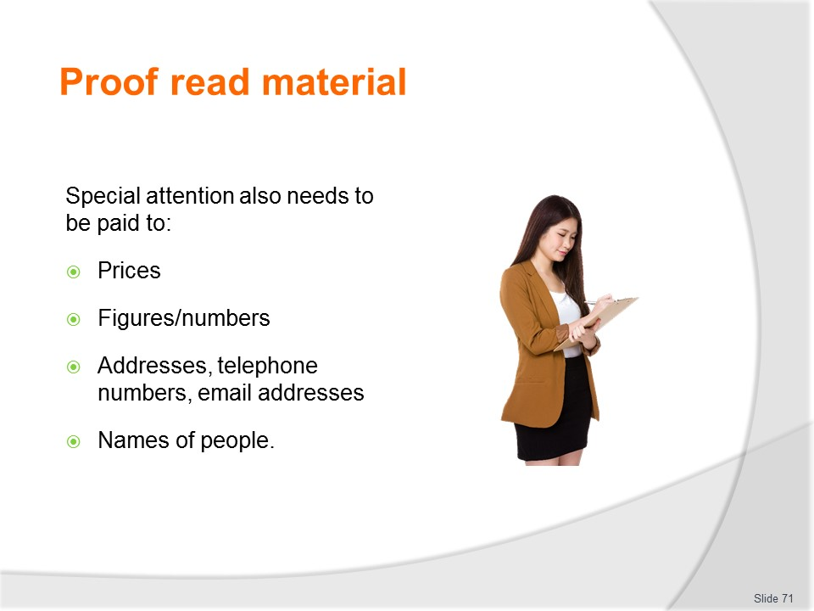
Slide No | Trainer Notes
Trainer adds other points to check when proofing documents:
- Prices
- Figures/numbers
- Addresses, telephone numbers, and email addresses
- Names of people to contact.

Slide

Slide No | Trainer Notes
Trainer informs in addition the proof reading is intended to:
- Check to ensure materials do not give unintended offence
- Verify the inclusion of all required information
- Check facts and figures contained in the item are accurate, current, relevant and comprehensive
- Ensure there are no last-minute changes to the information contained within the items – such as:
- Price fluctuations
- Amendments to legislation or travel schedules
- Unavailability of destinations or attractions.

Slide

Slide No | Trainer Notes
Trainer states when proof reading/as part of the proof reading process:
- Allocate time for it – do not rush this step and never skip it
- Do it more than once – never believe one reading will identify errors and/or omissions
- Leave time between readings – proof read this morning and then tomorrow, not straight away after the first reading
- Get more than one person to do it – a second (and third or fourth) pair of eyes is a good idea to gain different perspectives and optimise the likelihood of issues being detected
- Have someone who has not been involved in the development process read the materials – they will approach it with a more open mind
- If funding allows, use the services of a professional proof reader and editor.
Classroom Activity – Internet Research
Trainer facilitates online research and discussion relating to relevant sites such as:
- ‘Proofreading’ at http://writing.wisc.edu/Handbook/Proofreading.html
- ‘Top 10 proofreading tips’ at http://grammar.about.com/od/improveyourwriting/a/tipsproofreading.htm
- ‘How to copyedit and proofread written work’ at http://www.wikihow.com/Copyedit-and-Proofread-Written-Work

Slide
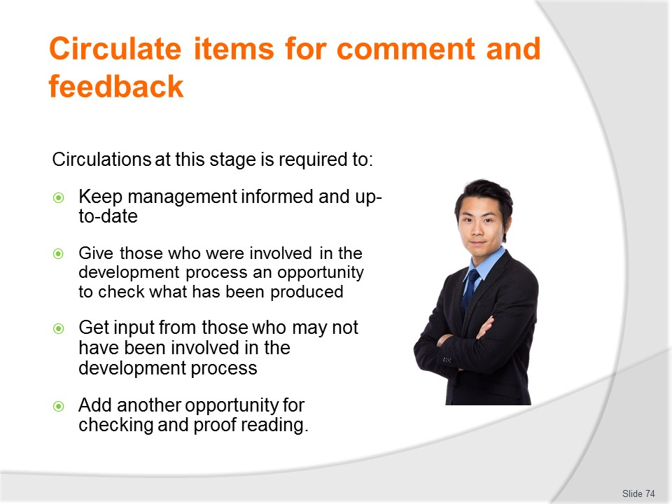
Slide No | Trainer Notes
Trainer explains need to circulate items at this stage is required to:
- Keep management informed and up-to-date – this is necessary to:
- Inform them about what is happening
- Keep them appraised on what is being developed
- Allow them to actively monitor progress on plans of which they are commonly aware/have prepared
- Obtain approval to proceed with the proposed items
- Give those involved in the development process an opportunity to check what has been produced – so they can:
- Verify the material which has been prepared
- and/or
- Make recommendations for improvement
- Get input from those who may not have been involved in the development process – this can:
- Enable thoughts from people outside the ‘development team’ who may have legitimate concerns to air and/or contributions to make
- Let them know what is being prepared and what they can expect in the near future
- Add another opportunity/dimension for:
- Proof reading
- Fact checking
- Identification of errors and omissions.
Slide
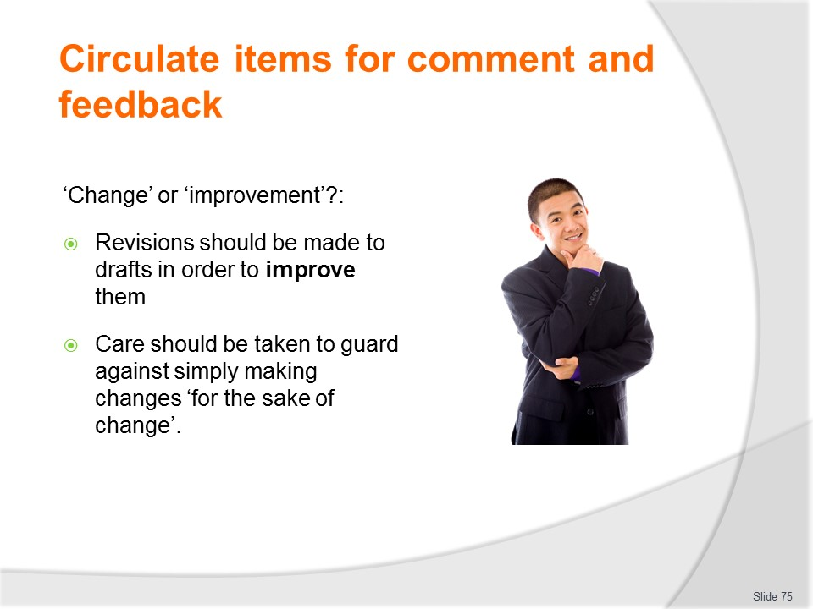
Slide No | Trainer Notes
Trainer stresses it is important to understand whenever materials are circulated to others for their comment or feedback there will invariably be comment or feedback.
- The problem is not all comment or feedback will result in improvement to what was originally prepared.
- Many comments are simply ‘changes’ which do nothing to genuinely improve the end product and it is improvement to the final item that should be the guiding principle by which all contributions are made.
- Change just for the sake of change should be ignored and avoided.

Slide
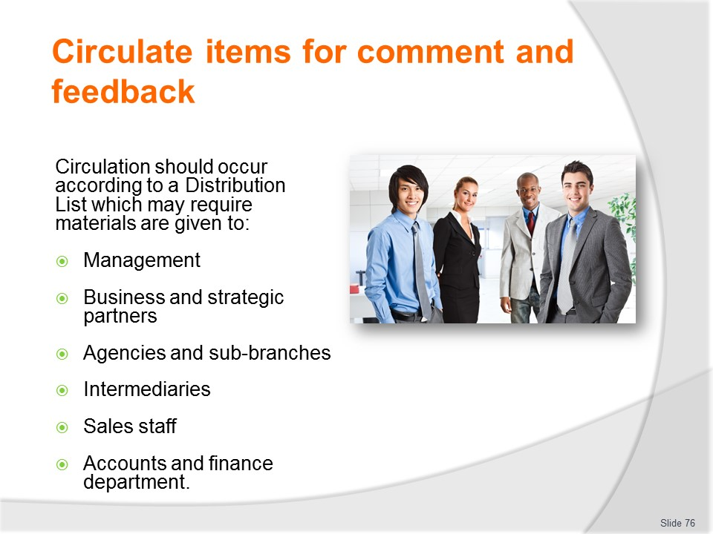
Slide No | Trainer Notes
Trainer notes the draft materials (which should have been proof read) should be circulated to designated personnel as specified by a ‘Distribution List’ for these materials. This Distribution List can vary over time and change depending on the content and focus of various marketing items but will frequently contain require circulation of items to the following:
- Management
- Business and strategic partners
- Agencies and sub-branches
- Intermediaries who will be involved in promoting/selling the product/service being featured
- Sales staff within the organisation
- Accounts and financial department.

Slide
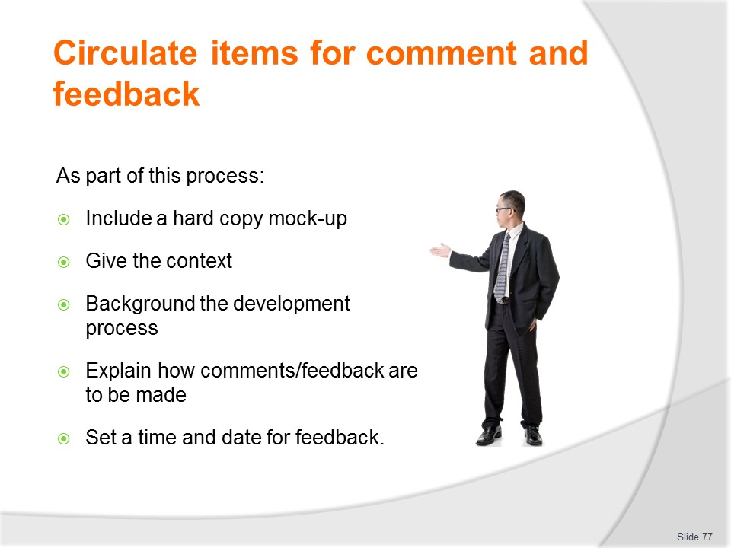
Slide No | Trainer Notes
Trainer highlights when forwarding these items for comment it is necessary to:
- Provide a hard copy mock-up – so readers get a genuine feel for the ‘real thing’ rather than asking them to provide feedback on an electronic /soft copy version.
- Nothing replaces the presence of an actual document/item to provide realism and generate responses
- Give the context for the item – that is:
- Advise those on the List of the focus and intent of the sales/marketing campaign that the item is part of
- Identify the target market/s
- Tell them of the objectives and targets it is hoped will be achieved
- Give them relevant start and finish dates for promotions
- Explain when, how and where the item will be used as a marketing tool
- Indicate the costs involved in relation to development/production of the item and other associated costs (which will differ according to the type of item but may [for example] include distribution costs, cost of buying advertising space)
- Background the development process – by:
- Giving the rationale behind the item and/or the content
- Naming those involved in the development process
- Referencing research undertaken which underpins the tactics/content of the item
- Explain how comments need to be made – for example:
- “Mark-up the included hard copy”
- “Send suggestions for change by email to me by 4:00PM on XX/XX/2017”
- “Attend the Marketing meeting at 2:30 XX/XX/2017 in the Board Room to provide your feedback”
- Set a time and date for comments/feedback to be returned – never leave the time/date open-ended. People always perform better when given a deadline to meet!

Slide
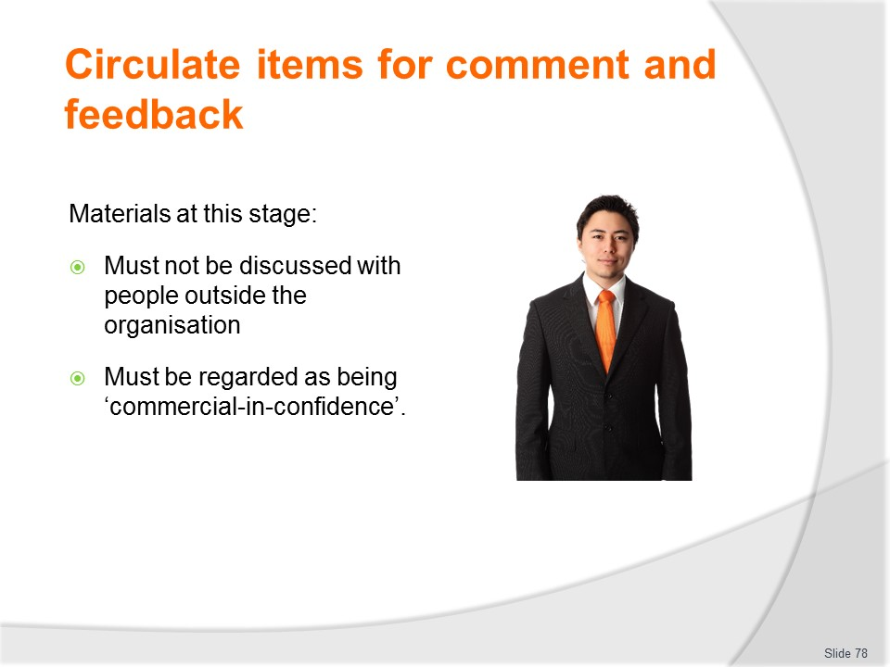
Slide No | Trainer Notes
Trainer highlights it needs to be stressed:
- That at this stage most of the details contained in these marketing materials are deemed to be commercial-in-confidence.
- This means they are private/secret and should not be revealed to anyone outside the organisation/outside the Distribution List.
- While the marketing materials/items will eventually be released to the public, at this point they are commercial-in-confidence and it is vital to remember this.

Slide
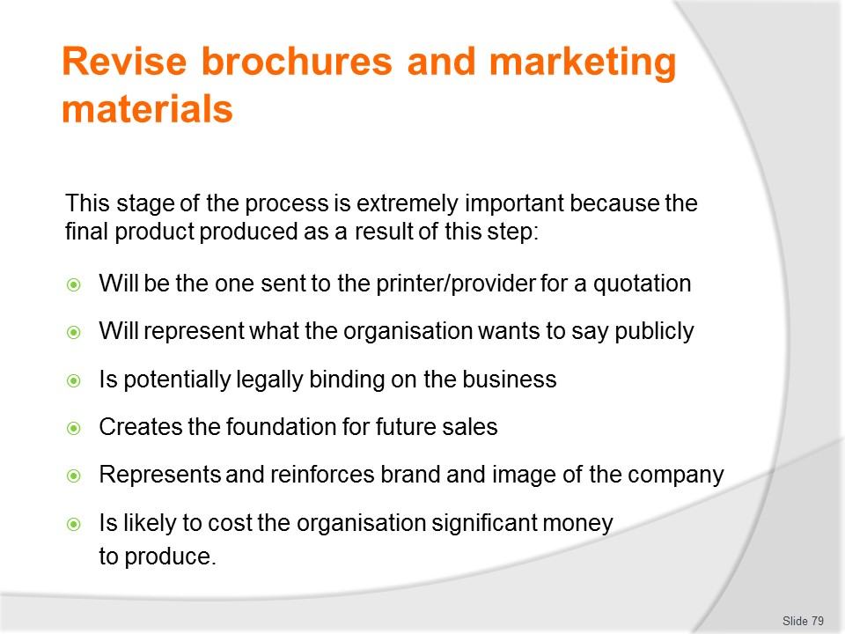
Slide No | Trainer Notes
Trainer explains this stage of the process is extremely important because the final product produced as a result of this step:
- Will be the one sent to the printer/provider for a quotation
- Will represent what the organisation wants to say publicly to its various target markets
- Is potentially legally binding on the business
- Creates the foundation for future sales
- Represents and reinforces the brand and image of the company
- Is likely to cost the organisation significant money to produce – so it needs to be right.

Slide
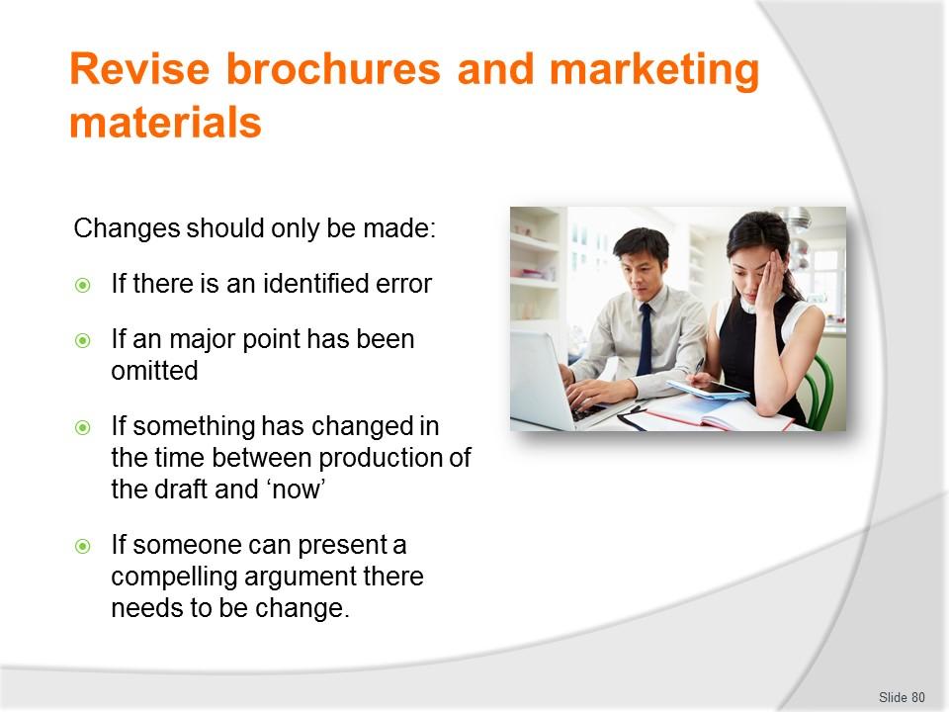
Slide No | Trainer Notes
Trainer explains that given the production of the original item is the result of much thought and deliberation, alterations should only be made:
- If there is an identified error – for example, in terms of:
- Costs, prices, dates, times
- Destinations, activities, inclusions
- Facts and figures, advice and information provided
- If an major point has been omitted – which may relate to:
- How to make a booking or the need to pay a deposit
- Limited vacancies/opportunities/seats
- A piece of legal advice/information
- A unique/important selling point
- If something has changed in the time between production of the draft and ‘now’ – such as:
- A new tax has been introduced
- The tax rate for a service has changed
- Legislation impacting the product/service has been introduced or amended
- Political or other factors have arisen which impact the trip/tour/product/service
- If someone can present a compelling argument there needs to be change – which can be based on factors such as.
- New market research findings
- New information about what the opposition are doing in relation to their promotion/marketing
- Emergence of a new market.

Slide
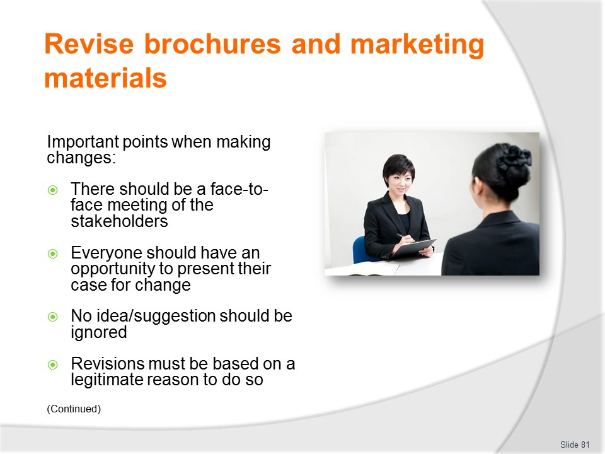
Slide No | Trainer Notes
Trainer identifies the following are essentials when revising materials:
- There should be a face-to-face meeting of the stakeholders – this is the best way to deal with this stage of proceedings
- Everyone should have an opportunity to present their case for change – and explain, defend and justify it
- No idea/suggestion should be ignored – this does not mean all ideas have to be accepted; it just means if someone believes they have a valid point to raise it should (at least) be aired and listened to even if it is subsequently dismissed

Slide
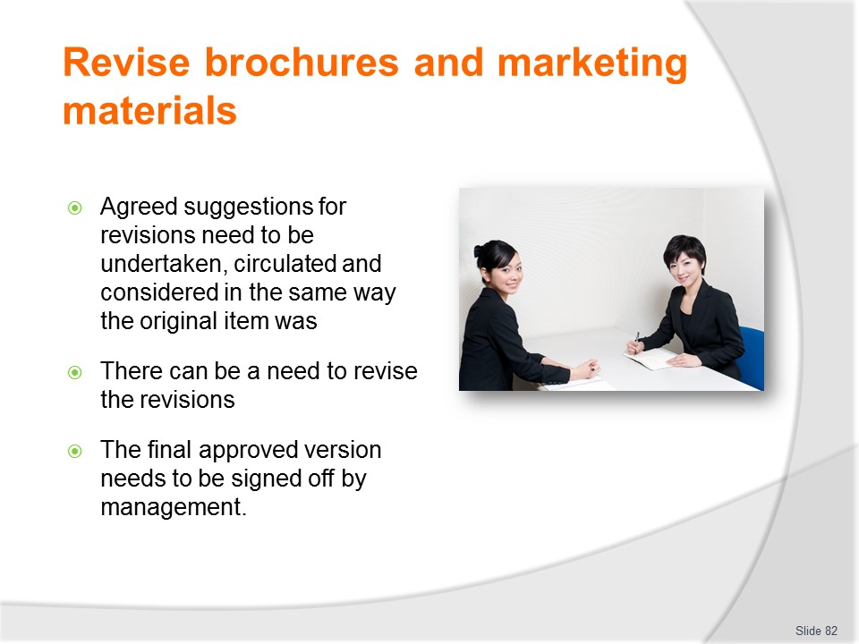
Slide No | Trainer Notes
Trainer continues identifying essentials when revising materials:
- Agreed suggestions for revisions need to be undertaken, circulated and considered in the same way the original item was – there needs to be another ‘review’ process of the revised draft material/item
- There can be a need to revise the revisions – there is no guarantee the revised version will be the final version: there can be a need for several draft versions to be created before the approved final version is developed
- The final approved version needs to be signed off by management – as authorising the item for further action/production and release.

Slide
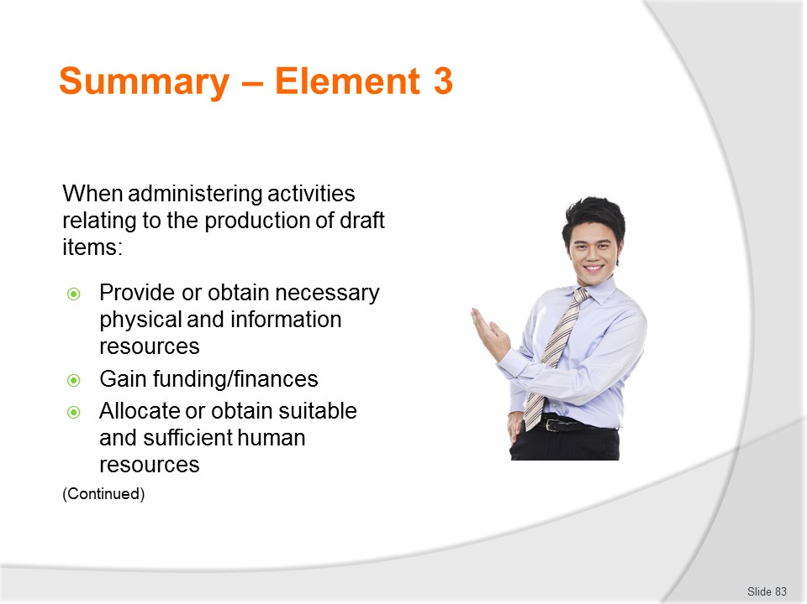
Slide No | Trainer Notes
 | Trainer provides a recap of the Element asking questions to check trainee understanding and responding to questions from trainees, as required.

Slide
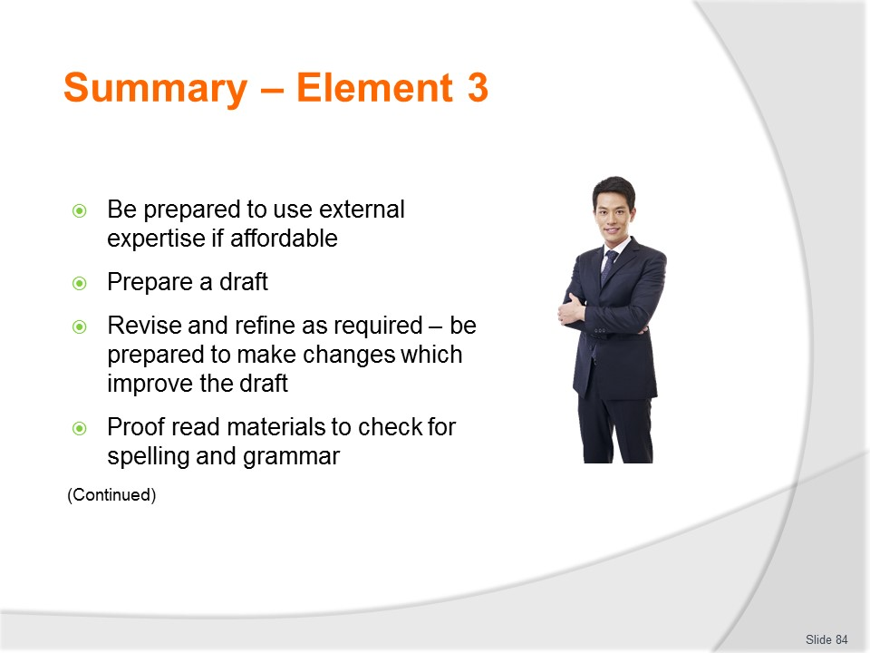
Slide No | Trainer Notes
 | Trainer provides a recap of the Element asking questions to check trainee understanding and responding to questions from trainees, as required.

Slide
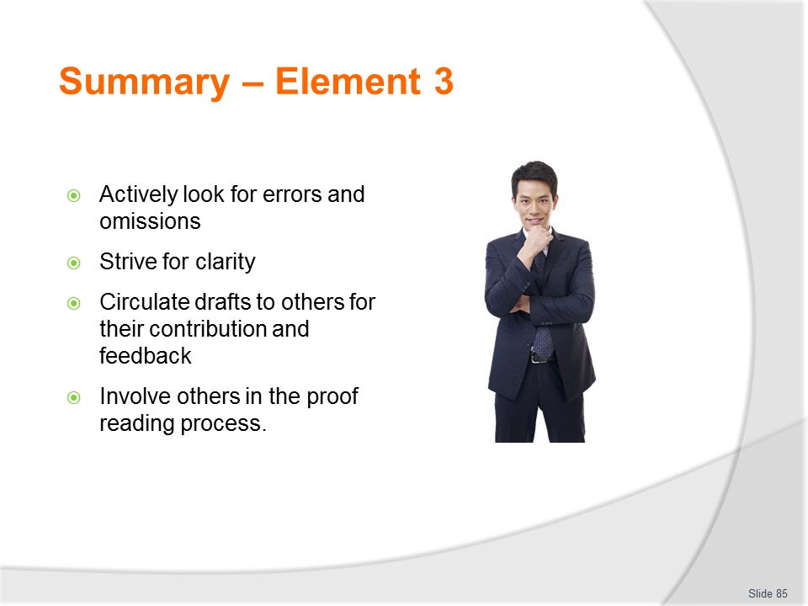
Slide No | Trainer Notes
 | Trainer provides a recap of the Element asking questions to check trainee understanding and responding to questions from trainees, as required.

Slide
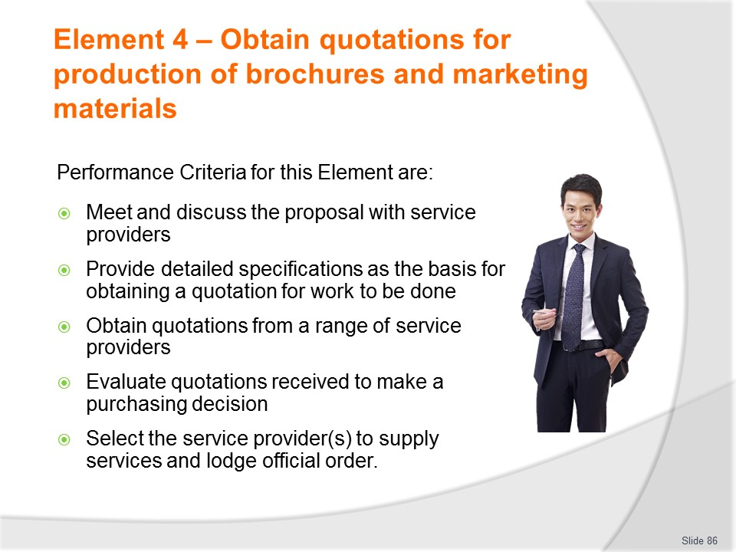
Slide No | Trainer Notes
Trainer identifies for trainees the Performance Criteria for this Element, as listed on the slide.
Class Activity – General Discussion
Trainer leads a general class discussion by asking questions such as:
- What might be included in specifications of work to be done in relation to the production of brochures and marketing materials?
- What are quotations?
- Why are they obtained?
- How are they obtained?

Slide
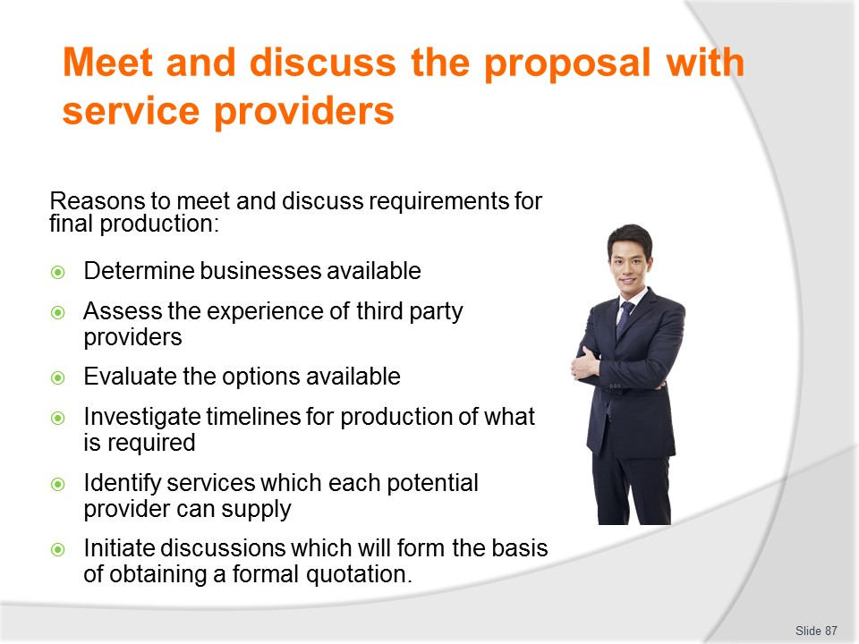
Slide No | Trainer Notes
Trainers states there is a need to meet and discuss the requirements for the final production of brochures and marketing materials with providers in order to:
- Determine who/which businesses are available to provide the goods and services required
- Assess the experience of third party providers in producing what is needed for other similar organisations
- Evaluate the options available to the organisation – the options may be local or international and there may be an internal/organisational requirement to focus on the use of (only) ‘preferred providers.
- Investigate the timelines applicable to the production of what is required
- Identify specifically the particular services which each potential provider can supply
- Initiate discussions which will form the basis of obtaining a formal quotation for the work to be done – see next section.

Slide
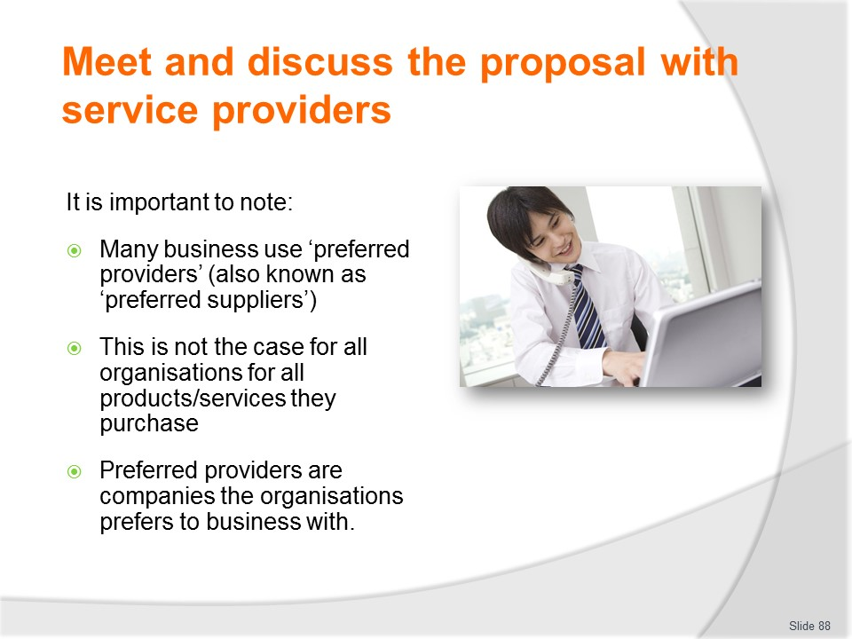
Slide No | Trainer Notes
Trainer explains:
- Many (but certainly not all) organisations have a ‘preferred providers’ (or ‘preferred suppliers’) list
- Companies on this list are providers the organisation prefers to do business with and the expectation is these are the businesses to be dealt with when producing marketing brochures/materials.

Slide
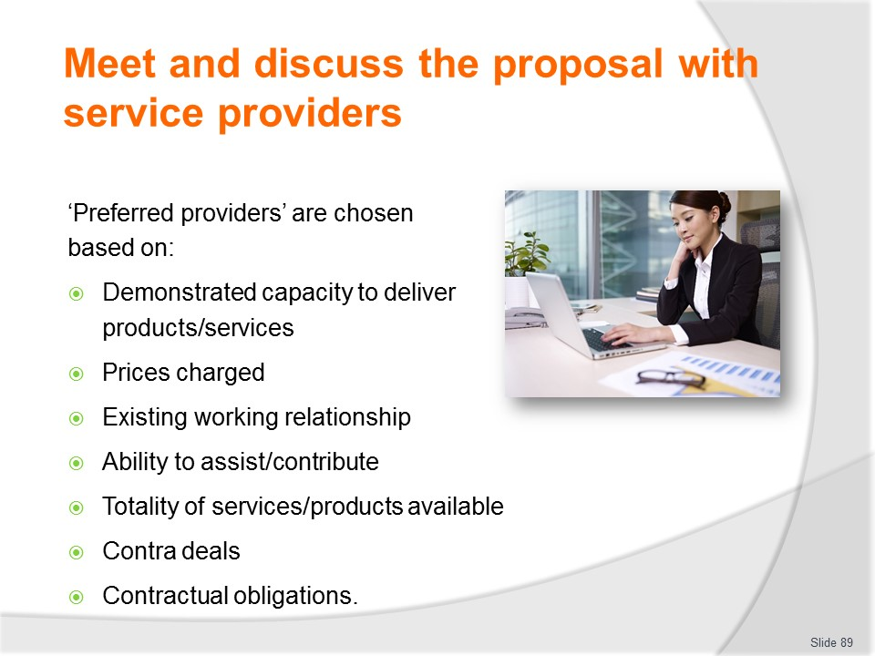
Slide No | Trainer Notes
Trainer states business on a preferred providers list have been chosen to be on the list as a result of various reasons such as:
- Their previous demonstrated ability to produce satisfactory work for the organisation
- Their capacity to quote good prices
- Their willingness to work with the organisation to produce what is required and meet imposed deadlines
- Their ability to provide assistance in the development and/or post-production phases for brochures and other materials (such as distribution; securing advertising space or ‘exposure’)
- Totality of services included in/as part of the quotation
- Contra deals established by the business owner
- Obligations imposed on the organisation by way of other contracts the business has entered into – which may oblige the company to use nominated businesses for certain services.

Slide
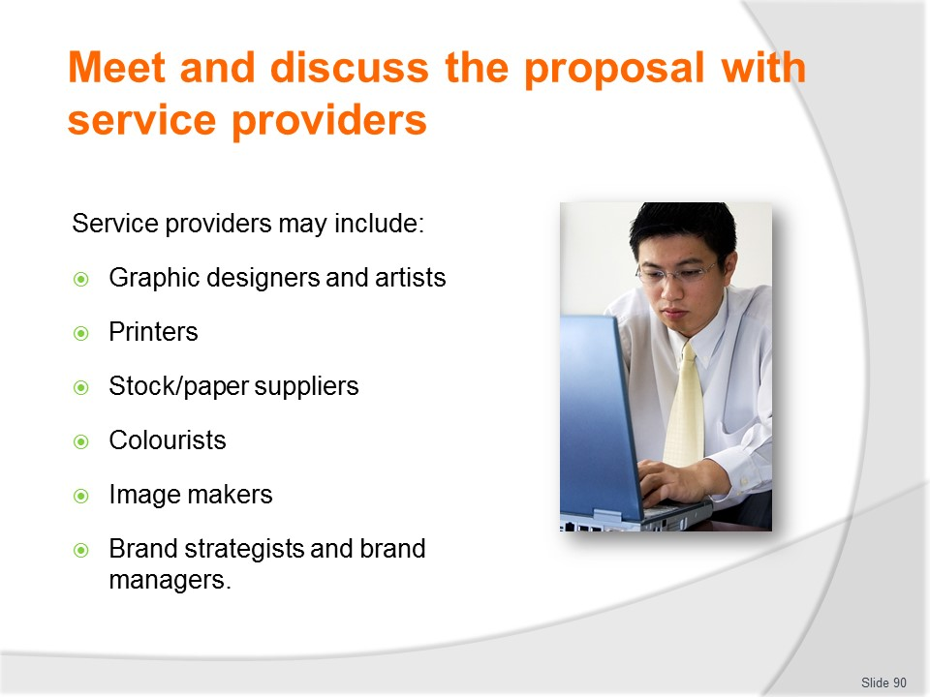
Slide No | Trainer Notes
Trainer identifies organisations who may be involved in this stage of the process there can be a need to consult internally and/or externally with:
- Graphic artists
- Graphic designers
- Printers
- Stock/paper suppliers
- Colourists/colour coordinators
- Image makers/consultants
- Brand strategists
- Brand managers.
Classroom Activity -= Guest Speakers
Trainer arranges for a selection of the service providers, identified on the slide, to attend and discuss the services they can provide in relation to the production of brochures and marketing materials.

Slide
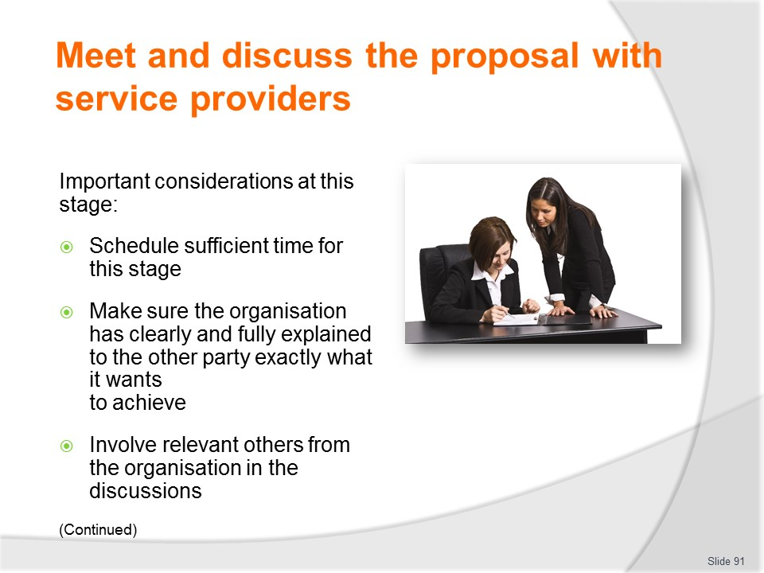
Slide No | Trainer Notes
Trainer advises important considerations at this stage are to:
- Schedule sufficient time for this stage of the operation – it is an essential aspect of what is occurring and merits sufficient time
- Make sure the organisation has clearly and fully explained to the other party exactly what it wants to achieve – there needs to be full disclosure about all relevant factors (such as but not limited to target market/s; objectives and goals; sales targets’ budget)
- Involve relevant others from the organisation in the discussions – so they are aware of what is taking place and the options being generated/sourced for the project

Slide
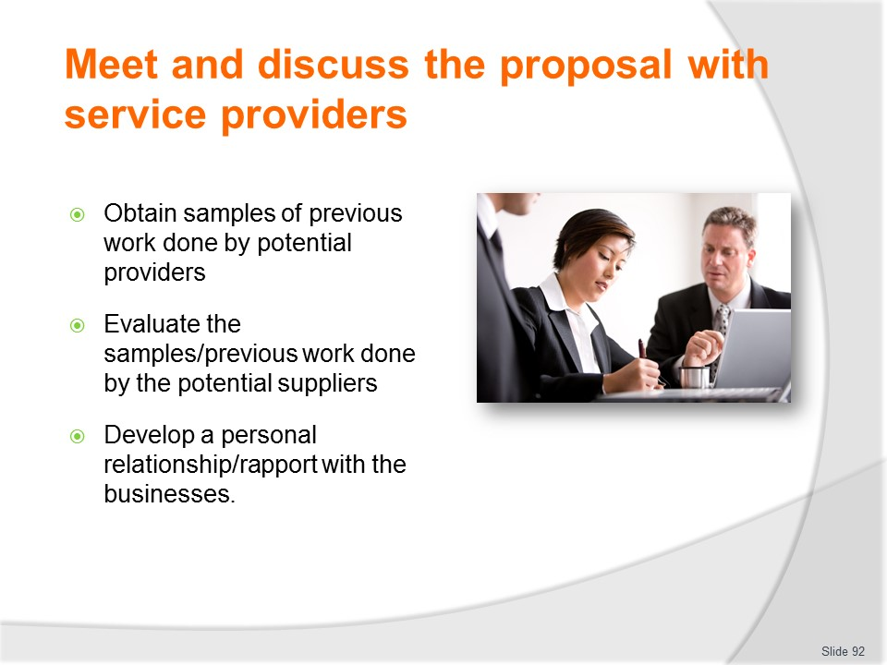
Slide No | Trainer Notes
Trainer continues advising important considerations at this stage are to:
- Obtain samples of previous work done by potential providers – it is always a good idea to select possible providers from organisations who have demonstrated experience and a successful track-record/history in the same market/industry/sector
- Evaluate the samples/previous work done by the potential suppliers – to assess how good it is and to check the ‘actual’ items meet the stated promises made by the company
- Develop a personal relationship/rapport with the businesses – as this tends to elicit more cooperation and commitment to the job.

Slide
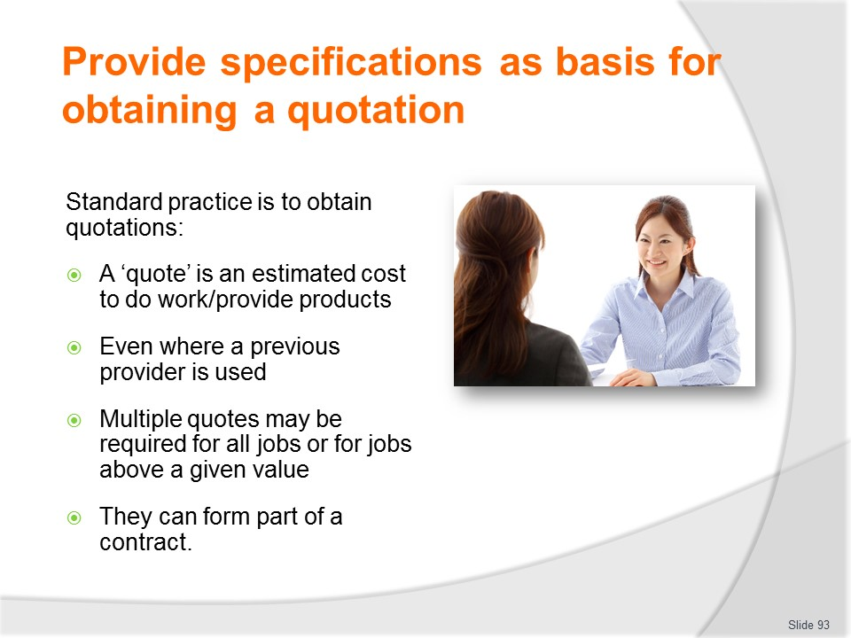
Slide No | Trainer Notes
Trainer advises before committing to the printing/production of brochures and marketing materials, it is standard practice to obtain a quotation.
- A quotation (or ‘quote’) is an estimated cost provided by the supplier for the items ordered.
- It may be required even where previous successful business has been transacted with the provider.
- Multiple quotations may be required for jobs over a set value – internal company policies or management preferences will determine what applies in this regard.
- A quote is also needed because it forms an important part of the contract between the organisation and the printer/provider.

Slide
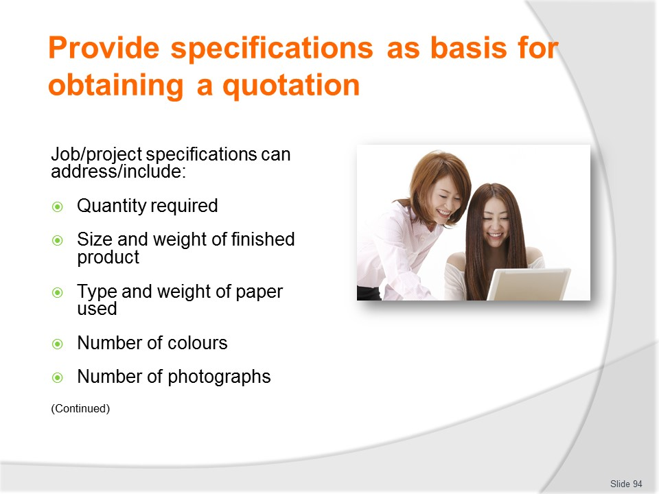
Slide No | Trainer Notes
Trainer discusses provision of specifications observing to obtain a quotation there is a need to provide the third party provider with a range of detailed information called ‘project/job specifications’ which can cover:
- Quantity required
- Size and weight of finished brochure
- Type or weight of paper to be used
- Number of colours
- Number of photographs.

Slide
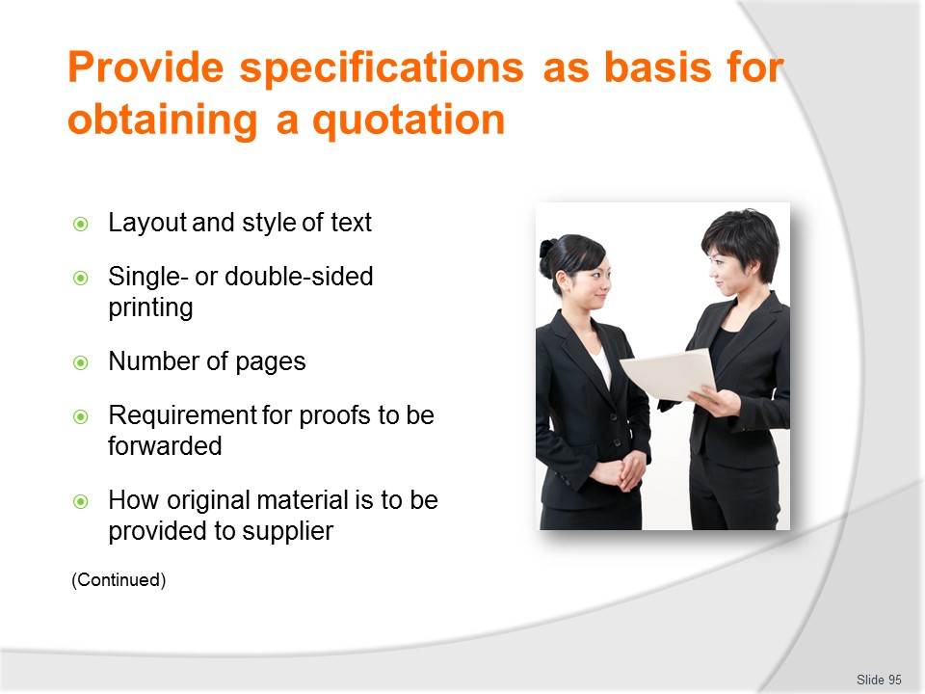
Slide No | Trainer Notes
Trainer continues discussing contents of specifications:
- Layout and style of text
- Whether brochure is to be printed on one or both sides
- Number of pages
- Requirement for proofs to be forwarded – this should be a mandatory and non-negotiable requirement
- How the original material is going to be provided to the printer/producer– for example, on disk or in hard (mock-up) copy form.

Slide
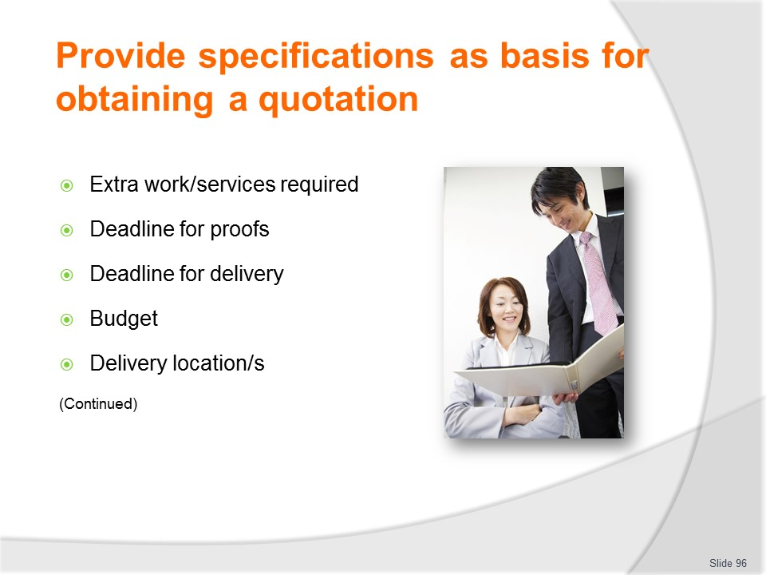
Slide No | Trainer Notes
Trainer continues discussing contents of specifications:
- Additional requirements required for the job – such as finishing and/or distribution
- Deadline for delivery of proofs
- Deadline for delivery of finished product
- Budget limitations/parameters
- Delivery location/s for drafts/proofs and finished products.

Slide
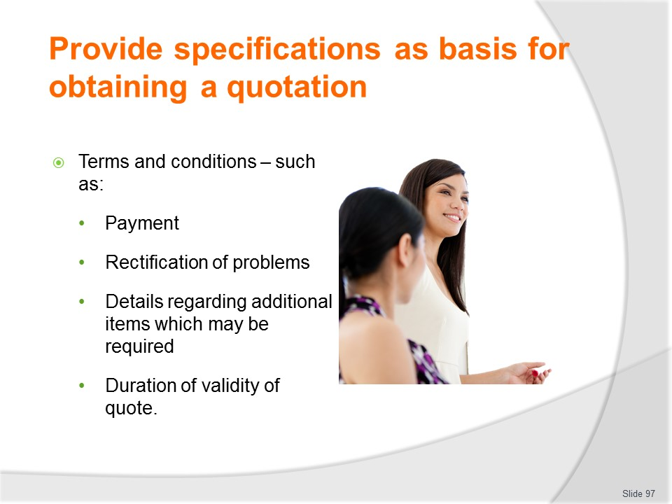
Slide No | Trainer Notes
Trainer continues discussing contents of specifications:
- Terms and conditions – relating to issues such as:
- Payment
- Rectification/redressing of problems.
- Production of and prices for additional materials if more items are subsequently required
- Time period for which the quotation is to be valid.

Slide
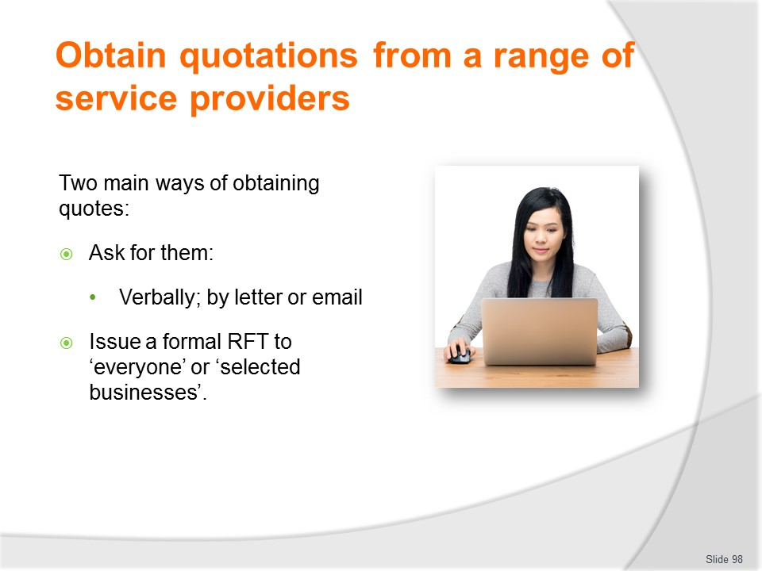
Slide No | Trainer Notes
Trainer explains quotes are commonly obtained in one of the following ways:
- Asking the providers who have already been contacted and with whom the work has already been discussed to submit a quote based on the specifications developed (as described). This request for a quotation may be made through:
- A formal letter requesting a quote
- An email
- An informal telephone call
- An in-person face-to-face request
- Offering a tender and releasing an RFT document – this offer asks ‘interested parties/providers’ to submit tender/quotes for the work and contains the details of the specifications for the work required. The RFT document may be:
- Circulated generally
- Targeted only to certain organisations the company wishes to do business with.
Classroom Activity (1) – Handout
Trainer distributes and discusses a sample RFT document.
Classroom Activity (2) – Internet Research
Trainer facilitates online research and discussion relating to relevant sites such as:
http://www.bestprintingonline.com/brochure-printing-quote.asp

Slide
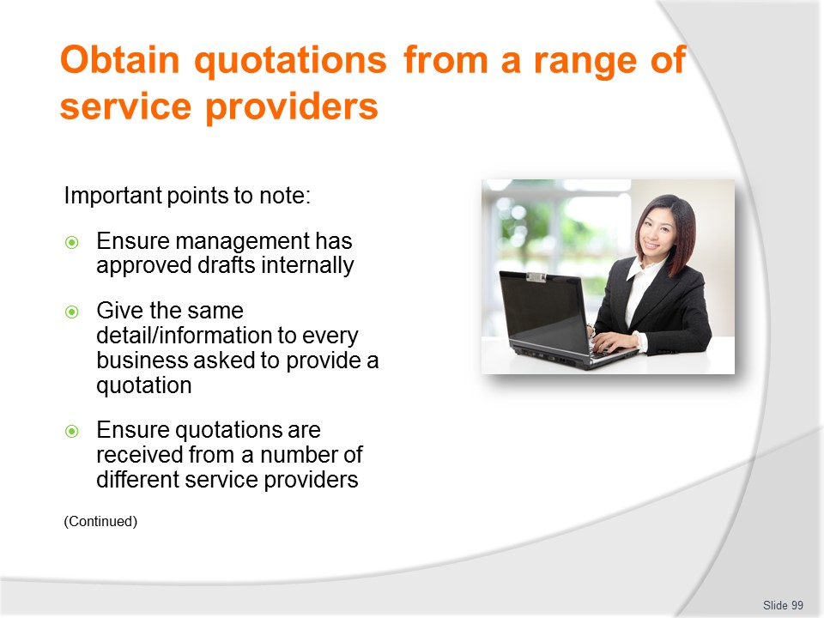
Slide No | Trainer Notes
Trainer indicates as part of the process of obtaining quotations:
- Ensure management has approved drafts internally for this stage of the process – make sure they have agreed/signed off on what is required and what is to be produced
- Give the same detail/information to every business asked to provide a quotation – this applies to:
- Provision of initial information/specifications
- Additional information supplied as a result (for example) of a query by one potential provider
- Ensure quotations are received from a number of different service providers – in keeping with internal requirements to obtain a variety of quotations prior to making a purchasing decision.

Slide
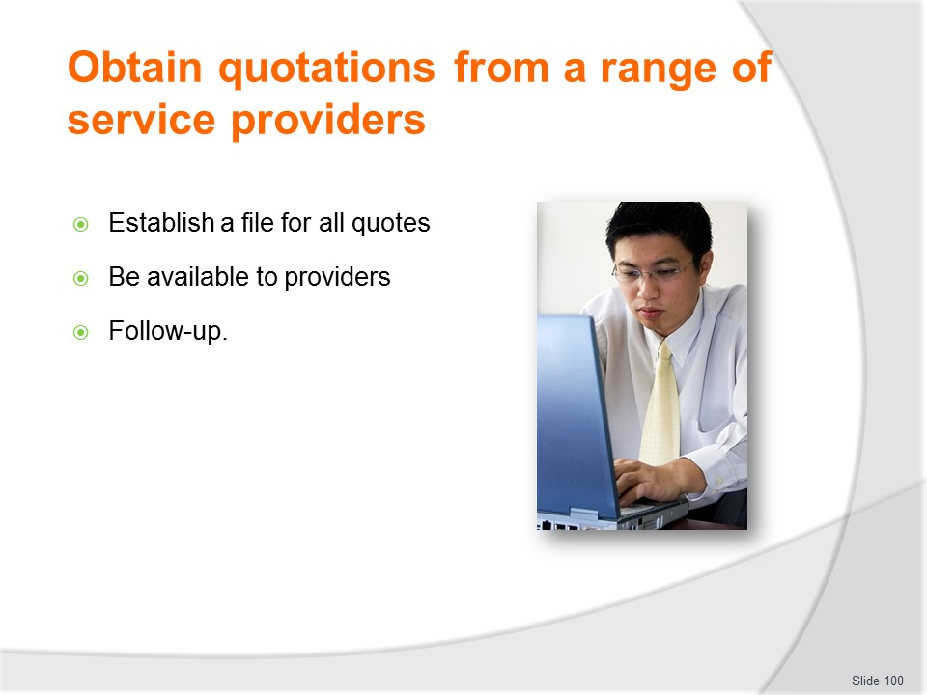
Slide No | Trainer Notes
Trainer continues highlighting important aspects to note:
- Establish a file for all quotes – so they do not get lost and are readily available for reference and comparison purposes
- Be available to providers – in order to provide further information to them and/or clarify issues as/if required
- Follow-up – as/if required. Be prepared to make a telephone call of contact a business that has been asked to provide a quote if a quotation has not been received from them.
Classroom Activity – Guest Speaker
Trainer arranges for an experienced industry person to attend and discuss what they do to obtain quotes for service providers.

Slide
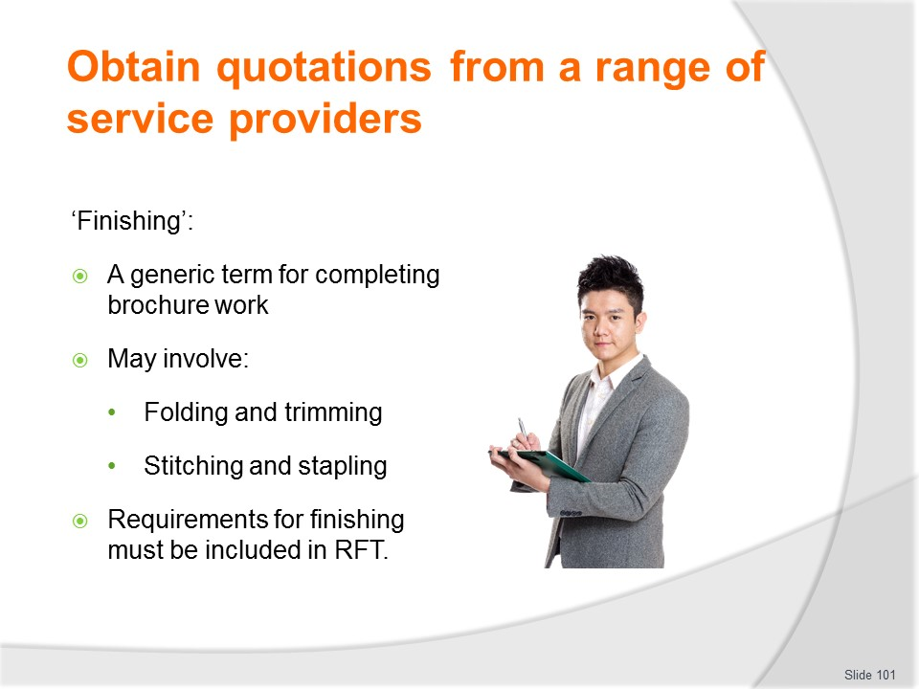
Slide No | Trainer Notes
Trainer explains ‘Finishing’ may be required for certain marketing materials/brochures and not for others.
- Finishing is a generic term referring to work the producer may need to undertake to completely ‘finish’ the product/item.
- Finishing highlights that simply printing/producing a page/pages of an item is not of itself sufficient to complete the job.
- In practice ‘finishing’ of brochures can involve:
- Folding
- Trimming
- Stitching
- Stapling.
- It is important to ensure specifications for what is required in this regard is included in the RFT as producers/printers will seek to levy additional charges for each of these tasks.
Classroom Activity – Guest Speaker
Trainer arranges for printer/service provider to attend and:
- What they need (information and other details) in order to provide a realistic quote for brochures and marketing materials
- Describe the elements and need for ‘finishing’.

Slide
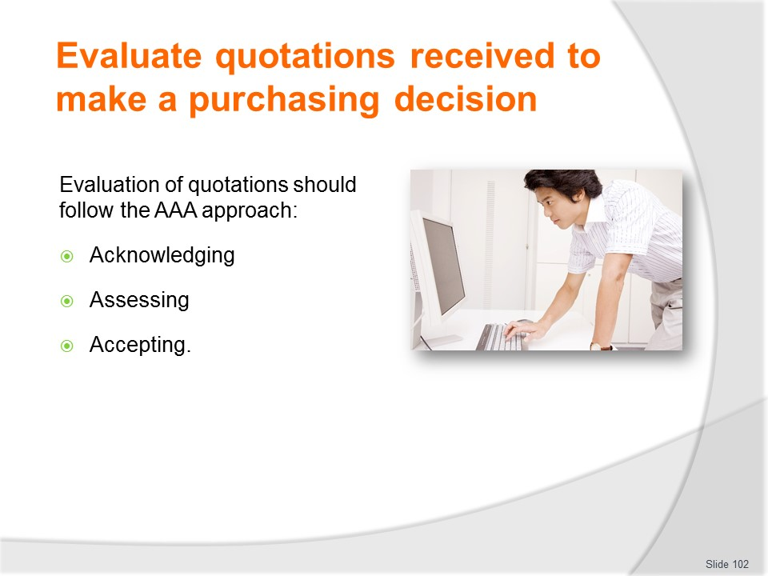
Slide No | Trainer Notes
Trainer presents the evaluation of quotations can be seen as AAA:
- Acknowledging
- Assessing
- Accepting – covered in the next section.

Slide
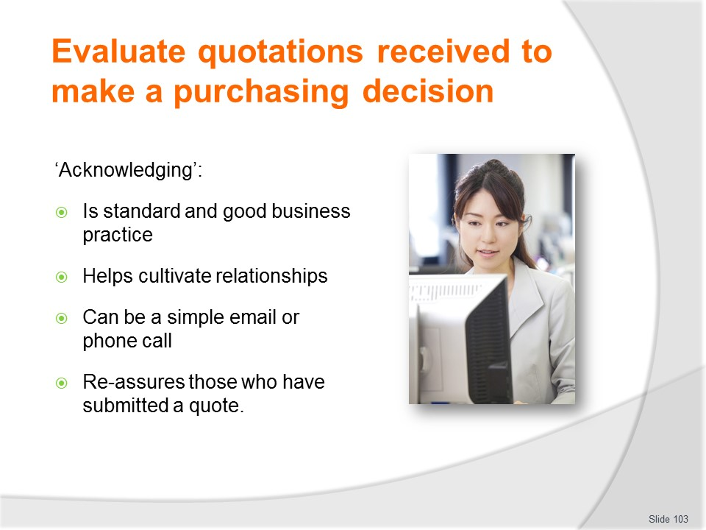
Slide No | Trainer Notes
Trainer discusses Acknowledging stating:
- It should be standard practice to acknowledge receipt of all quotations received. This:
- Is polite
- Is good business practice
- Helps develop the relationship already established with the provider.
- Acknowledging may simply take the form of:
- An email to show their email has been received – even a ‘Read Report’ response can reassure potential suppliers their quote has (at least) been received
- A phone call to say the quote has arrived.

Slide
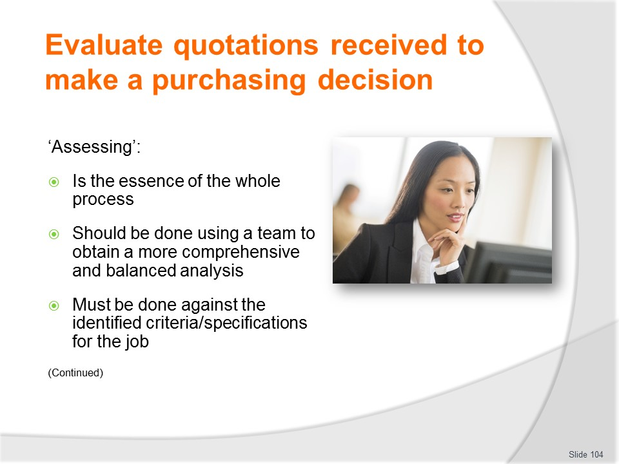
Slide No | Trainer Notes
Trainer discusses ‘Assessing’ saying this is the crux of the process and should involve:
- Developing a selection team who will evaluate all quotes received – this team should comprise a representative from all stakeholders and meet formally to discuss and analyse all submissions received. Using a team approach:
- Relieves one person of the responsibility of making a decisions
- Keeps people involved and aware of the development process
- Ensures different points of views and opinions are factored into the final decision about which provider to use
- Achieves a more balanced and comprehensive review of all proposals
- Assessing quotations against identified criteria for the production of items as contained in the specifications supplied – just to check the provider is able to provide and is quoting on the requirements for the job.
- Never assume the provider:
- Has interpreted the requirements as intended
- Is quoting on what was required
- Can deliver what is needed.

Slide
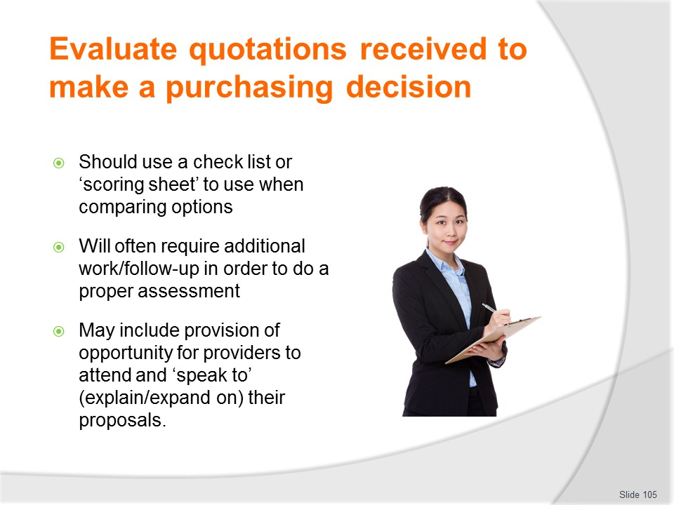
Slide No | Trainer Notes
Trainer continues discussing ‘Assessing’ quotations:
- Generating a check list or ‘scoring sheet’ to use when comparing options – so distinct and agreed topics (which commonly relate to/reflect the initial specifications) can be determined and analysis/assessment can be made on an objective basis for each quote
- Following-up as required – this can entail:
- Asking a provider for more information
- Getting a provider to clarify a term/part of their quote
- Obtaining more examples of their work
- Enquiring if a company who has not yet submitted a quote is actually going to forward one (especially if they were a favoured option)
- Providing an opportunity for those who provided submissions to ‘speak to’ their proposals – in many cases a quotation on its own never gives the full picture about a job.
- There is often a need for the company by submitting the quote to attend and explain their submission, discuss their approach and illustrate their rationale: this session also allows questions to be asked and answered.

Slide
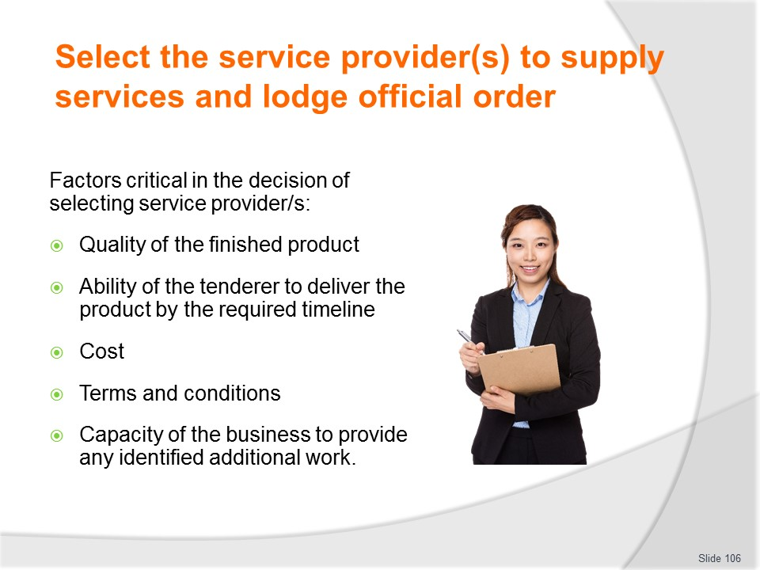
Slide No | Trainer Notes
Trainer highlights when a comprehensive and careful assessment of all quotations has been completed the successful tendered will be selected explaining factors which are critical in this decision relate directly to the specifications given to all companies who presented a tender – in essence final selection will be based on a combination of factors such as:
- Quality of the finished product
- Ability of the tenderer to deliver the product by the required timeline
- Cost
- Terms and conditions – such as:
- Amount of deposit (if any) required
- When first and/or final payment is required
- Guarantees of work quality
- Capacity of the business to provide any identified additional work (such as finishing, distribution, securing access to displays or gaining exposure to target markets).

Slide
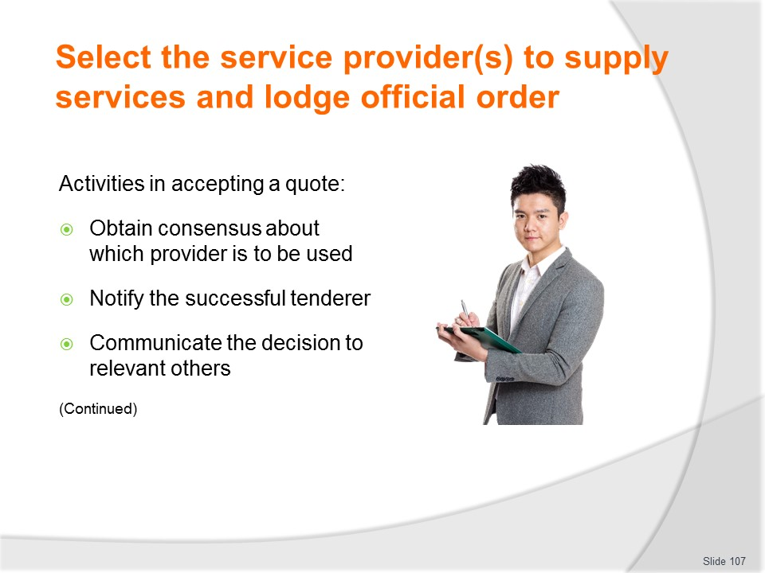
Slide No | Trainer Notes
Trainer presents activities involved in accepting a tender/quotation can include the following:
- Consensus agreement among selection team – as to:
- Who is the successful bidder
- Why they are being chosen
- Notifying the successful tenderer about the decision which has been made. The way this is done will depend on the existing relationship with the other business and the value of the work to be done. Notification may involve/require:
- A telephone call to advise them
- An email
- A formal meeting
- A handshake
- Raising of a Purchase Order for the work – see following slide
- Creation and signing of a legally binding contract.
- Communicating the decision to others – this will involve:
- Notifying other internal employees/personnel who were not part of the selection team
- Advising interested joint venture partners and other external stakeholders
- Internally – to relevant other personnel.

Slide
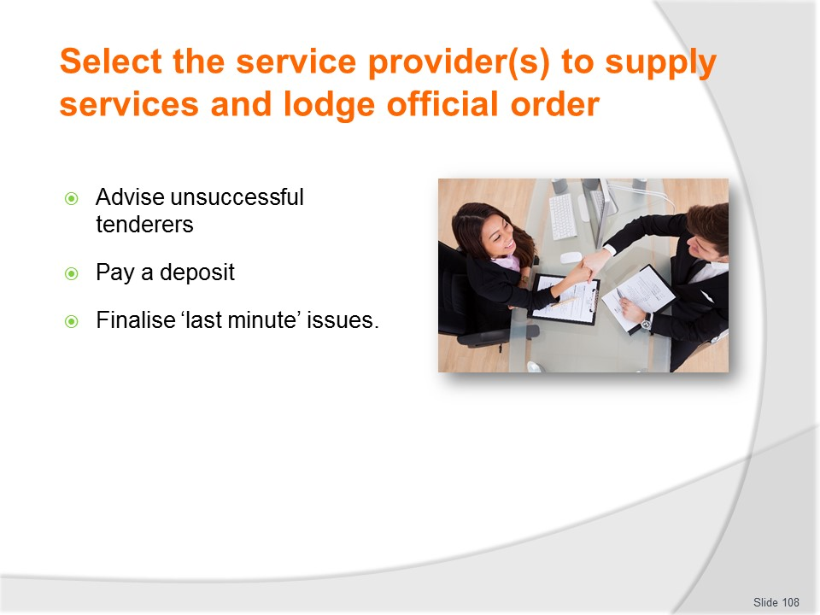
Slide No | Trainer Notes
Trainer continues presenting activities involved in accepting a tender/quotation:
- Advising the unsuccessful tenderers – this may involve:
- Thanking them for their interest – again, this is sound business practice
- Returning items forwarded as part of the submission process
- Explaining rationale for the decision – this can be a useful thing to do as it gives the businesses a better idea of what is needed should they elect to present future tender submissions
- Paying a deposit – this may be a requirement for some jobs and not for others.
- Different suppliers/providers have different requirements in this regard and their individual orientations are spelled out in their general/standing Terms and Conditions or in the terms and conditions for the individual job/contract.
- A percentage of the full price for the job is frequently used as the figure for a deposit with 10% being a commonly used figure.
- Finalising last-minute issues – even where a detailed analysis of various tenders has been carried out there are frequently last-minute details which need to be settled before the work can begin/be completed.
- This highlights many decisions made about the printed/producer to use:
- Are made before all final details are known
- Are often made on decisions other than the ‘final product’ which will be produced.

Slide
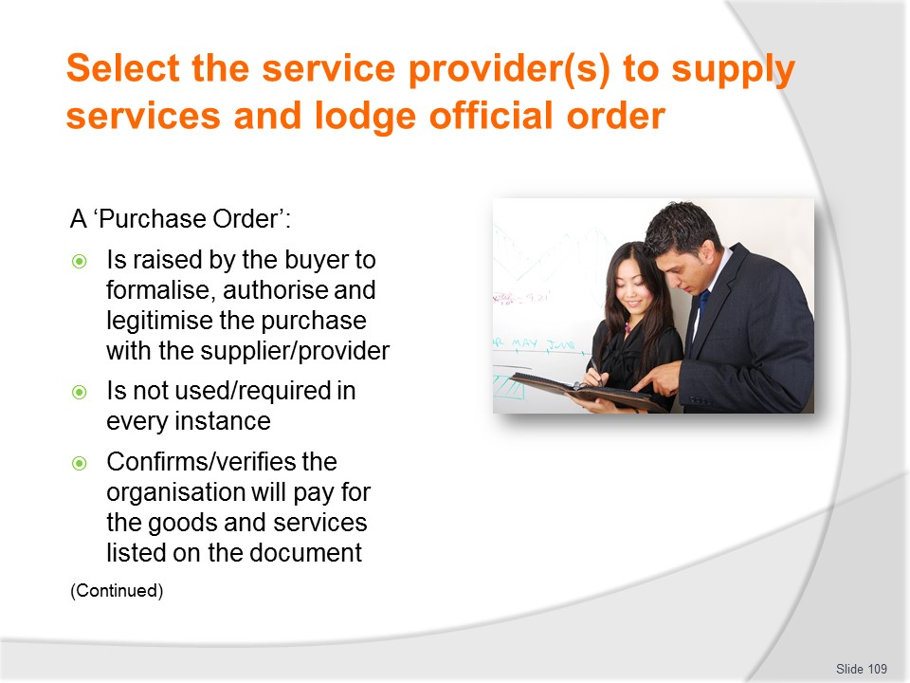
Slide No | Trainer Notes
Trainer explains role of Purchase Order stating:
- When the printer/supplier has been notified they have been awarded the job there may be a need to raise a Purchase Order
- Not all arrangements between organisations and providers will require a Purchase Order to be raised
- A Purchase Order is a document issued by the organisation and made out to the supplier authorising the supply of the products or services detailed in the document
- It confirms the organisation will pay the amount stated for the items listed.

Slide
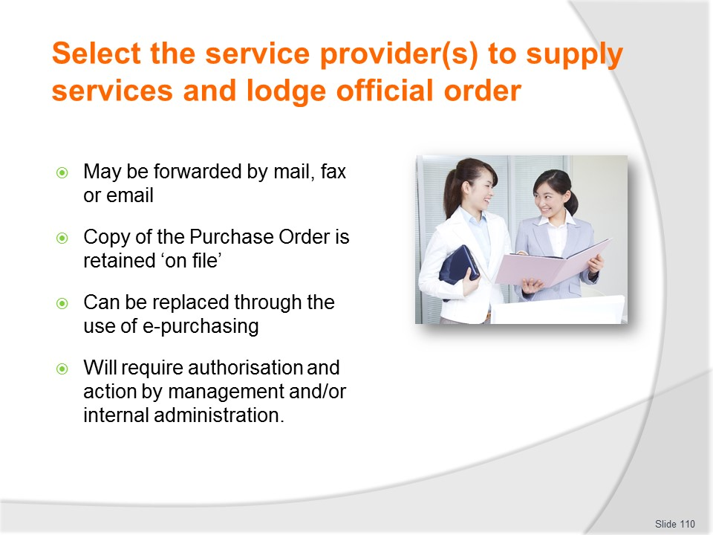
Slide No | Trainer Notes
Trainer provides more information on Purchase Orders stating:
- The Purchase Order may be forwarded to the supplier by mail, fax, or email.
- A copy of the Purchase Order will traditionally remain in the Purchase Order book to serve as reference for the business, or the original may be photocopied and placed in a file.
- It is also becoming more common today for purchasing with preferred suppliers to be carried out over the Internet, known as e-Purchasing.
- Raising a Purchase Order can require:
- Providing necessary details to the accounts or purchasing department
- Physically writing out the details of the purchase on a pro-forma Purchase Order document.

Slide
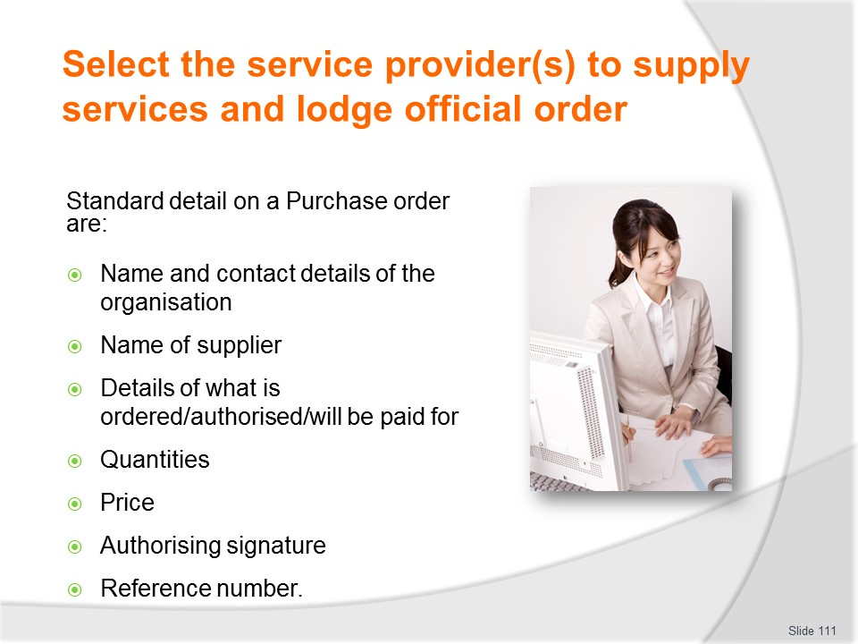
Slide No | Trainer Notes
Trainer explains content of Purchase Order as being:
- Name and contact details for the organisation buying the product/service
- Name of the supplier from whom the purchase is to be made
- Details of what is being ordered
- Quantities involved
- Price
- Signature of authorised representative/s from the organisation
- A number – for reference purposes.
Classroom Activity – Handout
Trainer distributes and discusses sample Purchase Order.

Slide
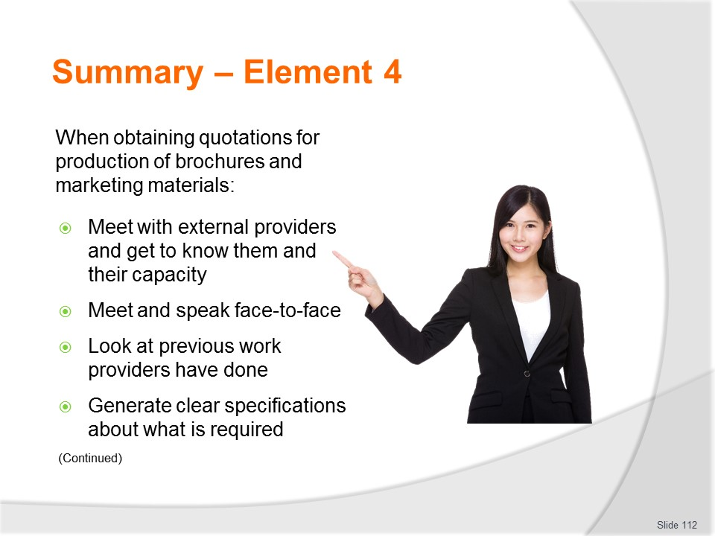
Slide No | Trainer Notes
 | Trainer provides a recap of the Element asking questions to check trainee understanding and responding to questions from trainees, as required.

Slide
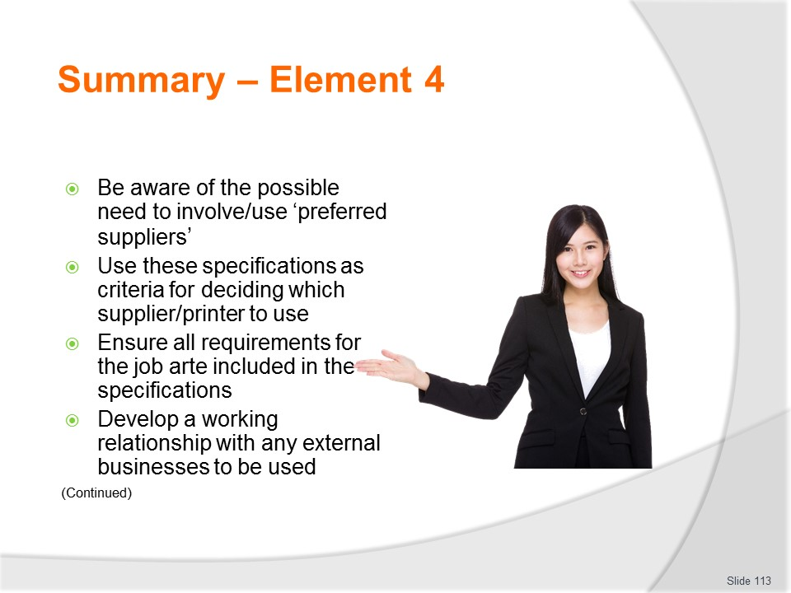
Slide No | Trainer Notes
 | Trainer provides a recap of the Element asking questions to check trainee understanding and responding to questions from trainees, as required.

Slide
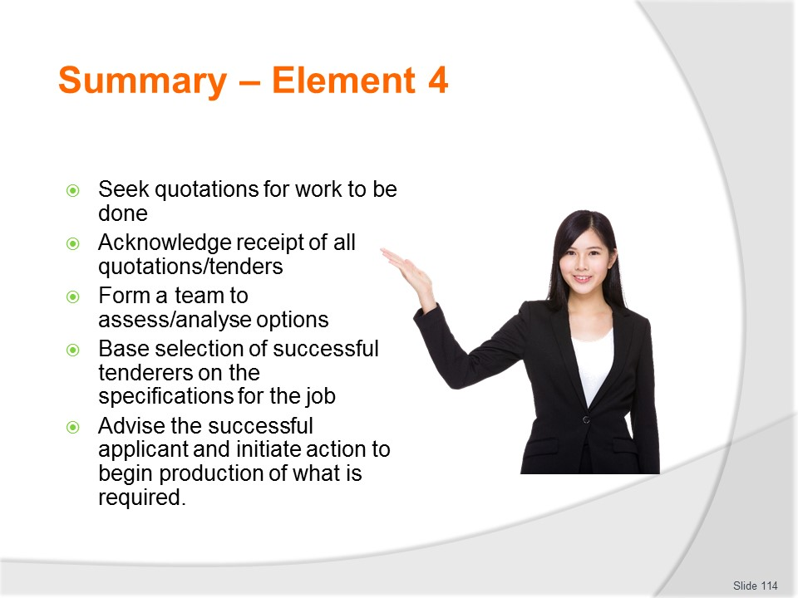
Slide No | Trainer Notes
 | Trainer provides a recap of the Element asking questions to check trainee understanding and responding to questions from trainees, as required.

Slide
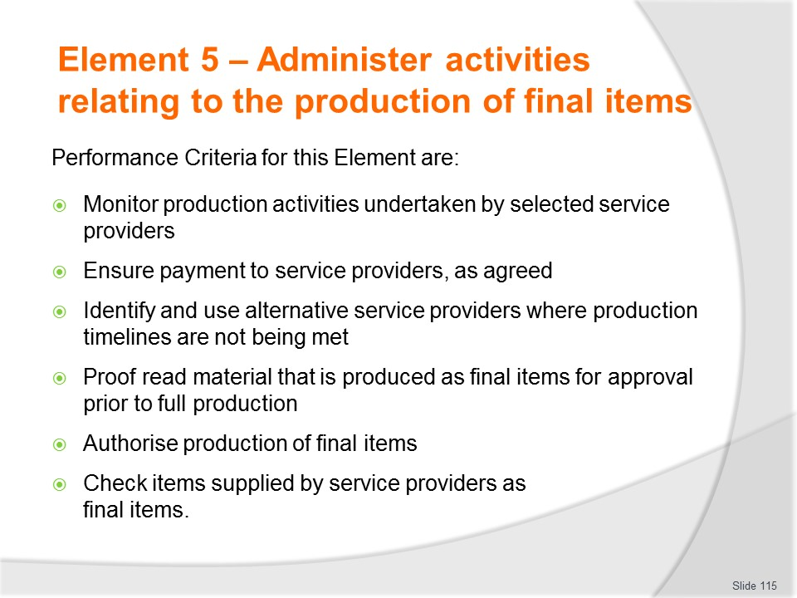
Slide No | Trainer Notes
Trainer identifies for trainees the Performance Criteria for this Element, as listed on the slide.
Class Activity – General Discussion
Trainer leads a general class discussion by asking questions such as:
- What activities might be involved in this phase of the process?
- Why are these activities important?
- Who may be involved?
- What is meant by ‘Plan B’?

Slide
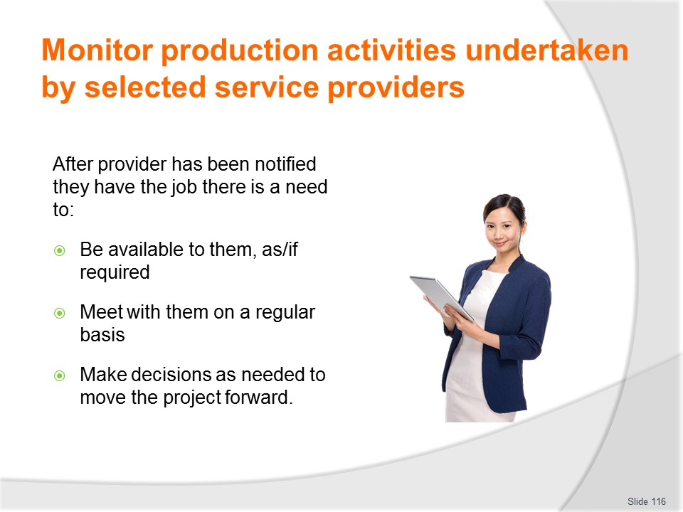
Slide No | Trainer Notes
Trainer indicates once the provider/printer has been informed they have secured the job (and supporting documentation/payments have been completed) there is commonly a need to:
- Be available as required – to:
- Answer questions about the project
- Provide direction or guidance in relation to matters raised
- Meet with service providers on a regular basis – this can be at their premises or elsewhere but these meetings are important to:
- Keep them focussed on delivering what has been promised/agreed
- Maintain their awareness deadlines agreed on remain important and necessary
- Enable emerging problems/issues to be addressed and resolved
- Cultivate a positive relationship.
- These meetings should be face-to-face as opposed to telephone meetings as it is harder for a provider to avoid questions and answer ‘difficult’ questions when talking in-person rather than over the phone.
- Make production-related decisions to move the project forward – as may be required for individual projects, for example:
- Decisions regarding production variations to product which may be required during the production phase
- Questions about revised deadlines – commonly relating to a need to a need to move ‘due by’ dates forward
- Requirements to alter initial quantities ordered – given this may be an upward or downward movement
- Decisions to alter copy – which can often relate to:
- Changes to dates, times and prices
- Inclusion alterations
- Need to produce the same thing (brochure or item) but in a different language
- Need to add supplementary services to the initial agreement/contract.

Slide
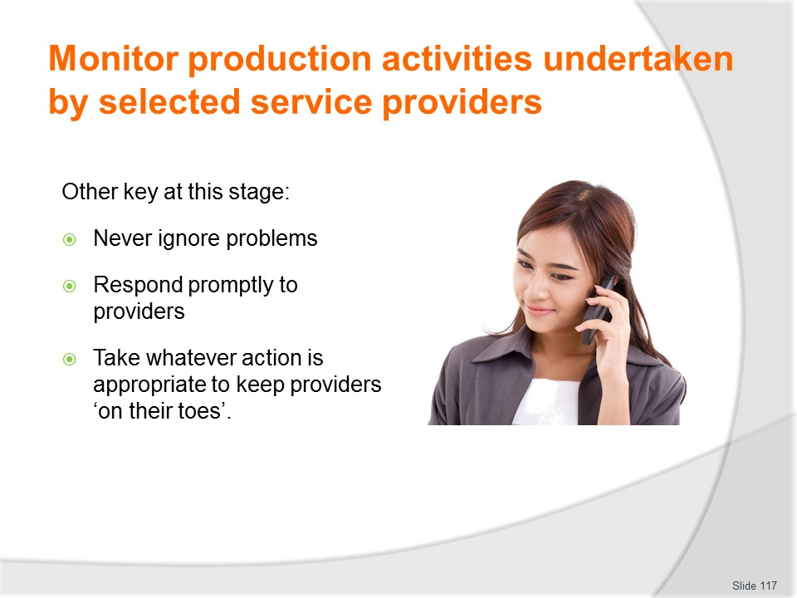
Slide No | Trainer Notes
Trainer presents key points to note at this stage of the process:
- Never ignore problems – as soon as an issue is identified (by either party) it must be addressed so it can be resolved.
- These problems tend not to resolve themselves – they have to be addressed, talked about and a plan of action determined for addressing whatever is causing the problem.
- It is worth bearing in mind few if any jobs of this nature exist in isolation from everything else.
- Respond promptly – to questions and issues raised by the printer.
- This helps indicate the urgency of the work/the need for the job to be completed by the promised date, and helps avoid giving the provider an ‘excuse’ for slow delivery.
- Keep providers on their toes – this revolves around keeping them accountable and means:
- Insisting they attend scheduled meetings with an account of what progress has been made since last meeting
- Obtaining proof materials as soon as they are ready
- Telling them action will be taken if they do not deliver on time and/or otherwise as required – this action may include:
- Taking legal action to recover damages
- Taking the business elsewhere to an alternate provider – see section 5.3
- Telling other organisations/industry groups about their failure to deliver.
Slide
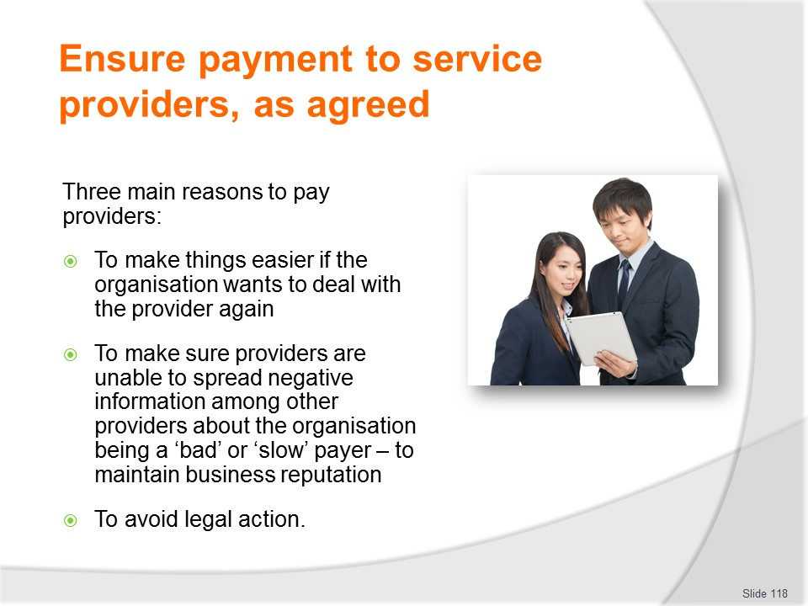
Slide No | Trainer Notes
Trainer emphasises the importance of paying providers and printers explaining there are three main reasons to pay these people:
- If the organisation wants to deal with them again it has to have developed a reputation as a ‘good payer’ – this means having in full and on time
- If they are not paid they will tell other providers/printers about the situation – and the reputation of the organisation will suffer as a consequence. It may even suffer to the extent no other business will want to deal with it.
- If they are not paid they may/will take legal action to recover the money they are owed – and the legal costs can add much more to what the organisation would have had to originally pay.

Slide

Slide No | Trainer Notes
Trainer stresses payment needs to be made:
- On or before the agreed date – there can be one or multiple dates for payment which need to be observed, for example:
- Date for payment of a nominated deposit – to show ‘good faith’ and an ability to pay
- Initial payment – this may be the first of several payment and is often a given percentage of the total job
- Progress payment/s – due at set times throughout the duration of an extended job
- Final payment – an end-of-job payment paid on completion of the work when the final product has been accepted and signed off on.
- For many small jobs a single payment is made and often required, say ‘within 14 days’, ‘within 30 days’ or otherwise according to the standard terms and conditions of the business.
- In the amount specified – this means:
- Amounts detailed and agreed to in a contract or other agreement must be paid without withholding any amount
- Allowable discounts may be deducted – these may be available (for instance):
- If early payment is made
- If the organisation belongs to a body/group that normally attracts an industry or other discount
- For repeat orders
- In the manner specified/agreed to – commonly local providers will pay in the currency of the home country and payment may be made in cash or by cheque.
- Foreign companies may have insisted payment is made in a stipulated currency.
- Other operators may require electronic payment (funds transfer) of some form.

Slide
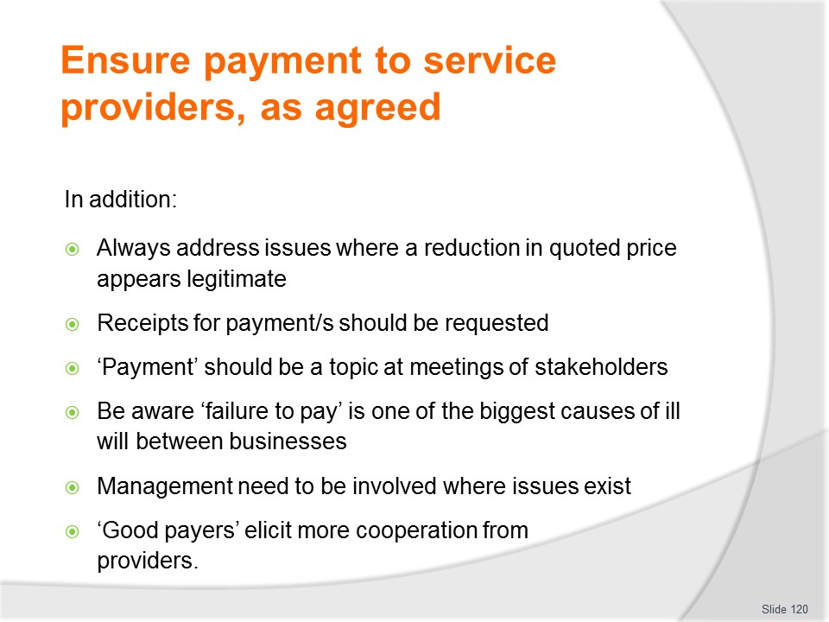
Slide No | Trainer Notes
Trainer adds it is also worthwhile noting:
- Matters where the organisation believes there should be a reduction in the quoted price (for example, due to lack of quality, mistakes, not meeting timelines) need to be raised with the supplier – it is never acceptable/sufficient to deduct an amount and tell the provider why this was done.
- The deduction needs to be discussed and an acceptable arrangement reached.
- Receipts should be requested and filed for all payments
- Payment should be raised as a topic in meetings – so providers have an opportunity to query what they have been paid and/or raise issues in relation to payment so they may be quickly addressed
- Failure to pay as agreed/promised/expected is one of the biggest causes of ill will among businesses – and has the potential to causes significant damage to business reputations
- Issues/problems relating to payment should be immediately forwarded to management for their attention
- An organisation that is a ‘good payer’ will elicit more cooperation and willingness to be flexible from the businesses it deals.

Slide
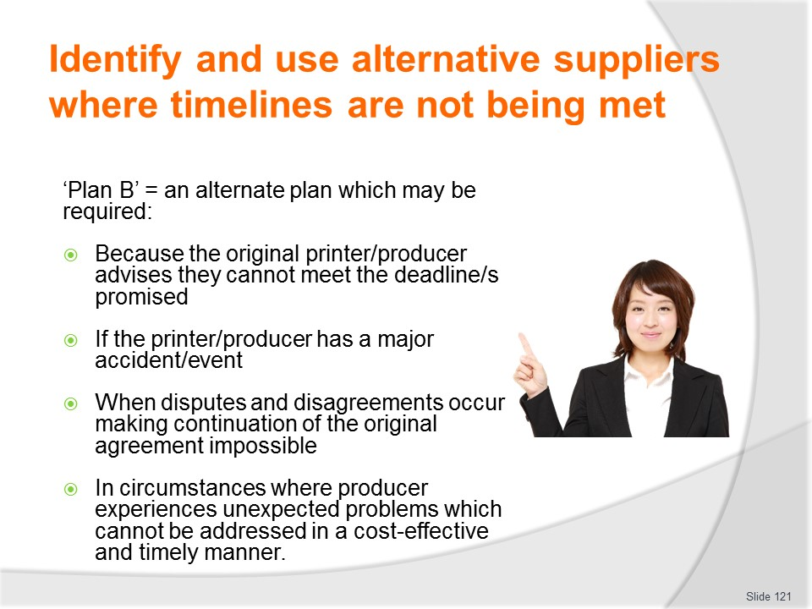
Slide No | Trainer Notes
Trainer discusses ‘Plan B’ explaining this is an alternate plan, the plan to be followed when the main/primary plan fails or cannot be implemented. In this context Plan B may be required:
- Because the original printer/producer advises they cannot meet the deadline/s they promised they could meet
- If the printer/producer has a major accident/event in their business and the effect is their capacity to manufacture items is reduced or has been lost
- When disputes and disagreements occur between the parties making continuation of the original agreement impossible
- In circumstances where the producer meets/experiences unexpected problems which cannot be effectively addressed in a cost-effective and timely manner.

Slide
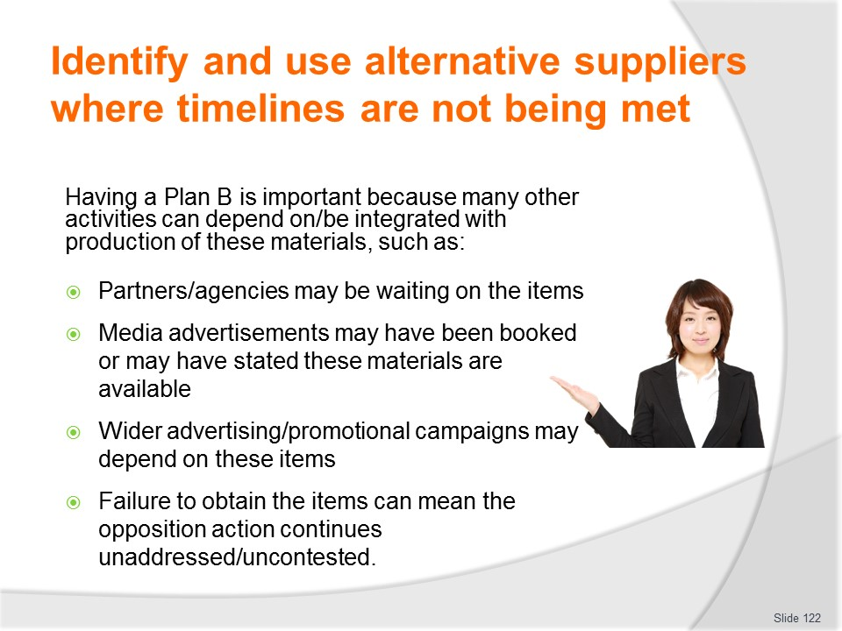
Slide No | Trainer Notes
Trainer states organisations are well-advised to have a Plan B for major jobs involving the production of brochures and marketing materials because there are nearly always other activities which depend on or are based on the physical/actual presence of the brochures/items in given numbers by a nominated date. That is, the production of brochures/items rarely stand/exist on their own – for example:
- Partners/agencies may be waiting for items by a given date – so they can distribute them/use them
- Media advertising space which relies directly on these items may have already been bought or booked – so the materials are required to underpin this advertising
- A wider promotion or advertising campaign could be jeopardised – as the materials are central to the central thrust of the initiative
- Action being taken by a competitor may be allowed to continue un-met without these brochures/items – as the organisation is unable to mount an effective ‘counter-offensive’ without them.

Slide
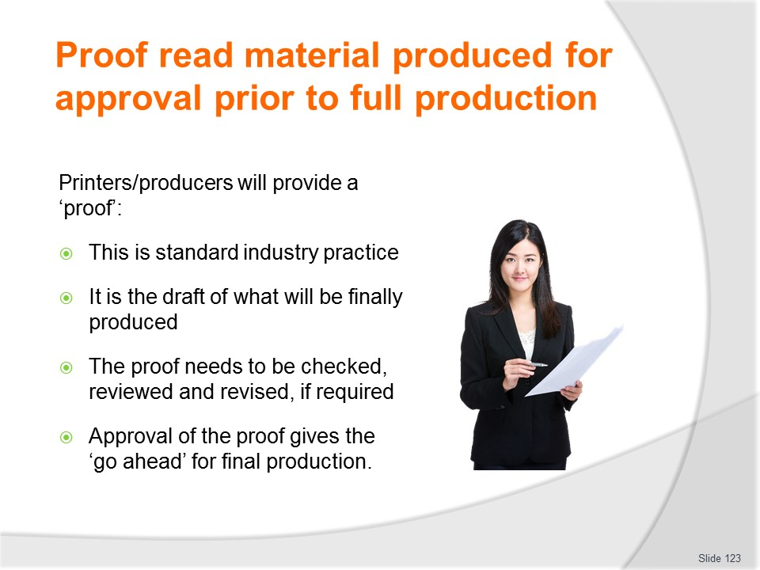
Slide No | Trainer Notes
Trainer explains when the printer/producer has been decided on they will work with the organisation to create a draft of the item/s required:
- This is called a ‘proof’.
- The proof will be forwarded to the organisation so:
- The draft can be checked and reviewed
- It can be approved for final production.

Slide
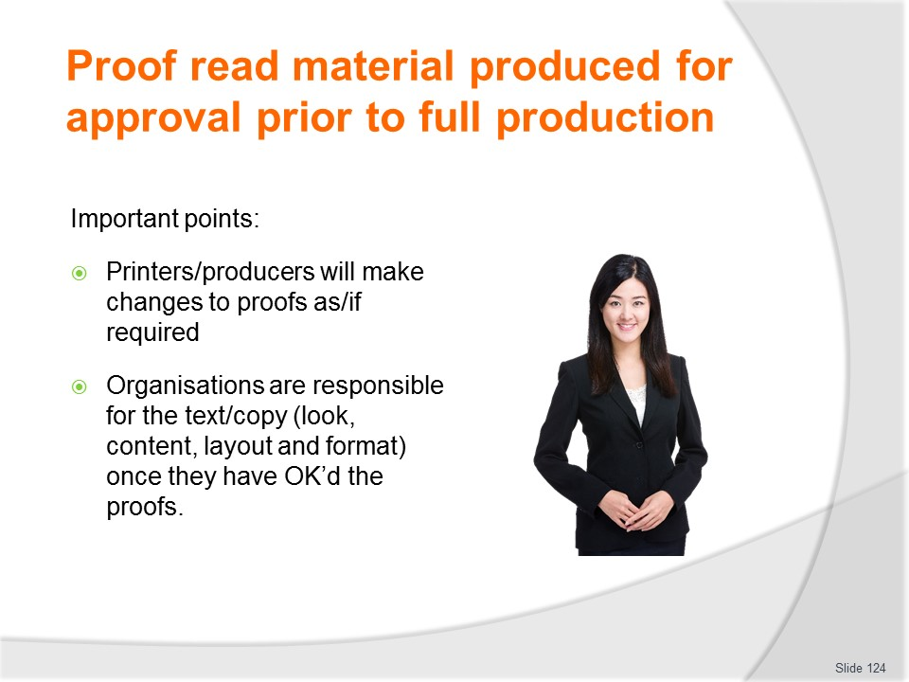
Slide No | Trainer Notes
Trainer gives two important points in relation to these proofs:
- The printer/producer will make changes to the proof as/if required by the client/organisation
- The organisation will be responsible for the correctness of the final proof once they have approved it for production.

Slide
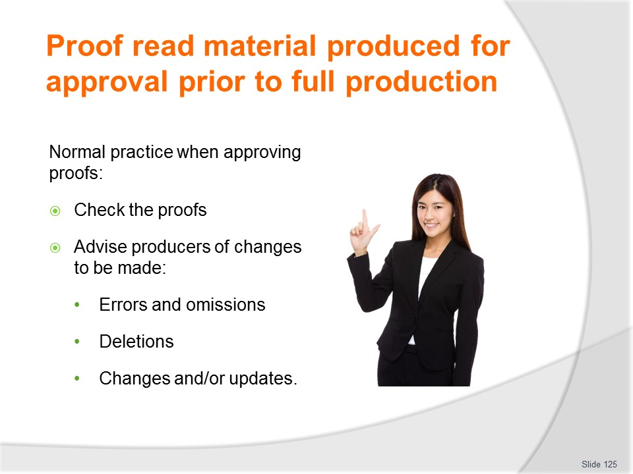
Slide No | Trainer Notes
Trainer presents normal practice in relation to ‘proofing’:
- Check the proofs – for accuracy and compliance with the specifications for the job and alignment with any draft materials supplied as part of the original arrangement
- Advise service providers of changes which need to be made – these may be:
- Errors that have been identified
- Omissions
- Things that need to be removed/taken out
- Changes or updates needing to be made to proofs prior to final production.
- In this context proof reading is the reading of ‘the proof’ as provided by the printer to check for errors and to make sure it complies with stated/agreed requirements.
- Once the proof has been accepted the brochures will be printed and/or the materials will be produced so it is important the proof is 100% correct.

Slide
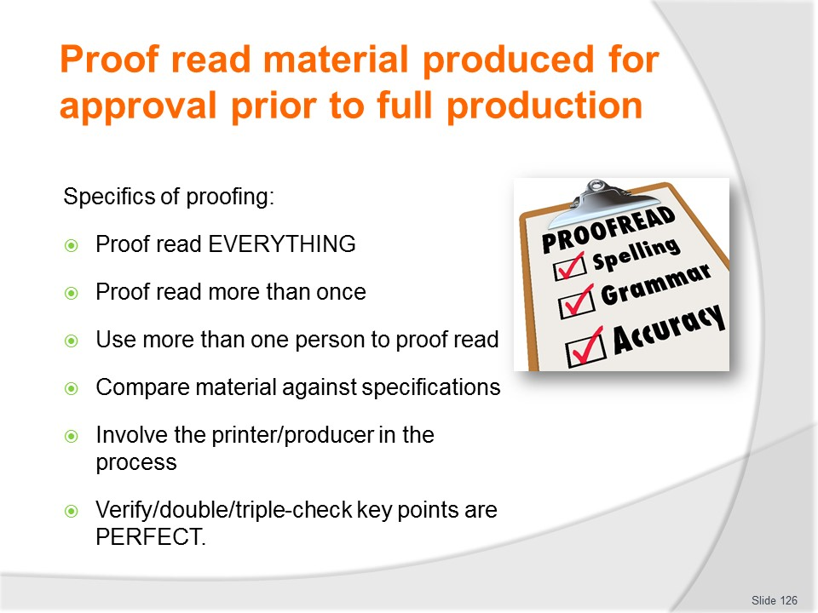
Slide No | Trainer Notes
Trainer identifies specifics of proofing:
- Proof-read everything – everything that is to be produced MUST be proofed prior to official approval
- Proof-read more than once – never just proof the article once: it is easy to miss/overlook an error or omission if things are read just once
- Get more than one person to proof the item – involve other staff, people from other departments and people from outside the organisation
- Compare material against the specifications provided – never rely on memory: always match questionable issues against the certainty of the material contained in the specifications
- Involve the printer/producer – the closer the relationship between the organisation and the printer/producer the better the final outcome of the whole process and the clearer the understanding about the problems and the results required
- Make sure the key points are perfect – while attention will have been paid to ensure content/copy is correct it is especially important to ensure:
- Telephone numbers are correct – and no digits have been transposed or are incorrect
- The business name has been correctly spelled
- Street and web addresses are correct.

Slide
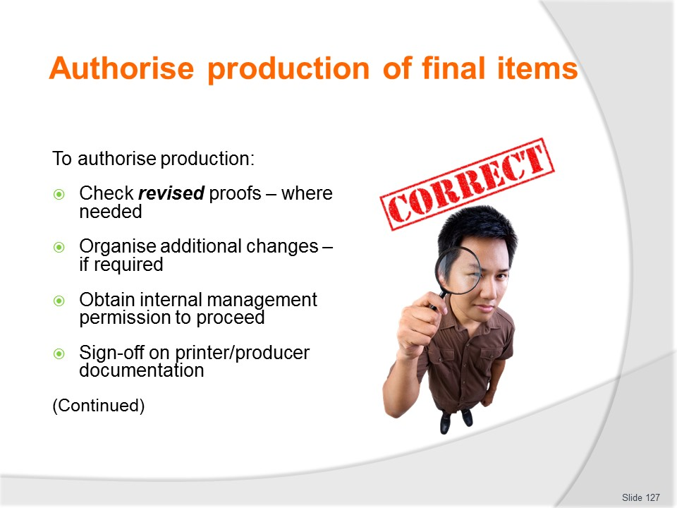
Slide No | Trainer Notes
Trainer identifies in order to authorise production it may be necessary to:
- Check revised proofs if this was required = to ensure revisions meet with requirements/specifications
- Organise additional changes – if/where this is necessary
- Obtain official authorisation from designated management to proceed – this may involve:
- Meeting with management to view/check the final draft/proof
- Receiving verbal permission to proceed
- Obtaining their signature on appropriate internal documentation
- Sign-off on a document provided by the printer/producer – giving them authority to proceed and confirming the provided proofs have been checked and are correct

Slide
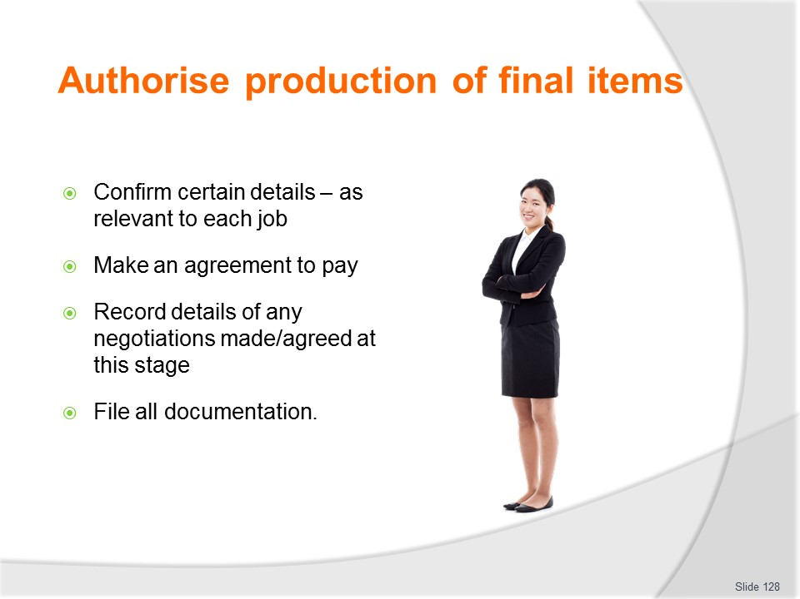
Slide No | Trainer Notes
Trainer continues discussing practices in authorising final production of items:
- Confirm certain details – these are always issues identified in the specifications and this process is an opportunity to:
- Make sure required dates, quantities and other needs remain as arranged
- Negotiate necessary changes
- Make an agreed payment – there is often a contracted requirement money needs to be paid to the printer/producer after final proofs have been agreed and before actual production starts.
- In many cases the printer/producer will not proceed with production until this money has been received so this is an important step in order to get materials produced by the time/deadline needed.
- Note any communication pertinent to requirements for changes – so there is a record of negotiations and arrangements for future reference
- File all documentation – in-keeping with standard business practice and for future reference.
Class Activity – Guest Speaker
Trainer arranges for a printer/producer to attend and:
- Discuss process of providing proofs
- Explain negotiations relating to changes required to proofs
- Detail how additional requirements are factored into original quotations.

Slide
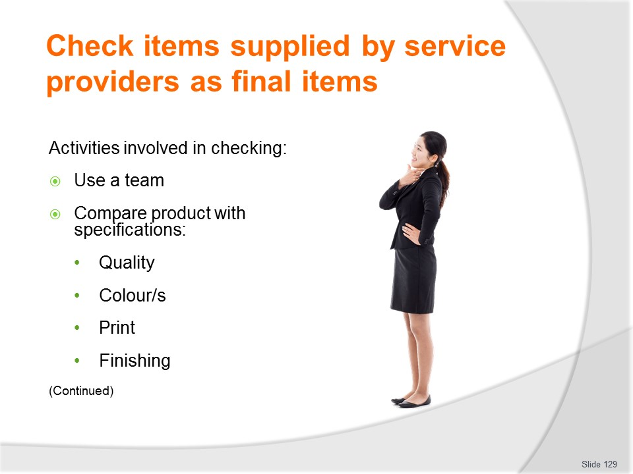
Slide No | Trainer Notes
Instructs the activities below are necessary when checking items supplied:
- Use a team to do the checking – as opposed to doing the job alone.
- This speeds up the process and optimises the likelihood of problems being identified
- Compare the finished product/s to the specifications and the approved proof/s – to make sure what has been delivered complies with what was needed/requested/paid for
- Check the quality of the final product – for example, with brochures there is a need to:
- Check colours used match what was required/agreed
- Check there is no ‘colour bleed’
- Check print clarity
- Check required finishing has been applied.

Slide
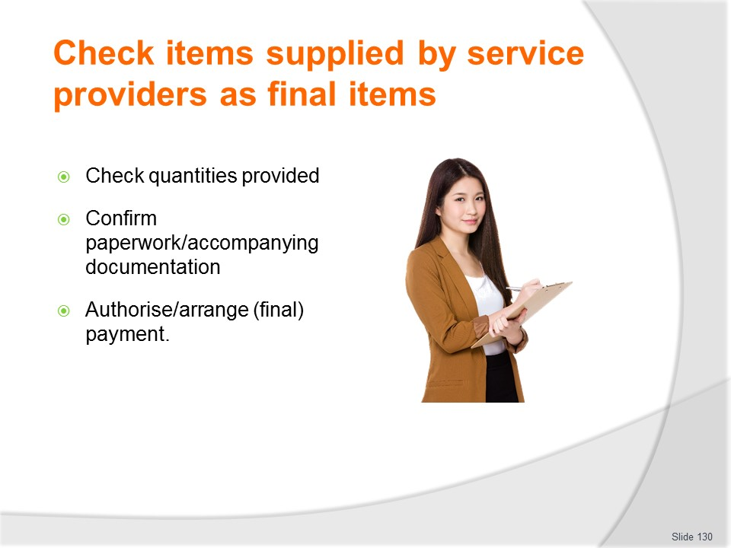
Slide No | Trainer Notes
Trainer continues listing activities necessary for checking final items:
- Check the quantities supplied – to make sure the numbers provided are actually the numbers ordered/required
- Confirm the paperwork for the job is correct – this may mean:
- Verifying invoice matches the quotation
- Ensuring invoice/statement aligns with purchase order
- Making sure there are no charges for services not requested or not provided
- Authorise final payment – to the service providers.
- It is important to pay promptly and as agreed in order for the organisation to remain a ‘good corporate citizen’ and to help create a positive relationship for the next time similar work needs to be done/negotiated.

Slide
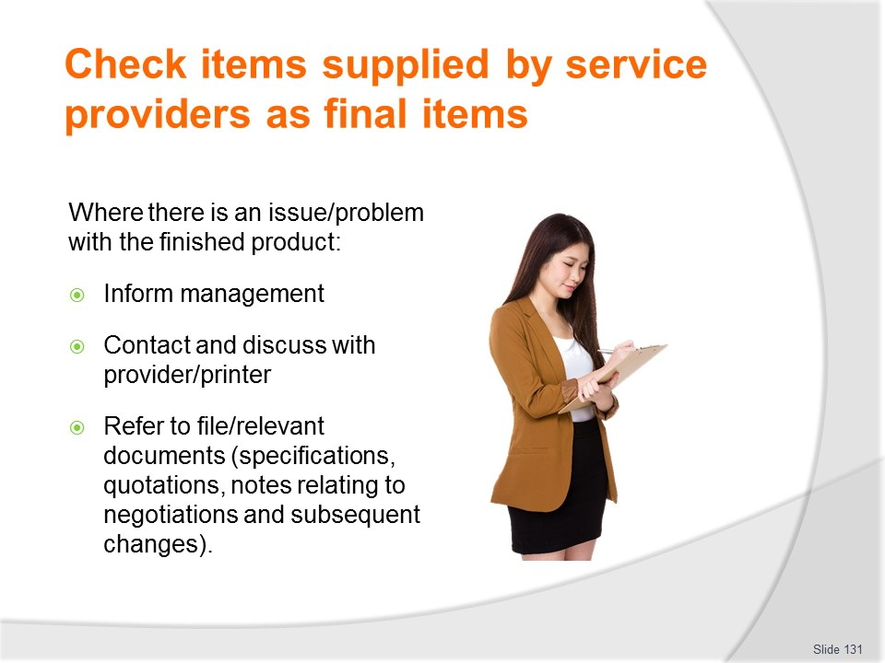
Slide No | Trainer Notes
Trainer where the finished product does not comply with the proof or other quality criteria, it is standard practice to:
- Inform management – so they can follow up with the printer/producer
or
- Immediately contact the provider and discuss the situation with them.
- It is at this stage a file copy of the quotation and the proofs become very important.

Slide
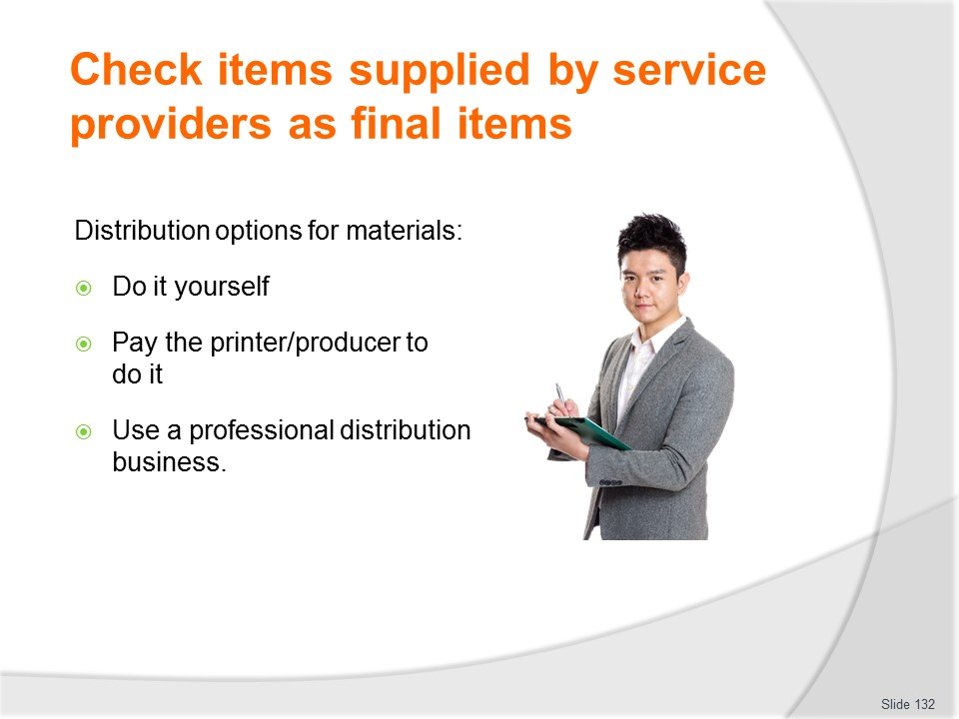
Slide No | Trainer Notes
Trainer states distribution options for materials are:
- The organisation distributes items themselves – this means the organisation maintains sole control over the process but also has sole responsibility for organising the work to be done.
- The printer/producer distributes them for an additional charge – according to a distribution schedule provided by the organisation
- Use a different business to handle distribution – such as a distribution house, distributor or courier service.
Classroom Activity – Internet Research
Trainer facilitates online research and discussion relating to relevant sites such as:
- http://www.sgflyerking.com/price.html
- http://www.asiaprintmart.com/flyers_distributions.html
- http://philippineflyerdistributor.webs.com/

Slide
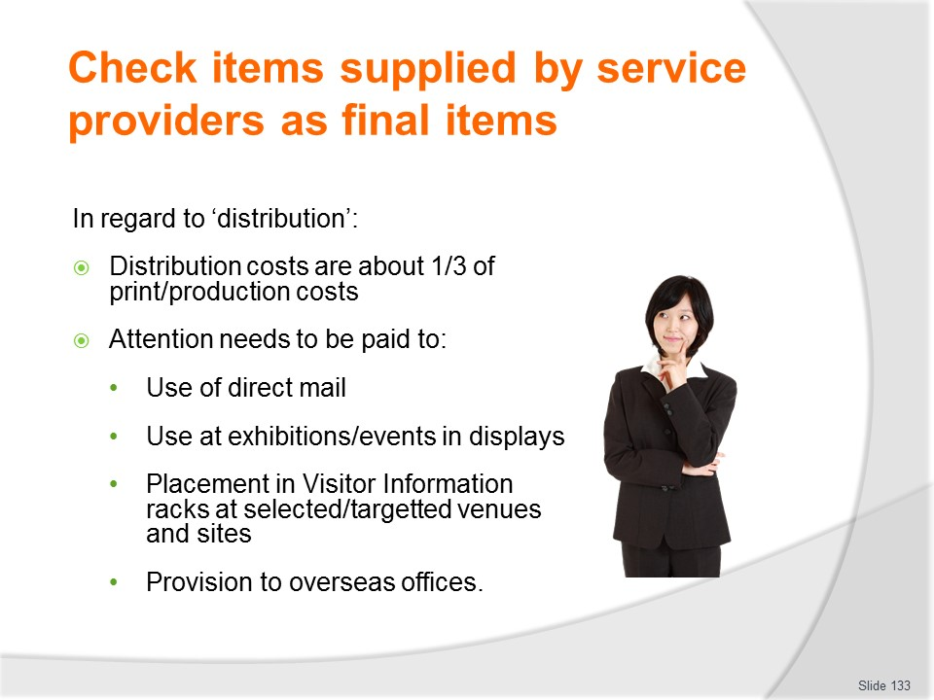
Slide No | Trainer Notes
Trainer adds that:
- As a guide, once the cost of design and print/production have been calculated an additional one third extra should be allowed for distribution costs
- Attention should be paid to consideration of how many brochures the business will distribute:
- By direct mail
- At exhibitions and other events where the business will have a presence (display/stand)
- Through brochure racks at information centres, carriers, accommodation facilities
- Through overseas offices.
Classroom Activity (1) Guest Speaker
Trainer arranges for representative from Distributor company to attend and:
- Describe services they provide
- Explain costs
- Provide tips and points to note when distributing
Classroom Activity (2) Guest Speaker
Trainer arranges for management of a relevant travel/tour business to attend and:
- Discuss their distribution of materials explaining:
- How they distribute
- Where they distribute
- Who they use and why
- Costs
- Suggest advice for future distribution of items for students.

Slide
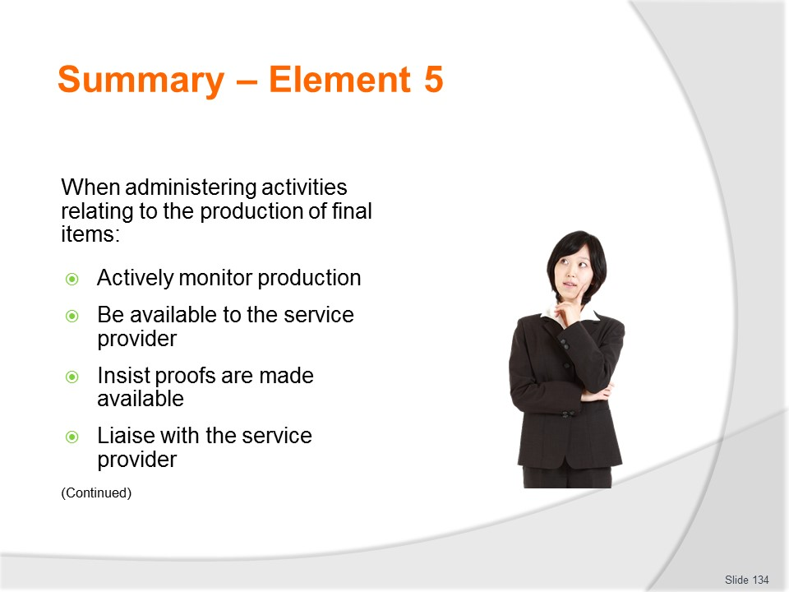
Slide No | Trainer Notes
 | Trainer provides a recap of the Element asking questions to check trainee understanding and responding to questions from trainees, as required.

Slide
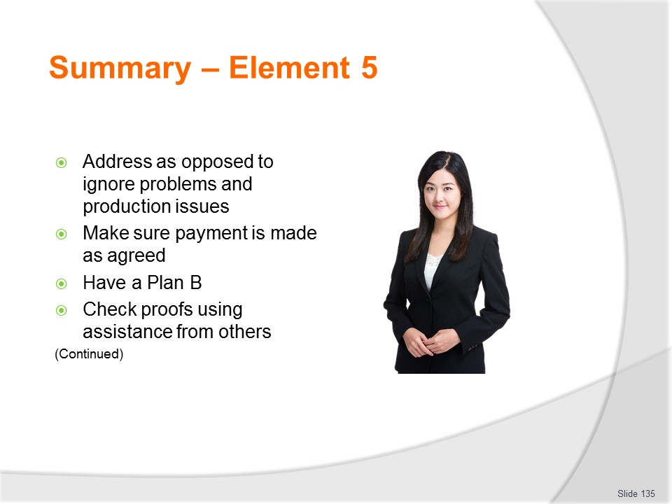
Slide No | Trainer Notes
 | Trainer provides a recap of the Element asking questions to check trainee understanding and responding to questions from trainees, as required.

Slide
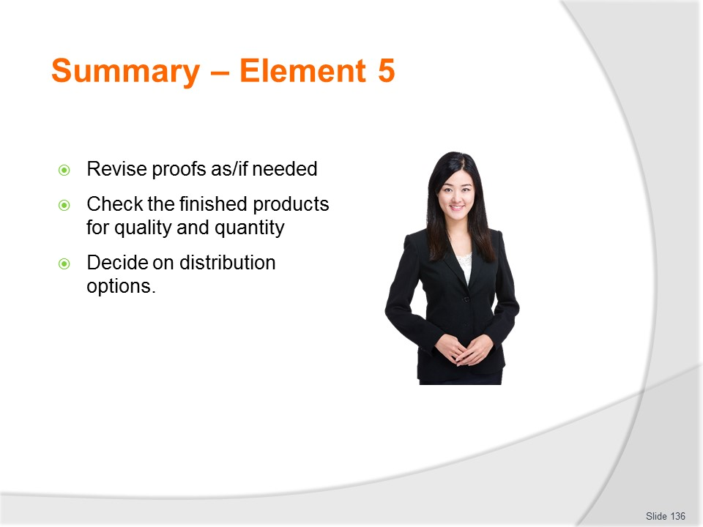
Slide No | Trainer Notes
Trainer provides a recap of the Element asking questions to check trainee understanding and responding to questions from trainees, as required.
Trainer thanks trainees for their attention and encourages them to apply course content as required in their workplace activities.

Recommended training equipment
Sample brochures of different destinations, attractions, tours, trips and travel – example must cover range of different:
- Colour options
- Fold types – including variety such as:
- Half-fold
- Tri-fold
- Accordion fold
- Z-fold
- Accordion fold
- Quarter fold
- Gate fold
- Single and multi-page
- Layouts, styles and formats
- Languages.
Range of branded merchandising materials used by travel and tourism operators – caps, pens, hats, T-shirts, rulers, bags and similar
Sample schedules, itineraries, price lists, time tables, tour and destination Fact Sheets, Information Kits for tours
Sample card/stock
Quotations for printing and other production work
Copies of draft materials prior to final approval
Range of DTP software:
- Adobe InDesign
- Adobe PageMaker
- FrameMaker
- Microsoft Office Publisher
- PagePlus
- PageStream
- QuarkXPress.

Instructions for Trainers for using
PowerPoint – Presenter View
Connect your laptop or computer to your projector equipment as per manufacturers’ instructions.
In PowerPoint, on the Slide Show menu, click Setup Show.
Under Multiple monitors, select the Show Presenter View check box.
In the Display slide show on list, click the monitor you want the slide show presentation to appear on.
Source: http://office.microsoft.com
Note:
In Presenter View:
You see your notes and have full control of the presentation
Your trainees only see the slide projected on to the screen
More Information
You can obtain more information on how to use PowerPoint from the Microsoft Online Help Centre, available at: http://office.microsoft.com/training/training.aspx?AssetID=RC011298761033
Note Regarding Currency of URLs
Please note that where references have been made to URLs in these training resources trainers will need to verify that the resource or document referred to is still current on the internet. Trainers should endeavour, where possible, to source similar alternative examples of material where it is found that either the website or the document in question is no longer available online.

Appendix – ASEAN acronyms
AADCP | ASEAN – Australia Development Cooperation Program
ACCSTP | ASEAN Common Competency Standards for Tourism Professionals
AEC | ASEAN Economic Community
AMS | ASEAN Member States
ASEAN | Association of Southeast Asian Nations
ASEC | ASEAN Secretariat
ATM | ASEAN Tourism Ministers
ATPMC | ASEAN Tourism Professionals Monitoring Committee
ATPRS | ASEAN Tourism Professional Registration System
ATFTMD | ASEAN Task Force on Tourism Manpower Development
CATC | Common ASEAN Tourism Curriculum
MRA | Mutual Recognition Arrangement
MTCO | Mekong Tourism Coordinating office
NTO | National Tourism Organisation
NTPB | National Tourism Professional Board
RQFSRS | Regional Qualifications Framework and Skills Recognition System
TPCB | Tourism Professional Certification Board





